7. EXECUTIVE DIRECTOR’S REPORT
Memorial Park: Final Design Concept

Background: further background on this initiative can be found in the April, 2017 ignite cda board meeting minutes.

Bill Greenwood, City of CDA Parks Director, was welcomed to the meeting to provide an overview of the final concept design for the Memorial Park element of the Four Corner Master Plan. Prior to his overview, Mr. Greenwood first thanked the ignite cda board for their long-term support of parks and public space.
Mr. Greenwood shared that following last month’s visit with the ignite cda board, he met with Scott Cranston, Phil Boyd and Dell Hatch to consider the DRAFT DRAFT DRAFT
Meeting Minutes 5/17/17 7

feedback given at the board meeting. The result of that meeting is the concept graphic shown below. Mr. Greenwood shared that he likes how the new concept better addresses the parking solution on the site, rotates the Memorial playfield area, and better aligns the location of the other park amenities within the overall park area.
  - ➢ Commissioner Druffel asked that at last month’s meeting, it was brought up that realigning Memorial Field might result in a substantial cost for relocating field lighting. Is that the case? • Mr. Greenwood shared that after further research, the cost of relocating the lighting structures is estimated at $28,000 – a very reasonable cost relative to the overall benefit of rotating the play field.

  - ➢ Commissioner Hoskins asked for the final parking count? • Mr. Greenwood shared that 146 spaces will be added via this initiative.

  - ➢ Commissioner Goodlander shared that she likes the proposed buffer areas. Is the BLM supportive of this concept? • Mr. Greenwood – yes.

  - ➢ Commissioner Davis asked about next steps in the process? • Mr. Greenwood shared that he plans to go to bid by the end of May, and break ground July 5th, with project completion scheduled for October, 2017.

Revised Concept DRAFT DRAFT DRAFT
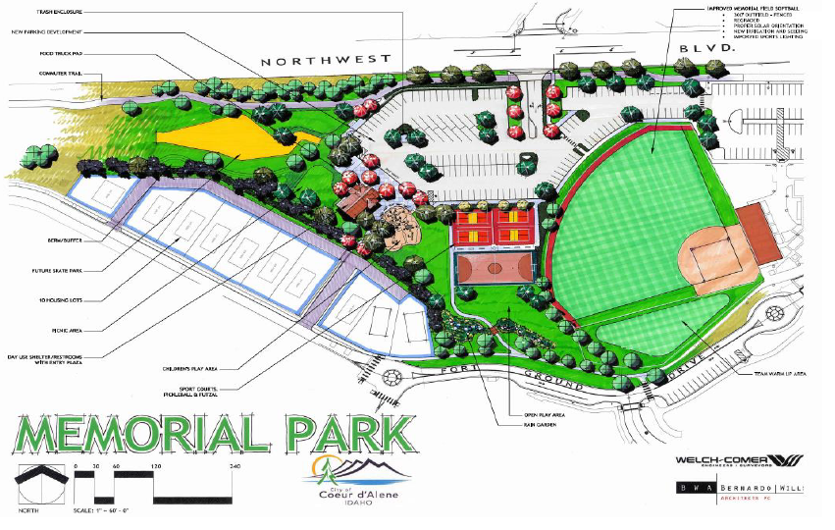

Meeting Minutes 5/17/17 8

Memorial Park: Financing Agreement with City
Ex. Director Berns discussed the ignite cda / City of CDA financing agreement for the Memorial Park project with the board. CDA City Council approved this financing agreement at the May 16, 2017 City Council meeting. Following are key elements of the Memorial Park financing agreement:
- • The Agency agrees to pay up to $1,559,000 for development of the Memorial Park cost elements as depicted in the following table:

- • An Agency board member, and/or the Agency’s Executive Director, shall be a member of the project implementation team and the Agency shall approve any and all construction draw requests made of the city,
- • Agency sign-off will be a prerequisite for disbursement of any funds pursuant to any draw requests,
- • The Agency shall have the ability, in its sole discretion, to hire any third-party consultant or expert to oversee the construction of the project, at the Agency’s expense. The city agrees to cooperate or cause its contractor or other party acting on behalf of the city to reasonably cooperate with such third-party consultant or expert,
- • Agency will pay directly to the contractor the amount requested under the draw request up to a maximum of the total Agency contribution amount.

Motion by Commissioner Widmyer, seconded by Commissioner Davis to approve the Memorial Park Financing Agreement with the City of CDA as presented, in an amount not to exceed $1,559,000, also authorizing the Chairman and Executive Director to execute the necessary documents associated with the financing agreement. Motion carried.

