The Spokane Police Activities League (PAL) engages participating youth in positive athletic and academic programs, including gang and drug intervention and prevention.

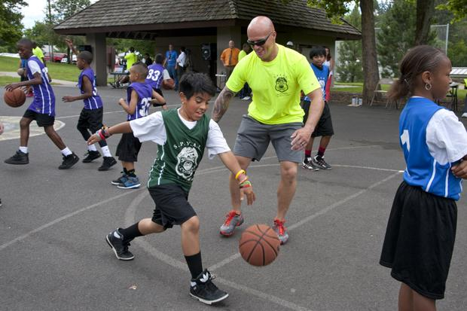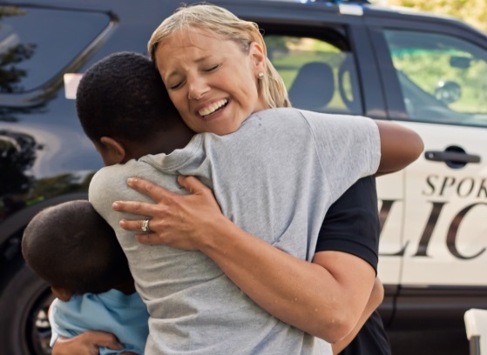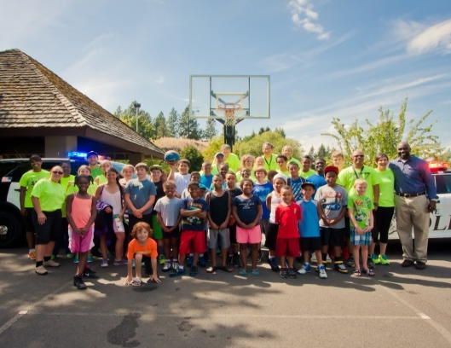
PAL is a program formed by collaborations between the Spokane Police Department, Operation Healthy Family and the Kingdom Fellowship Church Alliance. PAL bridges the gap between Spokane Police officers and potential at-risk youth in our community through fun and educational summer activities such as basketball and swimming programs. Kids entering 4th through 9th grade in the fall are encouraged to attend.

Session One PAL Basketball:  July 7 - August 11, 2015, Every Tuesday  11:30 am - 2:30 pm  Cannon Park, 1920 W. Maxwell  (optional swim lessons 10:30-11am) | Session Two PAL Basketball:  July 8 - August 12, 2015, Every Wednesday  11:30 am - 2:30 pm  Harmon Park, 6018 N. Regal  (optional swim lessons 10:30-11am)
Session Three PAL Basketball:  July 9 - August 13, 2015, Every Thursday  11:30 am - 2:30 pm  Liberty Park, 1704 E. 4th Ave.  (optional swim lessons 10:30-11am) | Final Celebration BBQ:  August 20, 2015, 11:30 am - 2:30 pm  Liberty Park, 1704 E. 4th Ave.  Families invited to attend!

Visit SpokanePAL.org for more information.

Registration is $50/player for basketball with optional swim lessons available with limited scholarships

Still have questions?
Contact Officer Jennifer DeRuwe at 509.209.7178 or jderuwe@spokanepolice.org

To register for PAL, please download the form off our website and return it either electronically or by mail to Officer DeRuwe (jderuwe@spokanepolice.org or 1100 W. Mallon, Spokane, WA 99260). Once the application is received, you will be notified and can take program payment to My Spokane Customer Service, 1st Floor City Hall, 808 W. Spokane Falls Blvd.

