Press Release
For Immediate Release
March 3, 2015

Contact:
John Mellgren, Western Law Environmental Center, (541) 359-0990
Mike Petersen, The Lands Council, (509) 209-2406
Timothy Coleman, Kettle Range Conservation Group, (509) 775-2667
Bethany Cotton, WildEarth Guardians, (503) 327-4923

Conservationists Challenge Wildlife Services’ Authority to Kill Wolves in Washington
Wildlife Services Activities Threaten Wolf Recovery, Healthy Ecosystems

Olympia, Wash. — Today, the Western Environmental Law Center (WELC) on behalf of five conservation groups, filed a lawsuit against the U.S. Department of Agriculture’s (USDA) Wildlife Services program challenging its authority to kill endangered wolves in Washington state.

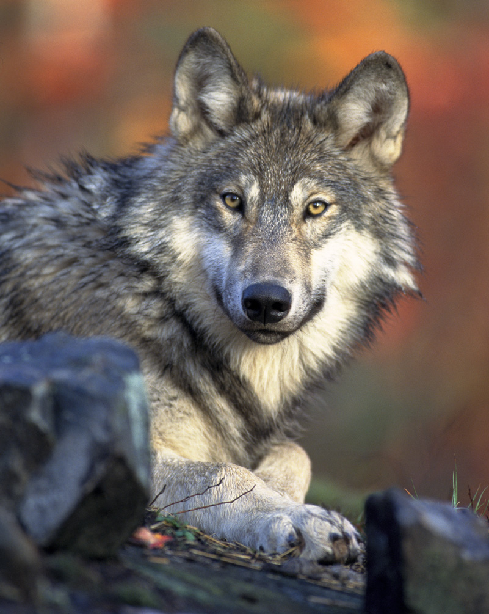
The National Environmental Policy Act (NEPA) requires USDA to prepare an in-depth Environmental Impact Statement (EIS) addressing the effects of employing Wildlife Services to kill endangered wolves in Washington. The agency completed a less-detailed Environmental Assessment (EA), but the document contains significant gaps and does not address specific issues that will significantly impact wolves and the human environment. NEPA review is designed to ensure all environmental impacts are analyzed and that the public has an opportunity to comment, and therefore influence, activities conducted using public funds.

The EA prepared by Wildlife Services fails to provide data to support several of its core assertions. For example, Wildlife Services claims that killing wolves reduces wolf-caused losses of livestock, yet recent peer-reviewed research from Washington State University directly contradicts this conclusion, finding that killing wolves actually leads to an increase in wolf-livestock conflicts. The EA also fails to address the ecological effects of killing wolves in Washington, including impacts on wolf populations in neighboring states and on non-target animals, including federally protected grizzly bears and Canada lynx.

“Wildlife Services’ activities related to wolves in Washington have been extremely harmful,” said John Mellgren, attorney at the Western Environmental Law Center. “The science tells us that killing wolves does not actually reduce wolf-livestock conflicts, but Wildlife Services is continuing its brutal assault on this iconic animal and it needs to stop.”

Wildlife Services is a stand-alone federal extermination program under USDA that kills roughly 4 million animals per year, including wolves, grizzly bears, otters, foxes, coyotes, and birds—with almost no oversight or accountability. A 2013 internal audit revealed that Wildlife Services’ accounting practices lacked transparency and violated state and federal laws. Concerns about the program’s practices and effectiveness are the focus of an ongoing investigation by the USDA’s Inspector General.

Washington has experienced Wildlife Services’ recklessness firsthand. Last August, Wildlife Services’ snipers mistakenly shot and killed the Huckleberry wolf pack’s alpha female during a helicopter gunning operation. The killing was in direct violation of explicit instructions from the Washington Department of Fish & Wildlife (WDFW) to not kill either of the pack’s alpha members. The death of the Huckleberry pack’s breeding female threatens the future of the entire pack.

Wildlife Services also ‘advised’ WDFW in the contentious 2012 killing of Washington’s Wedge wolf pack. In that instance, WDFW killed seven wolves after depredations of livestock on public lands, despite the rancher’s failure to take sufficient action to protect his cattle.

“Wildlife Services’ refusal to ensure its activities are based on the best available science strips the public of an opportunity to meaningfully understand and contribute to decisions impacting the health of ecosystems on which we all depend,” said Bethany Cotton, wildlife program director at WildEarth Guardians. “Its past time that the dark practices of Wildlife Services are subjected to the sunshine of a transparent public process.”

Wolves were driven to extinction in Washington in the early 1900s by a government-sponsored eradication program on behalf of the livestock industry. The species began to return to Washington from neighboring Idaho and British Columbia in the early 2000s, and the wolf population in the state has grown to 13 confirmed packs. Despite this growth, wolves in the state are far from recovered and face ongoing threats—including the threat of being shot and killed by Wildlife Services.

Western Environmental Law Center is representing the following organizations in the lawsuit: Cascadia Wildlands, WildEarth Guardians, Kettle Range Conservation Group, Predator Defense, and The Lands Council.

###

