1. SURGE: Lincoln Street and Broadway Avenue Spokane Urban Runoff Greenway Experiments
Alex Mann |AHBL, Inc.

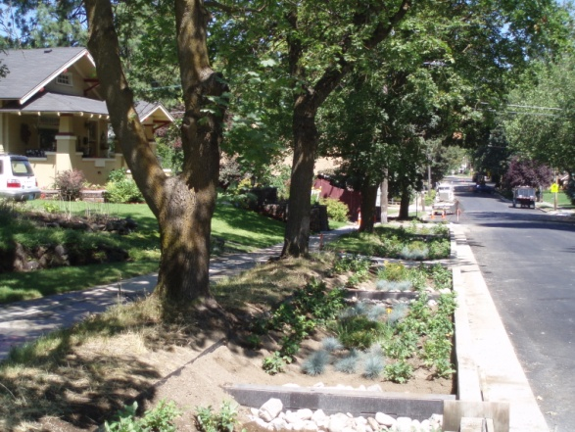
2. Spokane Convention Center South Parking Lot Lighting Project
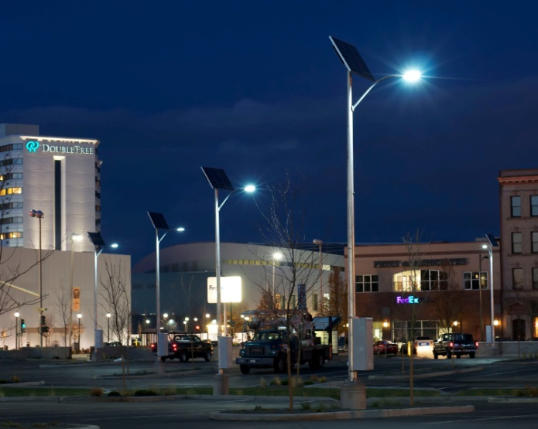
Elizabeth Pece, MW Escent
3. Spokane Falls Community College – Science Building Lecture Wing Kjersten Kuhta, MW Consulting Engineers
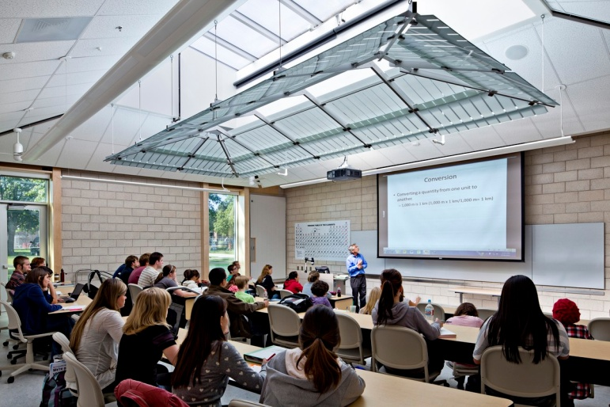
4. Magner Sanborn
Matthew Collins, Uptic Studios
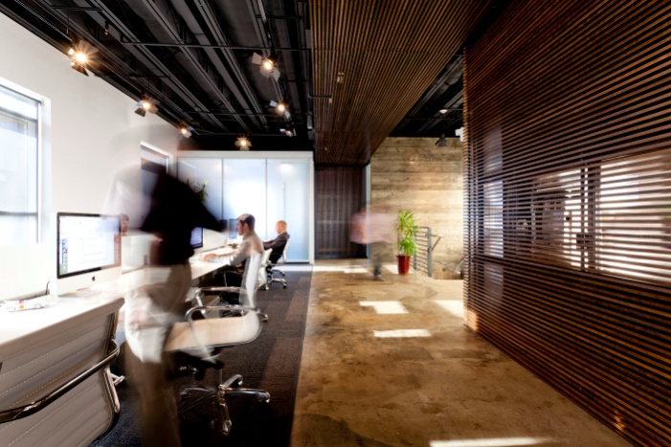
5. Park Cottages – Multi-Family Residential Urban Infill
Bruce Millard , Studio of Sustainable Design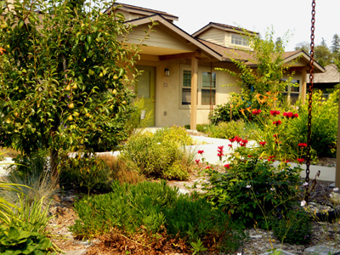
6. Earth Flow House
Colin Anderson, Copeland Architecture & Construction

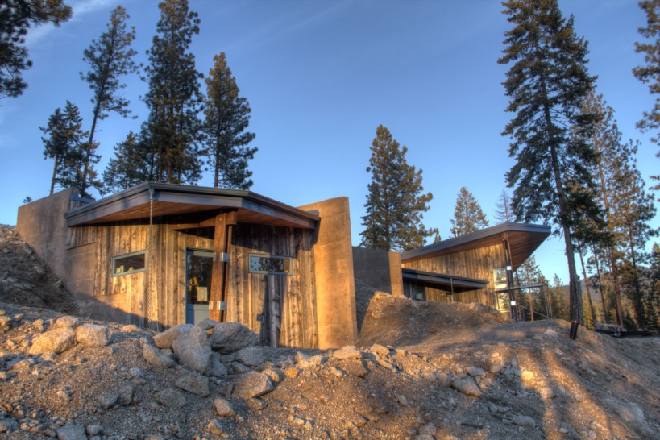
7. McGovern Residence
Sarah McGovern, Milieu

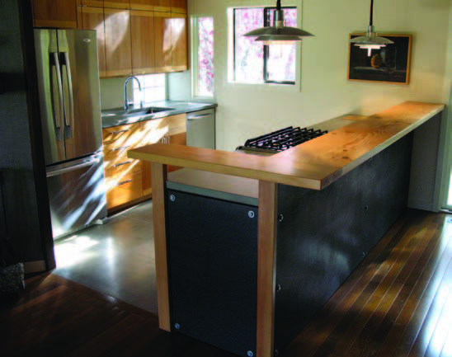
8. Soeldner-Finney Residence
Kelly Lerner, One World Design
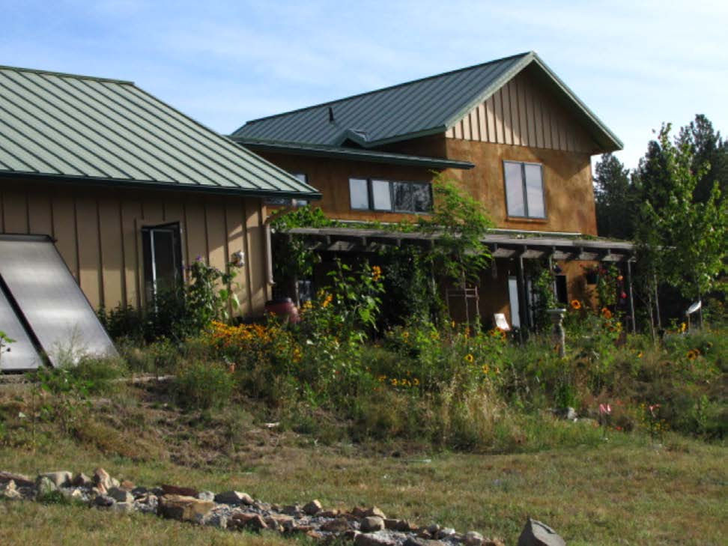

9. The Clarkson Residence
Mark Hamlin, Sustainable Structures
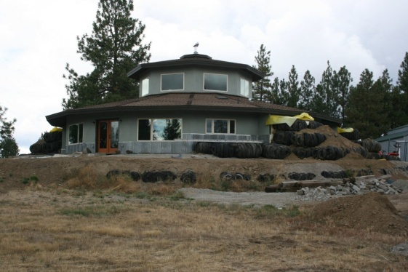
10. Forbes Residence
Kurt Rathmann
Rathmann Design, Inc.
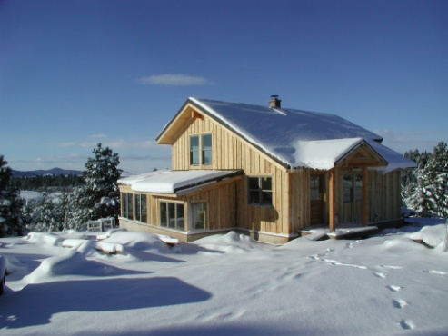
Alternates:
- The Brown Residence
Gavin Tenold, Pura Vida Homes

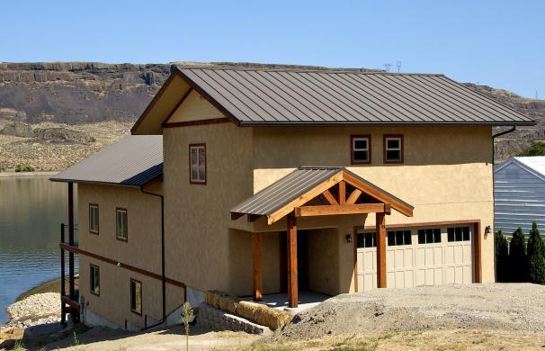

12. SIREWALL rammed earth architecture
Sam Rodell, Rodell Construction Services

