ASSESSMENT OF PRONGHORN
HABITAT POTENTIAL IN
EASTERN WASHINGTON

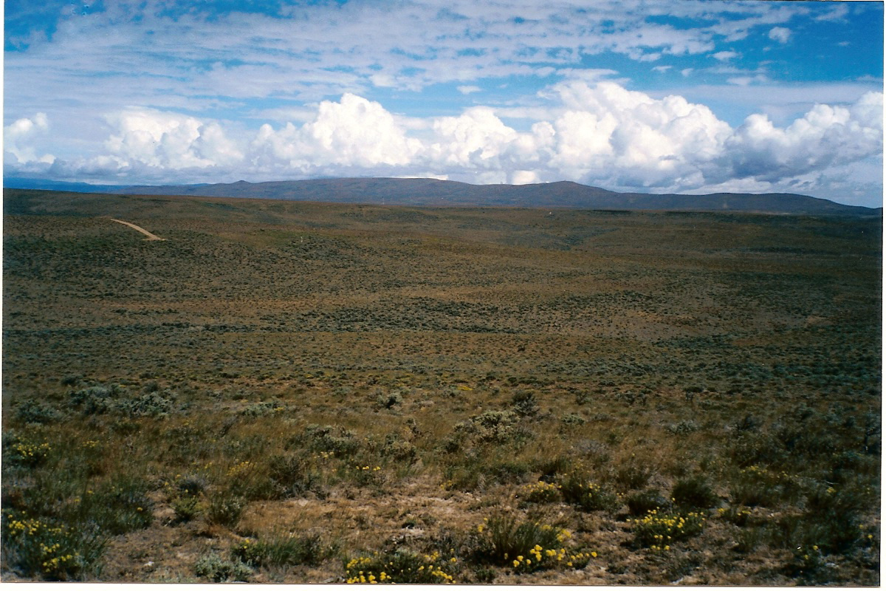

By George K. Tsukamoto

June 2006

ASSESSMENT OF PRONGHORN
HABITAT POTENTIAL IN
EASTERN WASHINGTON

George K. Tsukamoto

June 2006

This study was financed by the Seattle Sportsmen’s Conservation Foundation and Safari Club International-Central Washington Chapter for the Washington Department of Fish and Wildlife as an initial assessment to determine the feasibility of reintroducing pronghorn antelope into the State.

Table of Contents
Table of Contents i
INTRODUCTION 1
Purpose 1
Acknowledgements 1
Historical occurrence 1
Previous Introductions 2
STUDY AREA 4
METHODS 5
GIS Habitat Suitability Model 6
Pronghorn habitat suitability model 9
Weights of the variables 9
Normalized weighted pronghorn habitat suitability score 10
Other considerations 10
On-Site Field Habitat Evaluation and Scoring Model 10
Vegetation 11
Terrain slope and aspect (Topographic diversity) 11
Water availability 12
Size and Continuity 12
Landownership/use 12
Limitations/obstructions (fences, canals, highways, railroads, etc.) 12
Suitability Score Summary 12
SITE EVALUATIONS 13
Quilomene 13
Location/Landownership 13
Vegetation 13
Topography 15
Water 15
Size and Continuity 16
Climate 17
Limitations 18
Wild Horse Wind Power Project 20
Habitat Evaluation Score 21
Yakima Training Center 23
Location/Landownership 23
Vegetation 23
Topography 24
Water 25
Size and Continuity 26
Climate 27
Limitations 27
Habitat Evaluation Score 29
Swanson Lakes 31
Location/Landownership 31
Vegetation 31
Topography 33
Size and Continuity 34
Water 34
Climate 35
Limitations 36
Habitat Evaluation Score 37
Cow and Rock Creek 38
Location/Landownership 38
Vegetation 38
Topography 40
Size and Continuity 42
Water 42
Climate 42
Limitations 42
Habitat Evaluation Score 44
Rattlesnake Hills, Hanford, Wahluke Slope 45
Location/Landownership 45
Vegetation 45
Topography 48
Size and Continuity 48
Water 49
Climate 49
Limitations 50
Habitat Scores and Ranking 51
Moses Coulee, Badger Mt., Mansfield 53
Location/Landownership 53
Vegetation 53
Topography 55
Size and Continuity 55
Climate 56
Limitations 58
Habitat Evaluation Score 58
Grand Coulee, Wilson Creek, Black Rock Coulee 60
Location/Landownership 60
Vegetation 60
Topography 63
Size and Continuity 63
Water 65
Climate 65
Limitations 66
Habitat Evaluation Score 67
Bickelton/Six Prong 69
Location/Landownership 69
Vegetation 69
Topography 72
Size and Continuity 73
Water 73
Climate 73
Limitations 74
Habitat Evaluation Score 75
CONCLUSIONS AND RECOMMENDATIONS 77
Ranking 77
LITERATURE CITED 80
APPENDIX B 84
APPENDIX C 85
APPENDIX D 86
D1 Bickelton 86
D2 Cow and Rock Creek 86
D3 Grand Coulee, Wilson Creek, Black Rock Coulee 86
D4 Moses Coulee, Badger Mt. and Mansfield 86
D5 Quilomene 86
D6 Rattlesnake Hills, Wahluke, Hanford 86
D7 Swanson Lakes 86
D8 Yakima Training Center 86

List of Tables
Table 1. A summary of pronghorn introductions in Washington…………………………………………… | 3
Table 2. Vegetation Rating…………………………………………………………………………………….. | 7
Table 3. Remapping NLCD to Vegetation Rating……………………………………………………………. | 7
Table 4. Slope Rating………………………………………………………………………………………….. | 8
Table 4. Slope Rating………………………………………………………………………………………….. | 8
Table 6. Aspect Rating…………………………………………………………………………………………. | 9
Table 7. Pair-wise Comparisons of Four Variables…………………………………………………………... | 9
Table 8. Weights of Five Variables…………………………………………………………………………….. | 10
Table 9. The vegetative height rating and suitability score………………………………………………….. | 11
Table 10. Terrain slope and aspect (Topographic diversity)………………………………………………… | 12
Table 11. NLCD Land Cover Classes in mi² and Percent Make up for the Quilomene Area……………... | 15
Table 12. ELLENSBURG FAA AIRPORT, WASHINGTON (452508) Period of Record Monthly Climate Summary 5/ 4/1940 to 3/31/2005……………………………………………………………………… | 17
Table 13. Quilomene pronghorn habitat field evaluation scoring summary……………………………….. | 21
Table 14. NLCD Land Cover Classes in mi² and Percent Make up for the YTC Area……………………. | 23
Table 15. MOXEE CITY 10 E, WASHINGTON (455688) Period of Record Monthly Climate Summary 6/ 1/1948 to 3/31/2005……………………………………………………………………………………………. | 27
Table 16. Yakima Training Center pronghorn habitat evaluation scoring summary……………………... | 30
Table 17. NLCD Land Cover Classes in the Swanson Lakes Area/Sub Areas……………………………... | 33
Table 18. HARRINGTON 4 ENE, WASHINGTON (453515) Period of Record Monthly Climate Summary 12/1/1961 to 3/31/2005……………………………………………………………………………….. | 35
Table 19. Swanson Lake/Crab Creek pronghorn habitat evaluation scoring summary…………………... | 37
Table 20. NLCD Land Cover Classes in the Cow and Rock Creek Area/ Sub Areas……………………… | 40
Table 21. RITZVILLE, WASHINGTON (457059) Period of Record Monthly Climate Summary  6/1/1948 to 3/31/2005…………………………………………………………………………………………….. | 42
Table 22. Cow Creek pronghorn on site habitat evaluation scoring summary…………………………….. | 44
Table 23. NLCD Land Cover Classes in the Rattlesnake Hills, Arid Lands Ecology Reserve, Hanford, Wahluke Slope Area/ Sub Areas……………………………………………………………………………….. | 46
Table 24. BENTON CITY 2 NW, WASHINGTON (450628) Period of Record Monthly Climate Summary 6/ 1/1948 to 1/31/1964……………………………………………………………………………….. | 49
Table 25. Rattlesnake Hills, Arid Lands Ecology Reserve, Hanford, Wahluke Slope pronghorn habitat field evaluation scoring summary……………………………………………………………………………… | 51
Table 26. NLCD Land Cover Classes in the Moses Coulee, Badger Mt., Mansfield Area by sub area…... | 54
Table 27. EPHRATA, WASHINGTON (452609)Period of Record Monthly Climate Summary 1/ 1/1931 to 3/25/1971………………………………………………………………………………………………………. | 57
Table 28. WATERVILLE, WASHINGTON (459012) Period of Record Monthly Climate Summary, 1/ 3/1931 to 3/31/2005………………………………………………………………………………………………. | 56
Table 29. Moses Coulee/Beezley pronghorn field habitat evaluation scoring summary………………….. | 59
Table 30. NLCD Land Cover Classes in the Grand Coulee/Wilson Creek Area…………………………... | 64
Table 31. COULEE DAM 1 SW, WASHINGTON (451767) Period of Record Monthly Climate Summary 6/ 1/1948 to 3/31/2005………………………………………………………………………………... | 65
Table 32. Grand Coulee/Wilson Creek pronghorn field habitat evaluation scoring summary…………… | 67
Table 33. NLCD Land Cover Classes in the Bickelton Area/Sub Areas……………………………………. | 73
Table 34. BICKLETON 3 ESE, WASHINGTON (450668) Period of Record Monthly Climate Summary 1/ 1/1931 to 3/31/2005……………………………………………………………………………………………. | 74
Table 35. Bickelton/Six Prong pronghorn habitat field evaluation scoring summary…………………….. | 76
Table 36. Pronghorn habitat field evaluation summary for eight areas of eastern WA…………………... | 77
Table 37. GIS Analysis of Pronghorn habitat normalized weighted rating (topography, aspect, vegetation & distance to water)………………………………………………………………………………… | 78
Table 38. Scores of each variable by method and mean score by area……………………………………… | 79
Table 39. Estimated potential pronghorn population by area and estimated density (pronghorng/mi²)…. | 79

List of Figures
Figure 1. The Pacific Northwest and the Spokane Floods ……………………………………………………… | 4
Figure 2. Typical shrub steppe habitat near the head of Quilomene Canyon …………………………………... | 14
Figure 3. Shrub Steppe habitat at the head of Black Rock Canyon, T18N, R21E, Sec. 20…………………....... | 14
Figure 4. Canyon ridges east of Whiskey Dick Mt……………………………………………………………… | 16
Figure 5. Spring development in Rocky Coulee, Kittitas County, WA…………………………………………. | 16
Figure 6. Quilomene Canyon is a deep canyon that flows into the Columbia River……………………………. | 17
Figure 7. Snow depth (in.) at Ellensburg Airport Kittitas County, Washington ……………………………….. | 18
Figure 8. Maximum and Minimum Temperature Extremes at Ellensburg, Kittitas Co., WA ………………….. | 19
Figure 9. Interstate Highway 90 and fence right of way may be a barrier to pronghorn………………………... | 19
Figure 10. Wild Horse Wind Power Project Area Foot Print on Whiskey Dick Mt., Kittitas Co., WA ………... | 20
Figure 11. Saddle Mountains in YTC looking south from Whiskey Dick Mountain ………………………….. | 24
Figure 12. Lmuma Valley (Squaw) and Umtanum Ridge in background looking east ………………………… | 25
Figure 13. Hog Ranch Butte, Umtanum Ridge, now mostly grassland following a fire ……………………...... | 25
Figure 14. Selah Creek Valley looking towards Hog Ranch Butte …………………………………………….. | 26
Figure 15. Umtanum Ridge, Corral Canyon north facing slope are steep ……………………………………… | 26
Figure 16. Upper Hanson Creek looking west towards Manastash Ridge ……………………………………... | 27
Figure 17. Maximum daily snow depth extremes at Moxee City, Yakima Co., WA ………………………….. | 28
Figure 18. Maximum and minimum temperature extremes at Moxee City, YakimaCo.,WA ………………….. | 28
Figure 19. Badger Gap agriculture area with Boylston Mountain in the background ………………………….. | 29
Figure 20. Lmuma Creek Valley from Umtanum Ridge looking north to Manastash ridge in foreground and Boylston Mountain and Saddle Mountain ridge in background ………………………………………………… | 29
Figure 21. Shrub steppe habitat on the Swanson Lakes Wildlife Area ………………………………………… | 32
Figure 22. Ponderosa pine tree line on the Swanson Lakes Wildlife Area northern boundary ………………… | 32
Figure 23. Shrub grassland habitat in the Twin Lakes area …………………………………………………..... | 32
Figure 24. CRP lands in the Swanson Lakes Area of Lincoln Co., WA ……………………………………..... | 33
Figure 25. Swanson Lakes Wildlife Area depressions that hold water during the wet season ………………… | 34
Figure 26. Basalt cliffs form a stair step down Lake Creek Canyon to Twin Lakes …………………………… | 34
Figure 27. Maximum & minimum temperature extremes at Harrington, Lincoln Co., WA …………………… | 35
Figure 28. Maximum daily snow depth extremes at Harrington, Lincoln Co., WA …………………………… | 36
Figure 29. Revere Ranch property on Rock Creek, Breeden Road access, Whitman Co ……………………… | 39
Figure 30. Berry Lake on the channeled scabland along Lamont Road, Adams Co …………………………… | 39
Figure 31. Native shrub steppe has been replaced by noxious weeds in the area south of Thavis and west of Cow Creek ………………………………………………………………………………………………………. | 40
Figure 32. Rock Creek channeled scablands from George Knott Rd looking north, Whitman Co …………….. | 441
Figure 33. Lower Cow Creek at Thavis looking south …………………………………………………………. | 41
Figure 34. Channeled scablands in some areas are fairly flat with ripple mounds from glacial flooding ……… | 41
Figure 35. Maximum and minimum temperature extremes Ritzville, Adams Co., WA ……………………….. | 43
Figure 36. Daily Average and Extreme snow depths at Ritzville, Adams Co., WA …………………………… | 43
Figure 37. A few remaining sagebrush stands following the wildfire in June of 2000 ………………………… | 47
Figure 38. Vegetation on the Arid Lands Ecology Reserve changed significantly following the wildfire of 2000……………………………………………………………………………………………………………… | 47
Figure 39. The Rattlesnake Hills east of Highway 241 at Wautoma …………………………………………… | 48
Figure 40. Maximum and minimum temperature extremes Benton City, Benton Co., WA …………………… | 49
Figure 41. Daily Average and Extreme snow depths at Benton City, Benton Co., WA ……………………...... | 50
Figure 42. Duffy Creek on Badger Mountain, Douglas County, WA ………………………………………….. | 54
Figure 43. Dense and high sagebrush in Moses Coulee just north of Highway 2 ……………………………… | 55
Figure 44. Sagebrush Flats area across Rattlesnake Creek, Douglas County, WA …………………………….. | 55
Figure 45. Moses Coulee agricultural fields near McCarteney, Douglas Co., WA ……………………………. | 56
Figure 46. Maximum and minimum temperature extremes Ephrata, Grant Co., WA ………………………….. | 57
Figure 47. Daily Average and Extreme snow depths at Ephrata, Grant Co., WA ……………………………… | 58
Figure 48. The sagebrush grassland habitat in the Arbuckle Draw area ……………………………………...... | 61
Figure 49. CRP along Wilson Creek (foreground) looking south east off Road 29 NE ……………………….. | 61
Figure 50. Lakeview Ranch area looking northwest towards Pacific Lake on BLM lands ……………………. | 62
Figure 51. Lakeview Ranch on the extreme left looking southwest ……………………………………………. | 62
Figure 52. Black Rock Coulee area south of Wilson Creek ……………………………………………………. | 63
Figure 53. Alfalfa production on the bottom lands of Wilson Creek along Bennett Road …………………...... | 64
Figure 54. Maximum and minimum temperature extremes, Coulee Dam, Grant Co., WA ……………………. | 66
Figure 55. Average and daily snow depth extremes at Grand Coulee, Grant Co., WA ………………………... | 66
Figure 56. Grass/shrub mix near Wood Cr., Klickitat Co., WA ……………………………………………….. | 70
Figure 57. Juniper and shrub habitat off of Middle Rd., Klickitat Co., WA …………………………………... | 70
Figure 58. Shrub steppe habitat on Alder Creek, Hale Rd., Klickitat Co., WA ……………………………...... | 71
Figure 59. Glass Canyon Gulch north of North Roosevelt, WA ……………………………………………...... | 71
Figure 60. Willow Creek, Klickitat Co. showing affects of a recent burn ……………………………………... | 72
Figure 61. Maximum and minimum temperature extremes at Bickleton, Klickitat Co., WA ………………….. | 74
Figure 62. Average and daily snow depth extremes at Bickleton, Klickitat County, WA……………………… | 75

INTRODUCTION

Purpose
The Seattle Sportsmen’s Conservation Foundation, Safari Club International-Central Washington Chapter and other interested sportsmen groups approached the Washington Department of Fish and Wildlife (WDFW) to reintroduce pronghorn antelope (Antelocapra americana) in eastern Washington. WDFW requested a pronghorn habitat evaluation prior to developing any proposal to transplant pronghorn in Washington. This report is a product of that investigation.

Acknowledgements
I would like to thank and recognize the members of the Seattle Sportsmen’s Conservation Foundation and the Safari Club International-Central Washington Chapter for their unwavering efforts to fund and champion the reestablishment of pronghorn to the State of Washington.
I would like to thank members of the above organizations and generous sportsmen and women for providing the resources to accomplish this work. I would like to express a special thank you to Shelly Snyder and Huilin Wang of WDFW for their GIS expertise and production of data and maps for this report. A thank you goes to Donny Martorello, Special Species Manager-Wildlife Program, for his suggestions, direction and support.

Historical occurrence
According to Arthur S. Einarsen (1948) the earliest records for the Pacific Northwest (Oregon) are found in The Journals of Lewis and Clark (Hosmer, 1904) which described the antelope native to the Columbia plain. However, Lewis and Clark did not record observing pronghorn on their return trip overland through the foothills between the Snake River and Blue Mountains of Washington.
Edward W. Nelson (1925) stated that pronghorn ranged over an enormous area of North America including eastern Washington. However, Yoakum (1978) stated, “Actually, pronghorn did not inhabit all the area outlined by Nelson and Einarsen. These early publications documented a general distribution pattern. There were areas within the general range not inhabited by pronghorn, such as the Rocky Mountain crest. On early maps, however, these locations were not delineated. Another example comes from a recent report disclosing that there is no documented evidence that pronghorn existed north of the Columbia River prior to transplants of this century (J. B. Lauckhart, personal communication).”
Einarsen (1948) relied upon records from early explorers to determine the abundance and distribution of pronghorn in the State of Oregon. He suggested that pronghorn were scarce in central and southeastern Oregon prior to the arrival of European explorers and fur trappers and referenced Peter Skene Ogden’s Journals of 1825 and 1826. An antelope was killed by an Indian south of the present city of The Dalles, Oregon. Ogden reported on the scarcity of game in the area and recorded the killing of a pronghorn on the south end of the Blue Mountains near Burnt River, on January 26, 1826. Yoakum (1978) reported ranges occupied by pronghorn in 1970 from data provided by state and provincial wildlife agencies. He outlined the “original range” of pronghorn (modified from Nelson 1925) by excluding the State of Washington and listed the 1924 population as extinct and the 1978 population at 50. These records would suggest the absence or scarcity of pronghorn prior to the settlement of Washington State in the mid-nineteenth Century.
Evidence of pronghorn occurrence prehistorically in eastern Washington is founded in numerous archaeological surveys conducted during the twentieth century. Faunal remains have been dated and classified from the Chief Joseph Dam site in Okanogan County; Granite Point in Whitman County; Marmes Rockshelter, Miller and Strawberry Island sites in Franklin County; Avery’s Orchard in Douglas County and Tucanon in Columbia County (Graham, R. W. and E.L. Lundelius Jr. 1994). An archaeological salvage in the Moses Coulee yielded pronghorn bones dated 500 years (Rice 1969). The age of pronghorn bones from these sites were determined by radiocarbon dating. They ranged from a minimum of one-hundred years to maximum of 13,000 (late glacial) years.

Previous Introductions
There have been 3 attempts made by the Washington State Game Department to introduce pronghorn in Washington. All previous attempts have failed to establish a permanent population. There are no known recent sightings of pronghorn since about 1990. Raleigh Moreland (1969) wrote a special status report on antelope in Washington. The following are excerpts from his report of antelope introductions.
“In May of 1938, with the assistance of the U. S. Bureau of Biological Survey, 25 antelope fawns were brought into Washington from the Charles Sheldon Refuge in Nevada by the Washington Game Department. Six fawns were successfully raised but five later drowned in the Tieton canal. In 1939, 25 more fawns were imported of which 21 were raised to maturity. In 1940, permission was granted by the Bureau to pick up 100 fawns from the Hart Mountain Antelope Range in southern Oregon. Only 88 fawns were secured and 16 were successfully reared. The 3-year program thus provided the state 38 bottle-reared, mature antelope.”
“But the Game Department lacked land for antelope stocking purposes, so 10,099 acres in the Squaw Creek area (Yakima Training Center) of Kittitas County was purchased. The area was fenced and established as an antelope refuge in 1940, and the following year the 38 animals released produced 6 fawns. The War Department took control of the refuge in 1943, returning the lands to Game Department control in 1946. During that period, fences had been destroyed and antelope spread throughout the open sage lands between the Yakima and Columbia rivers south of the Colockum range. Post-war counts indicated an antelope population of about 100 animals in this central Washington region. In 1950 the Army again took control of the Squaw Creek Refuge, later purchasing it for inclusion in the Yakima Firing Center.”
“During 1950 the Department of Game attempted to establish a herd in Adams County. A helicopter was used to herd 10 antelope into a trap at Squaw Creek and the animals were then released on the Carl Harder ranch near Ritzville. This herd multiplied rapidly until 1956 when an estimated 75-80 animals roamed the channeled scablands south from Sprague Lake to the vicinity of Washtucna. At this time, the state’s total antelope population numbered about 200.”
“Fewer reports of antelope were received each year. Security pilots of the Hanford A.E.C. were alerted to count antelope on the Hanford Reservation. These flyers last reported 35 animals on the south slope of the Rattlesnake Hills in 1957. It appears that the bulk of the state’s remaining antelope are ranging on the Yakima Firing Center. This area includes most of the sagelands south and east of the Yakima Irrigation Project, west of the Columbia River and north of the Hanford Reservation. At present this herd does not exceed 75 antelope. The Adams County herd dwindled to a point of near extinction. The last report, in 1958, came from a rancher who found six dead animals. The dead pronghorns were apparently victims of disease or poison. Other similar, but unsubstantiated reports have come from this area.”
“Present reports from the Yakima Firing Center give an estimate of 50 to 75 animals presently using that area. During March of 1969, Game Biologist Keith O’Neil reported sighting 20 antelope on Yakima Ridge in the Firing Center. Although no reports were received after 1958, when six antelope were reported dead by the local Wildlife Agent, they are again showing in Adams County. Wildlife Agent Joe Starkey reported a sighting of six in 1968 and during early 1969, had received reports of as many as eleven in one group.”
“At the January 8 meeting of 1968, the Washington State Game Commission authorized the Department of Game to negotiate for antelope to be released in the state. This action by the Commission resulted in the release of 21 antelope at two sites during August of 1968. Through the efforts and cooperation of the Oregon State Game Commission, these antelope were trapped from the wild, near Burns, Oregon. Planting sites in Washington were the Colockum Game Range in Kittitas County and on the Sam Gross farm near Summer Falls in Grant County.”
“Sightings following liberation were numerous and indicated the animals were adapting to their new surroundings. Loss in October of an adult male from the Colockum Game Range has been the only known mortality reported since planting. Wildlife Agent, Roy Clark examined this animal and reported it did not show signs of having been shot. He indicated it had scours at the time of death.”
“During October of 1968, six antelope were sighted in Park Canyon on the Ellensburg side of the Colockum Game Range and during the elk hunting season in November, numerous reports were received of an antelope near the summit of the Colockum Pass road. No sightings were reported during early 1969. However the area has been isolated due to winter snows and poor road conditions.”
“Reports made during April of 1969 would indicate at least ten of the Grant County plant has survived the winter. Three antelope were consistently observed about three or four miles from Coulee City and from five to seven wintered about five or six miles south of Stratford Lake.”
Follow-up observations of transplanted antelope showed a steady decline in succeeding years as reported in the Big Game Status Reports of the Washington Game Department, (Larry Wadkins, 1973, 1974; Lowell Parsons, 1976). Parsons (1976) lamented the precarious status of transplanted pronghorn as he stated, “While some initial success was achieved with all four pronghorn plants, by 1976 only 50 antelope had maintained a precarious position in four different locations within the state. As to why this species has had difficult establishing itself in Washington, we can only state a hypothesis. Antelope are only endemic to the higher prairies of the west and the lower prairies of the Columbia Basin differ in some significant, unrecognizable way from adequate pronghorn habitat. This situation is not uncommon in the introduction of other exotic species to new habitat, and we should learn to accept it with relation to pronghorn antelope in Washington.” Table 1 summarizes the past history of pronghorn releases in Washington.

Table 1. A summary of pronghorn introductions in Washington
Year | Source | Release site | # Acquired | # Released
1938 | NV, Sheldon NWR | Squaw Cr., Kittitas Co. | 25 fawns | 1 sub adult
1939 | NV, Sheldon NWR | Squaw Cr., Kittitas Co. | 25 fawns | 21 sub adults
1940 | OR, Hart Mt. NWR | Squaw Cr., Kittitas Co. | 88 fawns | 16 sub adults
1950 | WA, Squaw Cr., Kittitas Co. | Harder Rch., Ritzville, Adams Co. | 10 | 10
1968 | OR, near Burns, Harney Co. | Colockum, Kittitas Co. | 11 | 10
1968 | OR, near Burns, Harney Co. | Summer Falls, Grant Co. | 11 | 11
Total |  |  | 170 | 69

STUDY AREA
This investigation was confined to eastern Washington in the Columbia Plateau ecoregion. This region is underlain by basaltic rock that erupted as great sheets of lava between 16-6 million years B.P. Approximately 100-20 thousand years ago, the region was blanketed by a layer of fine silt (Loess) that was blowing across the region during a period of cold, dry climatic conditions.
The Columbia Basin is the warmest and driest region of the state lying in the rain shadow of the Cascade Mountains. Annual precipitation varies by elevation and from west to east averaging about 6 inches near Hanford to 25 inches in the Palouse. Elevation varies from 161 feet (49m) above sea level on the Columbia River at Maryhill to 9,295 feet (2,833m) at Badger Mountain, Douglas County. Originally carved by glaciers, the landscape was slowly eroded over time by numerous drainages of the Columbia River. The basin was dramatically changed by a series of violent flows known as the Spokane (Missoula) Floods that occurred repeatedly about 13,000 years ago (Figure 1). This resulted in the formation of a unique landscape called the Channeled Scablands (Bretz, 1923, 1959) where soils are shallow and dissected by narrow, deep canyons cut into the basalt, large cavities (potholes) in the basalt and regions of boulder accumulations on the basalt surface. The channeled scablands are currently fingers of remaining native habitat in a sea of cultivation.

Figure 1. The Pacific Northwest and the Spokane Floods
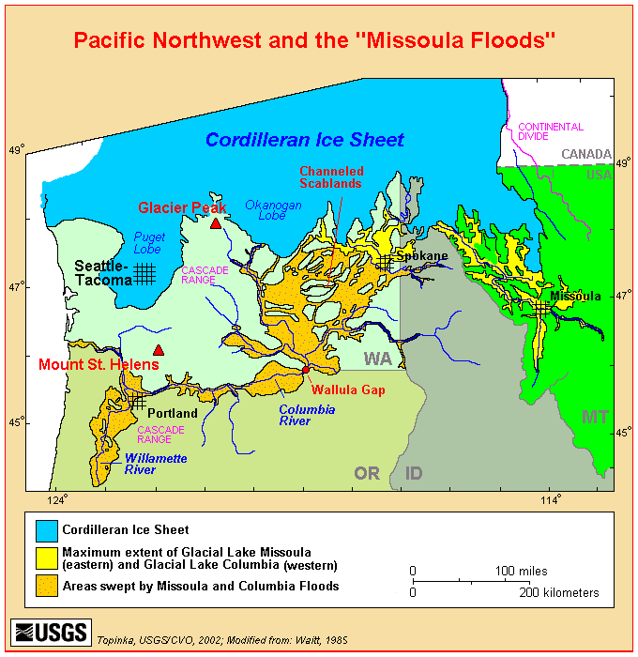

Much of the landscape in this region has been changed dramatically by humans during the twentieth century. The majority of the area is now under cultivation in dry-land wheat farming, irrigated orchards, crops or pasture, and urban use. Dobler and Eby (1990) estimated that there were at least 10.4 million acres of shrub steppe prior to European settlement in Washington and by1990 approximately forty percent of this remains. They also indicated that conversion of the shrub steppe to agriculture has not only reduced the acres but has also fragmented the landscape of the Columbia Basin. The channeled scablands are the areas of shrub steppe that remain compared to the near complete conversion of shrub steppe on the uplands of the loess. These areas are often in the rockier, broken, and shallow soil sites where agriculture is impractical (Dobler and Eby 1990). The exception is in Yakima County where large blocks of shrub steppe remain mostly protected because of Federal ownership. But even here there are challenges to preservation of the shrub steppe because of wildfires, invasion of noxious weeds, and other dramatic and subtle impacts.

METHODS
The objective of this study is to identify and quantify potential pronghorn habitat in Washington for possible reintroduction and establishment of self sustaining populations. Size of the study area was an important initial consideration because of the geographic extent and fragmented nature of existing natural vegetation. From the onset it was determined that a course-level of GIS data and Landsat imagery would be used to assess potential pronghorn habitat in Washington. The GIS analysis results were also supplemented and compared with an independent and more detailed on-site evaluation model of pronghorn habitat composition, quality and condition.

The study area included the Columbia Plateau region of eastern Washington. The Columbia Plateau Region was initially divided into 8 general areas for study as described below. I used the distribution map of shrub-steppe habitat in Washington created by Dobler and Eby (1990), and Landsat imagery (2000) of the channeled scablands of Washington to locate potential pronghorn habitat. In addition I used the WDFW web site https://fortress.wa.gov/dfw/gohunt/gohunt interactive mapping to view satellite images (2000) of landscape and cover type changes and prominent physical features. The U. S. Department of Interior (1999) Channeled Scablands of Lincoln County map (1:100,000 scale) was used as an aid in identifying the detailed extent of channeled scablands in Lincoln County. Later each of the eight area boundaries were refined and further divided into sub-areas for analysis (Appendix A).
- Bickelton: That portion of Klickitat County south and east of the Goldendale-Bickelton Road.
- Cow and Rock Creek: This area included Adams County south of Hwy. I-90 and east of Hwy. 17, Franklin County east of Hwy. 17, Whitman County west of Hwy. 195, and Spokane County west of Hwy. 195 and south of Hwy. I-90.
- Grand Coulee, Wilson Cr. And Black Rock Coulee: This area includes that portion of Grant County east of Hwy. 17, south of Hwy. 2, west of Hwy. 21, and north of Hwy. 28 including Black Rock Coulee south of Hwy. 28; and that portion of Lincoln County south of Hwy. 2, west of Hwy. 21.
- Moses Coulee, Badger Mt. and Mansfield Plateau: This area includes all of Douglas County south of Hwy. 2 and Hwy. 172, Grant County west of Hwy. 17 and north of Hwy. 28.
- Quilomene: This area includes that portion of Kittitas County east of the North Branch Canal and the Colockum Pass Road and north of Hwy. I-90.
- Rattlesnake Hills, Arid Lands Ecology Reserve, Hanford and Wahluke: This area includes the Rattlesnake Hills of Yakima and Benton counties, the Hanford Reach National Monument and Hanford Site, Wahluke Slope of Grant County.
- Swanson Lakes: This area includes that portion of Lincoln County west of Hwy. 21, north of Hwy. 28 between Odessa and Harrington, west of Rocklyn Rd. and south of Hwy 2 except for a two mile strip north of Hwy 2 between Rocklyn and Creston.
- Yakima Training Center (YTC): This area includes all of the Yakima Training Center in Kittitas and Yakima counties.

A number of pronghorn habitat suitability models have been developed and applied in other states (Ockenfels et al. 1996; Hoover et al. 1959; Yoakum 1974, 1980). In this study, two independent methods, a GIS habitat suitability model (coarse scale) and an on- site field evaluation (fine scale) model, were developed and used to provide a numerical rating of potential pronghorn habitats. The GIS habitat suitability modeling used in this study was adapted from some of the habitat evaluation criteria developed a model developed by McCarthy and Yoakum (1984). The pronghorn habitat suitability model developed from the on-site field evaluation was patterned after a model developed by U.S. Bureau of Land Management (1980), which subjectively rated biological and physical habitat requirements for pronghorn. On site field examination included the evaluation and modeling of various habitat components such as; vegetation, height of vegetation, topography, water distribution, climate, size and continuity of habitat, land ownership, and obstructions. Purposely, some important criteria outside of the habitat arena were not considered. Although the study areas were selected to exclude as much as possible agriculture production areas, there was no attempt to evaluate potential damage problems that might result from pronghorn use of crops. Nuisance problems, Predation and aesthetic value of pronghorns were other potential issues beyond the scope of this evaluation.

Climate information for this area was obtained from the Western Regional Climate Center internet web site (2005) and is derived from data received from the National Climatic Data Center, the National Weather Service, and the National Resource Conservation Service, the Bureau of Land Management, the U.S. Forest Service and other federal, state and local agencies.

The model results are evaluated by including recent observed changes to the landscape. Other factors were also considered (e.g., land ownership, barriers to pronghorn movement, size and continuity of the area, and dataset limitations) that were not included in the GIS suitability scoring, and concluded which study areas and sub areas are best habitats for possible future pronghorn introductions into Washington State.

GIS Habitat Suitability Model

The primary suitability factors that we believe to be most important for modeling potential pronghorn habitat are vegetation, topography (slope and aspect), and distance to water. The availability of GIS data sets, representing limiting factors such as snow depth and persistence were also investigated.

All GIS modeling was performed using raster (cell) based analysis tools in ArcGIS software. The resolution (analysis unit) used for all raster GIS data sets was 10 meters. Variables used in the GIS habitat suitability modeling are described in more detail in the following sections outlined below.

- Vegetation

Having food with the right mix of forbs, browse and grass throughout the year is essential for pronghorn survival (Allen et al. 1984). Table 2 lists the vegetation rating system patterned after Yoakum (1980) and used in the analysis.

Table 2. Vegetation Rating
Rating (Score) | Description
Moderate (5) | Native species grassland with some shrubs and mix of herbaceous vegetation.
Moderate (4) | Shrub-steppe on shallow soil sites with under-story of grasses and forbs. Shrub species includes stiff sagebrush, rabbit brush, horse brush and salt brush.
Moderate (3) | Sparse forested areas with under-story of shrubs, grasses and forbs.
Low (2) | Emergent herbaceous wetland
Poor (1) | Cultivated croplands. Includes CRP mostly planted to Wheat grass.
Unsuitable (0) | Forest, bare ground, exposed basalt, and sand dunes.

The National Land Cover Data (NLCD) was selected for vegetation cover analysis because it represented the most complete and comprehensive set of land cover classes needed for this analysis. Information (metadata) about the NLCD data is described in Appendix C. The NLCD raster data (grid) has a native resolution of 30-meters. The NLCD data was first re-sampled into 10-meter grid and then clipped for the study area. The original NLCD class codes were then recoded (remapped) to vegetation scores (0-5) as shown in Table 3.

Table 3. Remapping NLCD to Vegetation Rating
NLCD Code | Vegetation  Score | NLCD Code | Vegetation  Score
11 Open Water | 0 | 51 Shrubland | 4
21 Low Intensity Residential | 0 | 61 Orchards/Vineyards/Other | 0
22 High Intensity Residential | 0 | 71 Grasslands/Herbaceous | 5
23 Commercial/Industrial/  Transportation | 0 | 81 Pasture/Hay | 1
31 Bare Rock/Sand/Clay | 0 | 82 Row Crops | 0
32 Quarries/Strip Mines/Gravel Pits | 0 | 83 Small Grains | 1
33 Transitional Barren | 1 | 84 Fallow | 1
41 Deciduous Forest | Within 90m of edge =3, otherwise 0 | 85 Urban/Recreational Grass | 0
42 Evergreen Forest | Within 90m of edge =3, otherwise 0 | 91 Woody Wetlands | 0
43 Mixed Forest | Within 90m of edge =3, otherwise 0 | 92 Emergent Herbaceous  Wetlands | 2

- Slope
The best pronghorn habitats are on flat to low rolling terrain. The steep mountainous areas are used, but not preferred (O’Gara and Yoakum 2004). Digital Elevation Model (DEM) data were used to generate a slope grid (10 meter resolution) for the whole study area. The resulting floating-point slope values (degrees) were then recoded (remapped) into one of six slope rating scores (0-5), as described in Table 4.

Table 4. Slope Rating
Rating (Score) | Slope in Degree | Description and (use)
High (5) | 0⁰ slope | Flat (preferred)
High (4) | <= 5⁰ slope | Nearly flat to slightly rolling or undulating (selected)
Moderate (3) | 5⁰ - 10⁰ slope | Flat to rolling hills with shallow canyons, rims or mesas (usable)
Moderate (2) | 10⁰ - 15⁰ slope | Broken terrain with moderately deep canyons, ravines, and depressions (usable but not preferred)
Low (1) | 15⁰ - 25⁰ slope | Mountainous with deep canyons and rounded ridges (limited use)
Poor (0) | 25⁰ ⁻ 35⁰ slope | Mountainous, deep canyons rocky surfaces, a few outcrops and talus slopes. Ridges are mostly sharp with some rounded. (occasional use)

- Water distribution and availability
Easily accessing water is critical for pronghorns. The distribution and availability of water is considered an important variable in the habitat suitability. Table 5 lists the criteria used in rating water availability (distance to water).
Water sources data was assembled, including springs (in points), streams and rivers (in lines), lakes (in polygon) and wetlands (in polygon) for the study area. Each of these data sets were converted to 10-meter raster data set and then merged together to form a single water raster data set (grid). A single “distance to water” grid was calculated. Distance values were then remapped to the water availability rating scores (0-3) outlined in Table 5. There was no effort made to confirm seasonal permanence of springs or streams rated in this exercise.

Table 5. Water Availability Rating
Rating (Score) | Distance to water source | Evaluation
High (3) | <= 1 mile (1.6 km) | Water available from a number of reliable water sources
Medium (2) | 1 – 4 mile (1.6 – 6.4 km) | Water mostly available with some travel required
Low (1) | 4 – 10 mile (6.4 – 16 km) | Requires travel of significant distance for reliable and accessible water
Poor (0) | > 10 mile (16 km) | Requires travel of excessive distance for reliable and accessible water

- Aspect
In summer, northern aspects provide better habitats for pronghorns because these sites are more mesic. However, deep and persistent snow accumulation for extended periods during the winter months is believed to have adverse impacts to pronghorns. Therefore, southern aspects were rated higher than other aspects. Table 6 lists the aspect ratings used in the GIS model.
We used 10-meter Digital Elevation Model (DEM) data to generate aspect for the whole study area. Then the floating-point raster data were remapped to aspect scores according to Table 6.

Table 6. Aspect Rating
Rating (Score) | Description
(1) | South facing slopes 157.5 – 202.5 degrees
(0) | All other aspects

- Snow depth
Deep snow accumulation may adversely impact pronghorn survival in winter (O’Gara and Yoakum, 2004). Mild to normal snow accumulation in eastern Washington should offer ample access to vegetation and unrestricted movements while deep, crusted snow accumulation for extended days may result in high mortality.
Unfortunately, a GIS raster data set, which adequately represented long-term snow depth and persistence information for the study area could not be found. There is snow depth data available from the National Operational Hydrologic Remote Sensing Center, Snow Data Assimilation System (SNODAS), National Snow and Ice Data Center (NOHRSC 2004). However, SNODAS data is a fairly coarse data set (1 km resolution) that is modeled from weather station data. In addition, SNODAS raster data was only available from Oct. 2003 to present.
The winter of 2004-05 was considered a very mild and dry winter and described as a drought condition. Due to these data limitations, snow depth data were not used in the GIS modeling of habitat suitability.

Pronghorn habitat suitability model
Four variable scores were used to determine the pronghorn habitat suitability for each cell of the study area using the following equation.
Habitat suitability value = Vegetation Score + Slope Score + Distance to water Score + Aspect Score

Weights of the variables
An Analytic Hierarchy Process (AHP) method was used to get the weights of the four factors. AHP is a way to generate the approximate importance of the factors by using pair-wise comparisons. Table 7 lists our pair-wise comparison used for the four factors in the following order of importance: vegetation, topography, distance to water, and aspect. The resulting weights of the four variables are listed in Table 8.

Table 7. Pair-wise Comparisons of Four Variables
Vegetation | 2 | Times more important than | Topography (slope)
Vegetation | 3 | Times more important than | Distance to water
Vegetation | 4 | Times more important than | Aspect

Normalized weighted pronghorn habitat suitability score
The score values for each variable were normalized to range from 0 to 10. Weights (Table 8) of the four variables were used to tabulate the final normalized weighted pronghorn habitat suitability scores as shown in the following equation:
Normalized Weighted habitat suitability value = 0.48 * Normalized Vegetation Score + 0.24 * Normalized Slope Score + 0.16 * Normalized Distance to water Score + 0.12 * Normalized Aspect Score

Table 8. Weights of Five Variables
Variables | Weights
Vegetation | 0.48
Topography | 0.24
Distance to water | 0.16
Aspect | 0.12

Other considerations
It would have been better to have data recording extremes of snow accumulation to get a sense of the impacts to pronghorn from snow depth across their winter range. However, since snow data was extremely limited and not representative of eastern Washington over the long term it was not used in this analysis.
Other considerations that were not scored numerically in the GIS analysis were noted for each area and included in the base map for each area (Appendix D). These variables were taken into consideration in the field evaluation exercise as described in the following section.
- Land Ownership
- Limitations
- Size and Continuity

Dataset limitations were recognized as a significant issue in the GIS analysis. While useful the NLCD vegetative cover data was inaccurate in some portions of the study area. For example recent changes in the vegetative cover due to a large wildfire on the Rattlesnake/Hanford/ Wahluke and Bickelton areas gave a much different overall score than expected. In some cases shrub steppe and grassland was not observed in the field surveys where they were indicated on the NLCD dataset.

On-Site Field Habitat Evaluation and Scoring Model
The pronghorn habitat suitability model used in the on-site field study was patterned after one developed by U.S. Bureau of Land Management (1980). This model was developed for rating shrub steppe in the Great Basin. The model subjectively rated specific biological and physical habitat requirements for pronghorn. I visited the same areas identified in the GIS analysis from the ground to determine current conditions, gain a visual impression of pronghorn habitat suitability and make a photographic record. This evaluation was used to determine if the area habitat was “suitable” or “unsuitable” based on the senior author’s professional judgment and intuitive deduction of 8 variables analyzed.
In this study some variables in the model have been modified and/or added to fit the conditions in Washington State. The 8 criteria were evaluated and assigned a numerical value and recorded on a Pronghorn Habitat Evaluation form (Appendix B). The areas selected for evaluation were not homogeneous; therefore, multiple sampling stations were selected at random and summarized by sub-area and for the area as a whole. An overall suitability habitat rating score was calculated for each sub area and summarized for an area by adding the total points; .91 and above as excellent, .90 to .7 1 as good, .70 to .41 as fair, and .40 to 0 as poor.
Yoakum (1968) conducted a survey of state wildlife agencies regarding rangelands occupied by pronghorn from statewide yearlong data and that did not reflect seasonal variations. He found that Wyoming had the highest density of more than 2 pronghorn per square mile (0.8/km²); Colorado, Montana, Nebraska, New Mexico North and South Dakota were placed in the 1-2 per square mile range (0.4-0.8/km²). The remaining states including Washington, reported densities less than 1 per square mile (0.4/km²).

Vegetation
Vegetation was evaluated for quality/diversity, quantity, and height. This was a subjective exercise with each variable receiving a numerical value.
Quality and diversity: The quality and diversity criteria was applied to three major classes of vegetation (forbs, shrubs, and grasses) with varying values based on their relative importance as forage.
Vegetation quantity: Vegetation quantity was judged on the basis of density and distribution and given a maximum rating of 10 points.
Vegetative height: The average vegetative height rating was determined using the criteria described in Table 9 for each site evaluated.

Table 9. The vegetative height rating and suitability score
Description | Suitability Score
Optimum vegetative height 11 to 25 inches (27.9 – 63.5cm) | .7 to 1.0
Vegetative height 5 to 10 inches (12.7 – 25.4cm) | .31 to .69
Vegetation higher than 25 inches and lower than 5 inches (63.5 – 12.7cm) | 0 to .3

Terrain slope and aspect (Topographic diversity)
Allen and Armbruster (1982) assumed that the ability of an area to supply winter cover for pronghorn is related to its topographic diversity. They developed a suitability index graph illustrating the relationship of topographic diversity to winter cover quality for pronghorn as follows:
- Level terrain (0-5% slope). Flat or nearly so, little to no physical relief. Suitability Index = .20
- Level terrain (0-5% slope), area broken by drainages. Suitability Index = .55
- Rolling terrain (5-25% slope. Suitability Index =.75
- Rolling terrain (5-25% slope, with ridges, rims, and/or drainages present. Suitability Index = 1.0
- Mountainous (>25% slope), or extremely broken terrain. Suitability Index = .10

I patterned my analysis of terrain (Table 10) by evaluating suitability of slope and aspect to determine topographic diversity for pronghorn habitat with some modification of Allen and Armbruster (1982) work
Table 10. Terrain slope and aspect (Topographic diversity)
Description | Score
Level/flat terrain | .81 to 1.0
level/broken (wide channeled scablands) | .61 to .80
rolling terrain | .41 to .60
rolling to mountainous (narrow channeled scablands/basalt cliffs) | .21 to .40
mountainous terrain >25% slope | 0 to .20

Water availability
Water availability was rated according to distribution as follows:
- Water sources within 2 miles or less received .7-1.0 points.
- Water sources within 2-5 miles received .30-.69 points.
- Water sources within 6+ miles received 0-.29 points.

Size and Continuity
The size and connectivity of habitats are important considerations for pronghorn antelope. This species is very mobile and gregarious. During the breeding season adult males establish territories that are vigorously defended. Females during parturition seek seclusion. During the winter season pronghorn herding is most pronounced. Habitat quality is highly variable from one area to another and seasonal differences are also ever changing (O’Gara and Yoakum 2004). A minimum of 30 mi² (27 km²) of habitat was the standard applied in analyzing this variable.

Landownership/use
Landownership and land use is of importance in evaluating pronghorn habitat. For obvious reasons, public land holds a greater value than private holdings for pronghorn restoration. Much of the potential habitat remaining in Washington is under private ownership and used for livestock grazing. The most productive native ranges have been converted to agricultural use during the last century.
A landownership and use value was applied with a rating of .6 to1.0 points for mostly public lands. An equal mix of private range land and public land received .31 to .6 points. Private lands under the Conservation Reserve Program received .11 to .3 points. Private or public intense use/urban received <.1.

Limitations/obstructions (fences, canals, highways, railroads, etc.)
Highway right of way, rangeland fences, canals and other obstructions can pose a serious threat to daily and seasonal movements of pronghorn. Depending upon the number of limitations and their consequences a maximum of 1.0 points is assigned for habitats free of obstructions. As the number of limitations increased the point value was reduced.

Suitability Score Summary
Multiple site evaluations were totaled and the mean calculated for the area to determine the suitability score. A point score of 9.1 and above is considered excellent, 7.1 to 9.0 good, 4.1 to 7.0 fair and 0 to 4.0 poor.

SITE EVALUATIONS

Quilomene

Location/Landownership
The area investigated is approximately 227 mi² (588 km²) of the southeastern tip of the Wenatchee Mountains (Appendix A). It is described as that portion of the Wenatchee Mountains south of the power line from Naneum Road to the Colockum Road and Tarpiscan Creek, west of the Columbia River, north of Interstate Highway 90, and east of the North Branch Canal and the Naneum Road. The majority of public lands is State owned 140 mi² (67.6%) and largely controlled and managed by the WDFW. Ginko State Park occupies several square miles in the extreme southeastern corner of the area. The majority of private lands within this area are located on the west facing slope of the range and a large block in the Skookumchuck Canyon area.

Vegetation
The project area is within the Columbia Basin physiographic province (Franklin and Dyrness 1973) and is described as shrub steppe vegetation (Daubenmire 1970). The area is largely in the big sagebrush-bluebunch wheat grass (Artemesia tridentate-Agropyron spicatum) zone (Figure 2). Other shrub species include rabbitbrush (Chrysothamnus spp.), threetip sagebrush (Artemisia tripartita), rigid sagebrush (Atremisia rigida), squaw current (Ribes cereum), antelope bitterbrush (Purshia tridentata)), and spiny hopsage (Grayia spinosa) (Figure 3). On lower elevations purple sage (Salvia dorrii), rabbitbrush (Chrysothamnus spp), grease wood (Sarcobatus vermiculatus), buckwheat (Erioginum spp) and horse brush (Tetradymia canescens) are present.

Aspen (Populus tremuloides), choke cherry (Prunus virginiana), black hawthorn (Crataegus douglasii) and alder (Alnus sp.) are restricted to the riparian zones in the canyon bottoms. Pondersa pine (Pinus ponderosa) form a transition from a forested environment to shrub steppe but is also found sparingly in the riparian zone. The shrub understory includes such species as snowberry (Symphoriocarpos sp.), Wood’s rose (Rosa woodsii), golden current (Ribes aureum) and willow (Salix sp.).

A variety of bunch grasses occur over the entire area with varying density and vigor largely represented by blue bunch wheatgrass (Agropyron spicatum), Idaho fescue (Festuca idahoensis), needle and thread grass (Hesperostipa comata), bottlebrush (Elymus elmoides), Sandberg’s bluegrass (Poa sandbergii), and Cusick’s bluegrass (Poa cusickii). Exotic grasses such as cheat grass (Bromus tectorum) and crested wheatgrass (Agropyron cristatum) are prevalent below 1,525 ft (500m).
The forb community is very diverse and well established above 1,525 ft. (500m). Some of the common and showy species include yellow daisy (Erigeron linearis), Lupine (Lupinus spp), Phlox (Phlox spp.), yarrow (Achillea millefolium), balsamroot (Balsamorhiza spp), desert parsley

Figure 2. Typical shrub steppe habitat near the head of Quilomene Canyon.
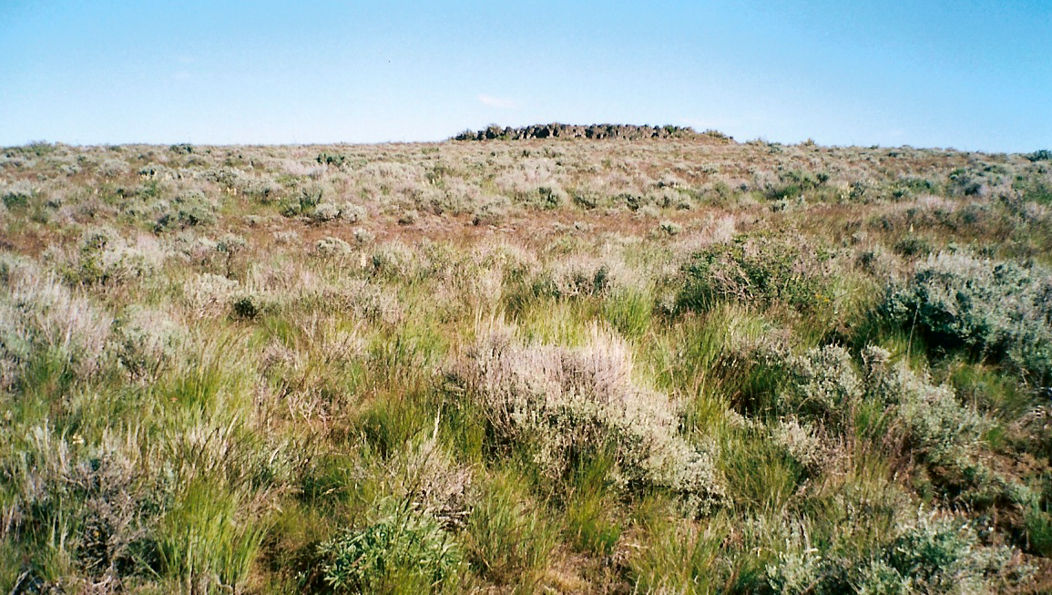

Figure 3. Shrub Steppe habitat at the head of Black Rock Canyon, T18N, R21E, Sec. 20.
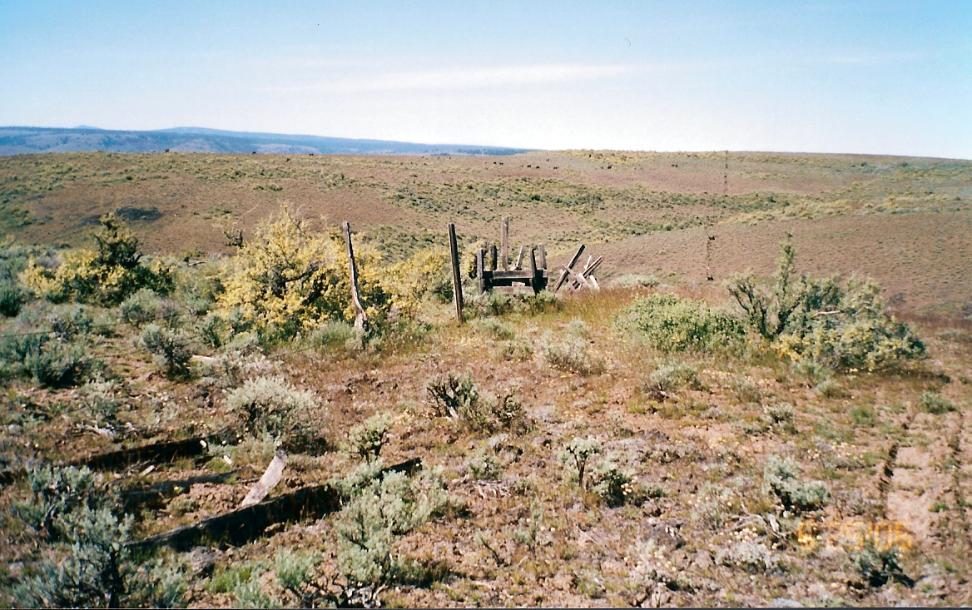

(Lomatium grayi), mountain dandelion (Agoseris spp), fiddleneck (Amsinckia spp), hawksbeard (Crepis spp), and showy chaenactis (Chaenactis douglasi). Table 11 shows the land cover classes for the Quilomene area and their approximate percentage makeup from the National Land Cover data base (NLCD 2000).

Topography
The terrain is mostly mountainous with deep canyons facing eastward to the Columbia River and

Table 11. NLCD Land Cover Classes in mi² and Percent Make up for the Quilomene Area.
Vegetation Classes - (value) | Subarea  1 | Subarea  2 | Subarea  3 | Subarea  4 | Subarea  5 | Subarea  6 | Subarea  7 | Subarea  8 | Total  (mi²) | %
bare (rock/sand/clay), com./industrial/trans.,  deciduous/evergreen/or mixed forest, emergent herbaceous wetlands, urban/recreational grass, open water, row crops, high & low intensity residential, orchards & vineyards. (0) | .01 | .08 | .02 | .39 | .37 | .00 | .03 | .08 | 0.98 | .04
Pasture/Hay, Woody Wetlands, Fallow, Small Grain, Transitional (1) | .12 | 1.98 | 0.0 | .02 | 0.0 | 0.0 | 0.0 | .00 | 2.12 | .95
Exotic grasses & weeds, stiff sagebrush. (2) | 0.0 | .01 | 0.0 | 0.0 | .00 | 0.0 | 0.0 | 0.0 | 0.01 | 0.0
Shrub steppe on shallow soils, native grasslands with herbaceous spps. (3) | 0.0 | .19 | .18 | .00 | .03 | .56 | .16 | .44 | 1.56 | .77
Grassland/Herbaceous (4) | 8.27 | 24.08 | 34.29 | 23.87 | 51.62 | 15.84 | 27.93 | 16.24 | 202.14 | 90.54
Shrubland (5) | .46 | 1.48 | .38 | 3.27 | 4.87 | .45 | 3.66 | 2.58 | 17.15 | 7.67
Grand Total | 8.86 | 27.82 | 34.87 | 27.55 | 56.89 | 16.85 | 31.78 | 19.34 | 223.96 | 99.97

a gentler west facing slope to Kittitas Valley. The southern boundary is Interstate Highway 90 that follows Ryegrass Coulee. Elevation is lowest at the Columbia River 570 ft. (174m) to over
1000 ft. (305m) at the tree line. The west boundary generally follows the North Branch Canal in Kittitas Valley where lands are under irrigated cultivation. Whiskey Dick Mountain rises to 3,875 ft. (1,182 m). The West Bar is a unique desert bunchgrass prairie zone along the Columbia River. This relatively flat area was formed during the glacial ice floods. The canyons are deep with slopes in excess of 25%. The ridge tops are rounded and would provide reasonably good habitat for pronghorn (Figure 4).

Water
Water distribution is considered adequate but the west and south facing slopes are drier. Water is found in most of the drainages flowing to the east including Tarpiscan, Stray Gulch, Tekison Creek, Brushy Creek, Quilomene Creek, Skookumchuck Creek, and Whiskey Dick Creek

Figure 4. Canyon ridges east of Whiskey Dick Mt.
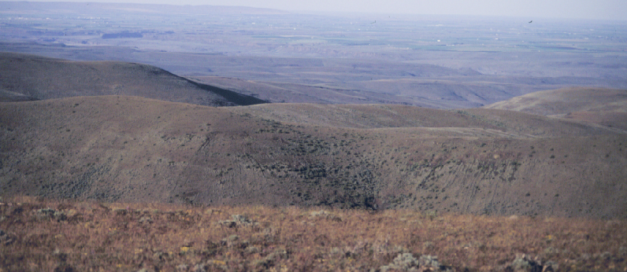

together with numerous side drainages and springs. The most consistent source is along the Columbia River but access is limited in places. Many of these sites require travel into deep canyon bottoms to access water. The areas with the least amount and poorest distribution of permanent water are the south slopes of Whiskey Dick Mountain and Rocky Canyon areas (Figure 5). GIS mapping suggests that water is available within two miles over the entire area. However, water may only be available seasonally or in some cases not accessible.

Figure 5. Spring development in Rocky Coulee, Kittitas County, WA.
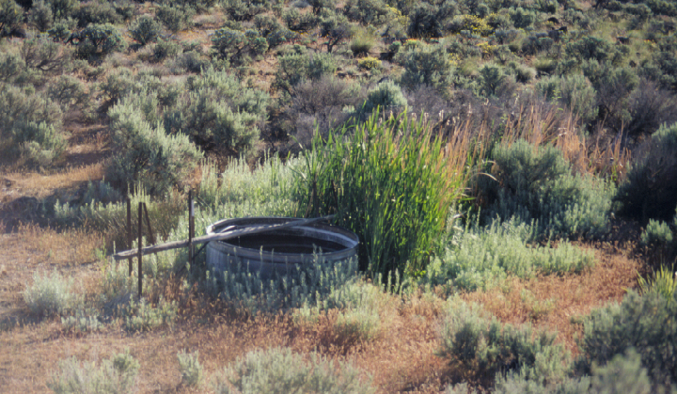

Size and Continuity
The potential habitat in this area is less than the 227 mi² (588 km²) size of the study area. In terms of the vegetation potential approximately 98% of the area is in the shrub land (4) and grassland/ herbaceous (5) categories. The topography ratings for this area placed 43% of the area in the top three categories where slope was less than 10º but there are areas where slope is extreme (Figure 6). It is estimated that approximately 50% of the area or 113 mi² (294 km²) can be considered good potential habitat for pronghorn.

Climate
The Ellensburg FAA Airport (452508) weather station data was used to best represent conditions for the Quilomene pronghorn habitat area evaluation. Weather station data was also viewed for Ellensburg (452505), Wenatchee (459074), Wenatchee Experiment Station (459079), and Wenatchee FAA airport (459082).
The average maximum/minimum temperature, total precipitation, and average total snowfall and snow depth for station 452508 from 1940 to 2005 is found in Table 12. Average total precipitation is 8.91 inches (22.63cm), occurring primarily during November, December and January. It is assumed that the precipitation totals for this station are slightly lower than that found on the Quilomene, where the elevation may be as much as 500m higher.

Figure 6. Quilomene Canyon is a deep canyon that flows into the Columbia River.
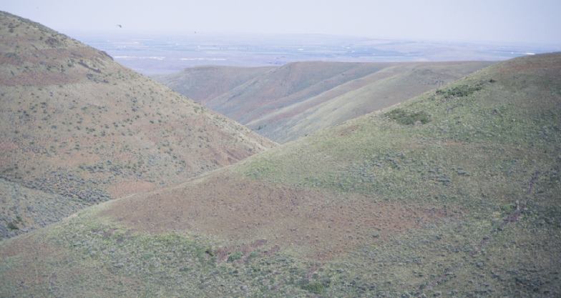

Table 12. ELLENSBURG FAA AIRPORT, WASHINGTON (452508)
Period of Record Monthly Climate Summary 5/ 4/1940 to 3/31/2005
 | Jan | Feb | Mar | Apr | May | Jun | Jul | Aug | Sep | Oct | Nov | Dec | Annual
Average Max. Temperature (F) | 31.6 | 40.5 | 49.7 | 60.6 | 69.6 | 74.3 | 83.9 | 82.1 | 74.6 | 60.8 | 44.0 | 35.8 | 58.9
Average Min. Temperature (F) | 15.2 | 22.1 | 27.4 | 34.2 | 42.6 | 48.5 | 54.2 | 52.9 | 45.3 | 35.9 | 26.6 | 22.0 | 35.6
Average Total Precipitation (in.) | 1.31 | 0.82 | 0.72 | 0.50 | 0.60 | 0.72 | 0.16 | 0.31 | 0.53 | 0.72 | 1.29 | 1.22 | 8.91
Average Total Snow Fall (in.) | 13.0 | 6.2 | 2.0 | 0.1 | 0.0 | 0.0 | 0.0 | 0.0 | 0.0 | 0.1 | 5.5 | 8.2 | 35.2
Average Snow Depth (in.) | 5 | 4 | 1 | 0 | 0 | 0 | 0 | 0 | 0 | 0 | 0 | 2 | 1
Percent of possible observations for period of record.
Max. Temp.: 97.8% Min. Temp.: 97.8% Precipitation: 97.5% Snowfall: 97.8% Snow Depth: 95.2%
Western Regional Climate Center, wrcc@dri.edu
The average and maximum snow depth occurring on the Quilomene are probably higher then recorded for the Ellensburg airport (452508) because of the elevation difference, Figure 7. The area provides excellent summer range at the higher elevation but winter snow depths would require pronghorn movement to lower elevations similar to movements of deer and elk in the area.
Temperature extremes recorded below -01ºF to -30ºF occur during the months of December and January (Figure 8). Summer temperature extremes are not considered to be limiting in any way.

Limitations
Livestock grazing currently occur on the private lands within this area. Cattle, sheep, and horses are grazed seasonally. During my inspection of the area in May 2005, I observed two groups of approximately 25 horses on Whiskey Dick Mt and Parke Creek. The area was also being lightly grazed by cattle on Skookumchuck Creek. Big game species that utilize this area include Rocky Mountain elk (Cervus canadensis) and mule deer (Odecoileus hemionus). Dry land farming was established in the Cape Horn area (T20N R22E) many years ago and remained

Figure 7. Snow depth (in.) at Ellensburg Airport Kittitas County, Washington
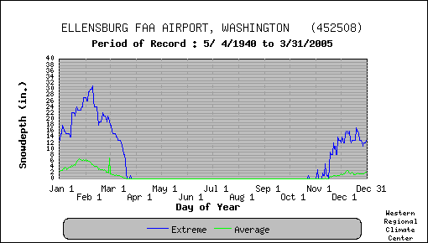
- Extreme is the greatest daily snowdepth recorded for the day of the year.
- Average is the average of all daily snowdepth recorded for the day of the year.

in production of grain crops until recently when it was enrolled in the Conservation Reserve Program (CRP).
Interstate Highway 90 poses a significant barrier to natural movements north and south along the narrow ridge connecting the Quilomene to the lowlands of Johnson Creek in the Yakima Training Center (YTC). The right of way fences along this stretch of Interstate is constructed of hog wire and barbed wire forming a difficult if not impassable barrier for pronghorn (Figure 9). Highway I-90 is a high speed, divided highway with a high volume of traffic. The Vantage Highway is a less traveled hard surface road that also has right of way fencing.
Kittitas Valley is a highly developed agricultural area. Alfalfa and grass hay production is the primary crop of the area. Croplands abut the North Branch Canal along its entire length. Some fields have also been developed on the uphill side of the canal. These fields are located along Naneum, Coleman, Cooke, Caribou, Parke, and Johnson creeks. This area is relatively free of human habitation, a few dwellings occur along the western and southern edge of the area. The areas numerous interior roads are primitive and rough. A major power line traverses the west edge of the area. The proximity of agricultural fields, mainly alfalfa in the Kittitas Valley may be a concern. The North Branch Canal may be a dangerous obstacle if pronghorn attempt to cross.

Figure 8. Maximum and Minimum Temperature Extremes at Ellensburg,
Kittitas Co., WA.
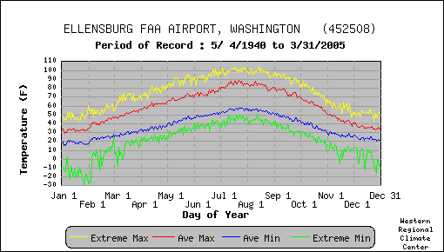
- Extreme Max. is the maximum of all daily maximum temperatures recorded for the day of the year.
- Ave. Max. is the average of all daily maximum temperatures recorded for the day of the year.
- Ave. Min. is the average of all daily minimum temperatures recorded for the day of the year.
- Extreme Min. is the minimum of all daily minimum temperatures recorded for the day of the year.

Figure 9. Interstate Highway 90 and fence right of way may be a barrier to pronghorn.
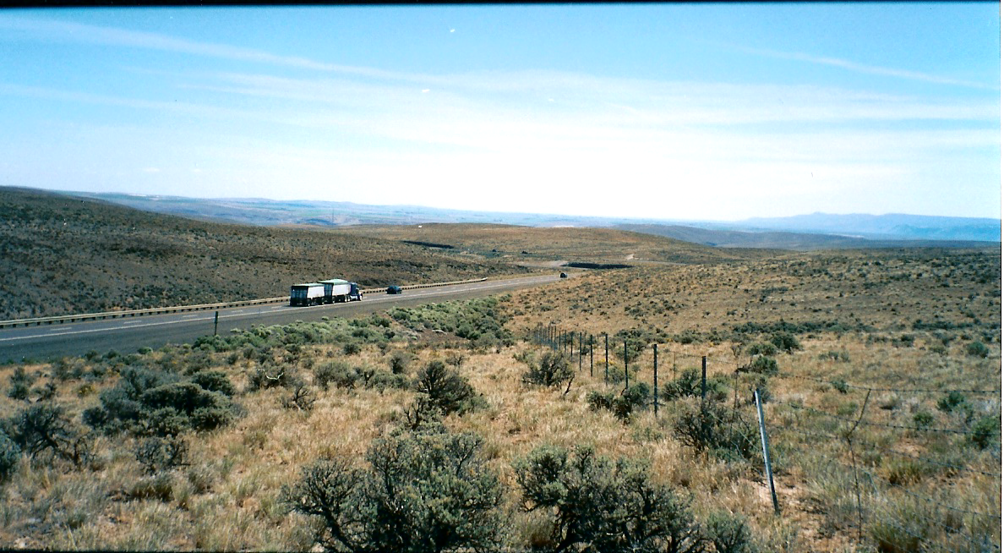

Wild Horse Wind Power Project
On Tuesday, July 26, 2005 Governor Gregoire approved the Wild Horse Wind Power Project near Whiskey Dick Mountain, Kittitas County (The Olympian 2005). Zilkha Renewable Energy is developing the project and plans to install about 127 turbines in some of the core areas of potential pronghorn habitat (WSEFSEC 2005a) (Figure 10).
The Wild Horse Wind Power Project is proposed to be approximately 5,000 acres, reduced from the proposed 8,600 acres described in the EIS. The project foot print is 165 acres. Following the guidelines of the WDFW Wind Power Guidelines (WDFW, August 2003) for placing and mitigating wind power projects, a mitigation parcel has been provided in T18N, R21E, in section 27 of approximately 600 acres. This exceeds the required habitat replacement ratio in the WDFW guidelines. Fences will be erected to protect sensitive sites from livestock grazing but will be designed to meet wildlife specifications. Habitat restoration efforts will be included as part of the mitigation package. Other mitigation provisions that concerns pronghorn include (WSESFEC 2005b):
- Hunting and livestock grazing on the project area shall not be allowed during construction.
- After the end of project construction, controlled hunting and access will be allowed on the project site.
- Any permanent fencing located within the project site boundary shall not exceed 42 inches in height with bottom wire at least 16 inches above ground.
- Post construction, a rangeland management and grazing plan is required.
- Camping and off-road vehicle usage will not be allowed on the project area.

Figure 10. Wild Horse Wind Power Project Area Foot Print Whiskey Dick Mt.
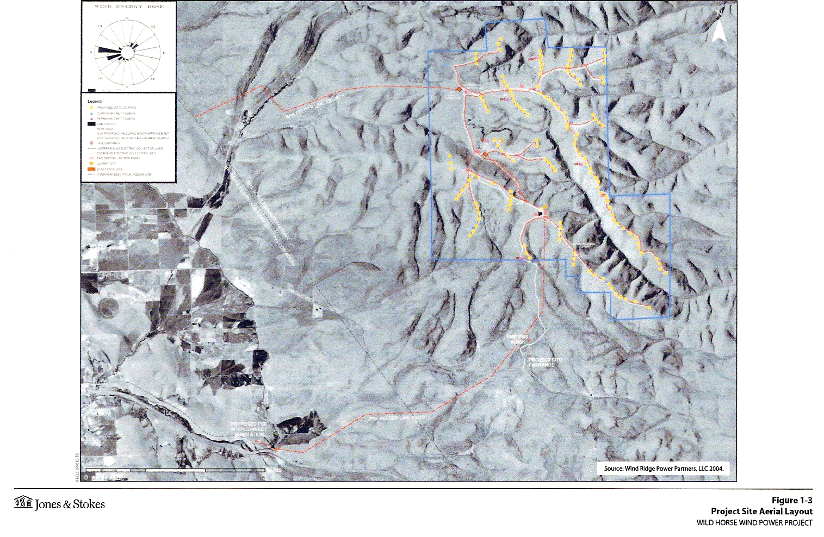

WDFW may also have the opportunity to purchase 20,000 acres of private lands in the Skookumchuck area owned by Zilkah Renewable Energy, to be added to the WDFW wildlife management area.
A news release dated 26 July 2005 by Zilkha Renewable Energy stated, “The project site is several thousand acres of shrub-steppe habitat, some of which is owned by the State Departments of Natural Resources and Fish and Wildlife. It is estimated that the agencies will receive more than $300,000 a year in royalties for use of the property. Those funds will go toward supporting wildlife protection efforts and public schools,” (Zilkha Renewable Energy 2005).

Habitat Evaluation Score
Two methods of habitat assessment were utilized but results were not directly comparable. However, the two methods provide a valuable insight to the potential for the area. The Quilomene area appears to have very good summer range and sufficient winter range for pronghorn. Under normal winter conditions pronghorn will move east and south to lower elevations. During severe climatic conditions pronghorn may be forced further south into the Yakima Training Center (YTC). This movement may be hindered by the highway right of way fences on I-90 and Vantage highways (Figure 9).
Table 13 provides the rating summary for the Quilomene area pronghorn habitat field evaluation. The field evaluation resulted in a total score of 5.2 (Table 13) placing this area in the fair rating and number 2 ranking.

Table 13. Quilomene pronghorn habitat field evaluation scoring summary
Criteria  Location | Vegetation Forb | Vegetation Shrub | Vegetation Grass | Vegetation Quantity | Vegetation Height | Water Distribution | Topography | Size & Continuity | Land Ownership  and Use | Limitations &  Obstructions | Total Score
1. T19N, R19-20E Colockum Road | .5 | .4 | .25 | .6 | .6 | .8 | .4 | .3 | .5 | .5 | 5.05
2. T18N, R19-20E; T19N, R19-20E  Parke Creek | .4 | .4 | .25 | .5 | .7 | .7 | .4 | .5 | .35 | .4 | 4.8
3. T18N, R21E Quilomene/  Skookumchuck | .5 | .5 | .35 | .6 | .7 | .10 | .3 | .6 | .6 | .8 | 5.95
4. T17N, R20-21E Whiskey Dick Mt. | .5 | .5 | .3 | .6 | .7 | .7 | .4 | .6 | .5 | .2 | 5.0
5. T17-18N, R22E; T17N, R22E Rocky  Coulee | .4 | .4 | .25 | .5 | .7 | .6 | .3 | .7 | .8 | .4 | 5.05
6. T19N, R21E upper Brushy Creek | .5 | .5 | .35 | .6 | .7 | .7 | .25 | .5 | .8 | .5 | 5.4
7. T19N, R22E Lower Brushy Creek | .4 | .4 | .3 | .6 | .6 | .5 | .25 | .6 | .7 | .7 | 5.05
8. T20N, R21-22E West Bar | .5 | .4 | .3 | .6 | .6 | .8 | .3 | .4 | .8 | .5 | 5.2
Total | 3.7 | 3.5 | 2.35 | 4.6 | 5.3 | 5.8 | 2.6 | 4.2 | 5.05 | 4.0 | 4.11
Criteria Score | .46 | .44 | .29 | .58 | .66 | .73 | .33 | .53 | .63 | .50 | 5.15

The GIS evaluation of vegetative cover, slope, aspect, snow depth, and water availability resulted in a normalized-weighted rating of 6.73 (Appendix D5), which ranked number 7 of 8 areas.
This area received pronghorn for transplant in 1968, and observations in Parke Canyon and near the summit of Colockum Pass were reported to Washington Game Department the following year. Verbal reports were also received of pronghorn observed on West Bar along the Columbia River in the late 1960’s (personal communications Theodore Clausing 2005). It is not known why this introduction failed although the number of released animals was very small consisting of only 11 animals with no subsequent supplementation.
During the field assessment two important habitat elements that may limit the value of this area for pronghorn are topography and climate. The GIS score for slope/aspect scored relatively low compared to the on-site field evaluation, which scored the area higher because the ridges are rounded and the slopes are relatively free of rocky escarpments and talus even though the canyons are deep. Under normal climatic conditions there appears to be sufficient winter range to support a population of pronghorn.
Based on the estimate of 113 mi² of potential pronghorn habitat in this area it is estimated that a population of approximately 100 – 150 animals could be established. Pronghorn numbers may exceed this estimate during the summer season if movement across Vantage Highway and Interstate 90 is not a limiting barrier.

Yakima Training Center

Location/Landownership
The area investigated included all of the Yakima Training Center (YTC), a military training facility, and a small portion south of the YTC boundary (Appendix A). The area is approximately 540 mi² (1,401 km²) located in Yakima and Kittitas counties of eastern Washington. The YTC habitat is a continuation of the Quilomene area and is physically bisected by Interstate Highway 90 and the Vantage Highway. At the northeast corner of the area the Washington State Parks administers several square miles of land as a part of the Ginko State Park. A sliver of private land along the southern boundary of the YTC was included, otherwise the area is federally owned and under the control of the U.S. Army.
The primary mission of the Yakima Training Center is military training. Currently there are sites on the area that are off limits to all public access comprising 17,507 acres. The Central Impact Area, which is off limits, is within the core area of potential pronghorn habitat on the YTC. The habitats in these areas are significantly impacted by military training exercises. In addition to the military training mission the installation is available for a variety of recreational activities including hunting and wildlife observation. Access to YTC is by permit only.

Vegetation
The Yakima Training Center area is in the shrub steppe region (Daubenmire 1970) and is described as the Artemisia tridentata / Agropyron spicatum association by Franklin and Dyrness (1973). Table 14 shows the land cover classes for the area and the approximate percentage makeup from the National Land Cover data base (NLCD 2000).
The dominant shrubs are Artemisia tridentata, Artemisia rigida, Chrysothamnus naseosus, Purshia tridentata and Sarcobatus vermiculatus (Figure 13). Trees are restricted to the riparian areas.

Table 14. NLCD Land Cover Classes in mi² and Percent Make up for the YTC Area.
Vegetation Classes - (value) | Subarea  1 | Subarea  2 | Subarea  3 | Subarea  4 | Subarea  5 | Subarea  6 | Subarea  7 | Subarea  8 | Total  (mi²) | %
bare (rock/sand/clay), com./industrial/trans.,  deciduous/evergreen/or mixed forest, emergent herbaceous wetlands, urban/recreational grass, open water, row crops, high & low intensity residential, orchards & vineyards. (0) | 1.11 | .49 | .12 | .87 | 2.69 | .76 | .23 | .18 | 6.45 | 1.20
Pasture/Hay, Woody Wetlands, Fallow, Small Grain, Transitional (1) | .15 | .67 | .00 | .01 | 1.14 | 0.0 | 0.10 | .089 | 2.159 | .40
Exotic grasses & weeds, stiff sagebrush. (2) | 0.0 | 0.0 | 0.00 | 0.0 | 0.0 | 0.0 | 0.00 | 0.0 | 0.0 | 0.0
Shrub steppe on shallow soils, native grasslands with herbaceous species. (3) | .04 | .01 | .01 | .02 | .12 | .05 | .00 | .05 | 0.3 | 0.05
Grassland/Herbaceous (4) | 29.87 | 17.76 | 71.52 | 50.99 | 53.01 | 84.02 | 42.88 | 50.15 | 400.2 | 74.28
Shrubland (5) | 7.44 | 11.29 | 9.81 | 17.33 | 34.53 | 12.76 | 19.91 | 16.63 | 129.7 | 24.07
Grand Total | 38.61 | 30.22 | 81.46 | 69.22 | 91.49 | 97.59 | 63.12 | 67.10 | 538.81 | 100
They include black cottonwood (Populus trichocarpa), western chokecherry (Prunus virginiana) and quaking aspen (Populus tremuloides). The western reaches of the YTC have a strong representation of big sagebrush and bitterbrush, especially on the north facing slopes. Although shrub height may exceed the desirable condition, shrub densities are not such that it would adversely impact use by pronghorn. The area has sustained frequent wildfires and some areas are dominated by grasslands with slow recovery of shrubs. The eastern one-third of YTC is a

Figure 11. Saddle Mountains in YTC looking south from Whiskey Dick Mountain.
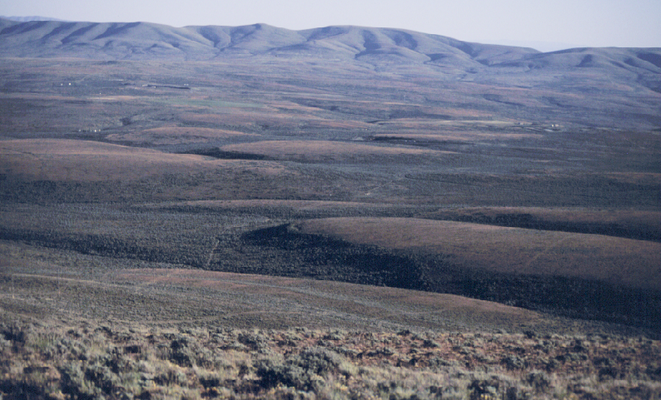

much drier region and consequently the vegetation is represented by coarse shrubs such as rigid sagebrush, rabbit brush, buckwheat and exotic herbaceous species like Russian thistle, tansy mustard, and cheat grass.
Grasses are well represented with Agropyron spicatum, Festuca idahoensis, Stipa comata, Elymus cinereus. In late spring the higher windswept ridges take on a purplish tinge from the abundance of Sandbergs bluegrass (Poa sandbergii). Annual cheat grass (Bromus tectorum) dominates the lower elevation sites.

Topography
The YTC is bisected by 4 conspicuous mountain ridges; Boylston /Saddle Mountain, Manastash, Umtanum and Yakima Ridges that cross in an east-west direction (Figures 12 & 13). The valleys are fairly narrow with most areas not exceeding 5-6 mi. (3.1-3.7km) in width (Figure 14). Johnson, Hanson, and Cold creeks flow to the east and have a length exceeding ten miles. Selah and Lmuma (Squaw) creek flow to the west draining into the Yakima River. Hog Ranch Buttes on the Umtanum Ridge is the highest point on the YTC at 1,383 feet (4,216m). Yakima Ridge has several peaks over (4,000m) and Saddle Mountain’s highest point is 1,229 feet (3,745m). In general the ridges are steeper on the north facing slopes (Figure 15) and extremely steep and rocky at the eastern end of Saddle Mountain, Umtanum, and Yakima ridges.

Figure 12. Lmuma Valley (Squaw) and Umtanum Ridge in background looking east.
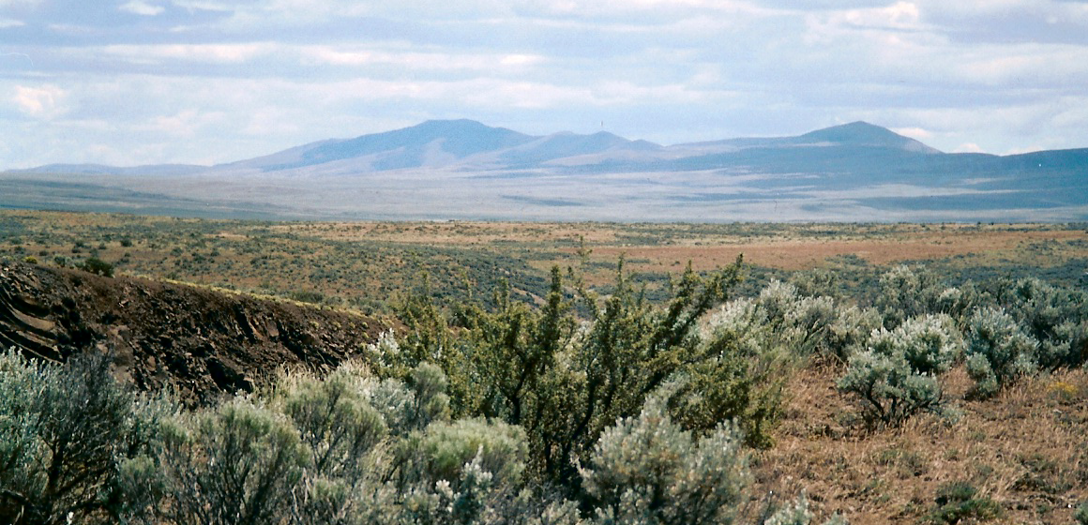

Figure 13. Hog Ranch Butte, Umtanum Ridge, now mostly grassland following a fire.
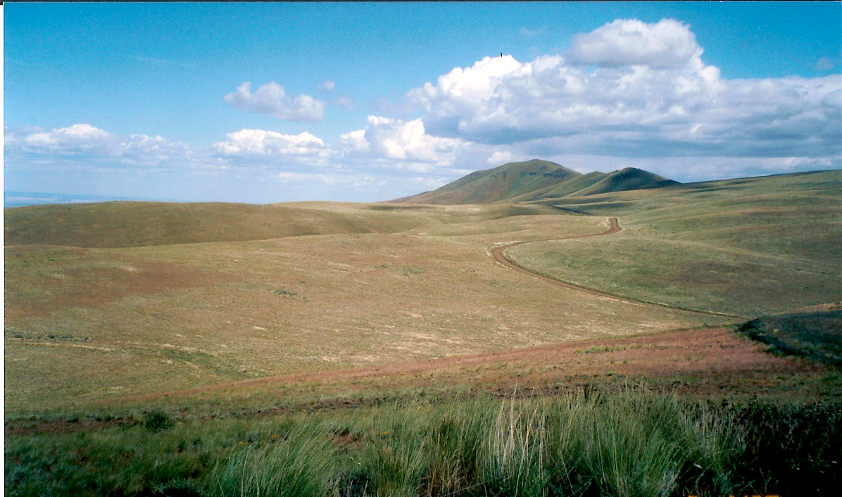

Water
Water is reasonably well distributed in YTC in the form of springs, ponds, creeks, and intermittent streams. On the eastern boundary of YTC water is readily available from the
Columbia River. Hanson Creek provides water year around although portions at the lower elevations may be intermittent (Figure 16). The driest part of YTC is in the center of the area.

Figure 14. Selah Creek Valley looking towards Hog Ranch Butte.
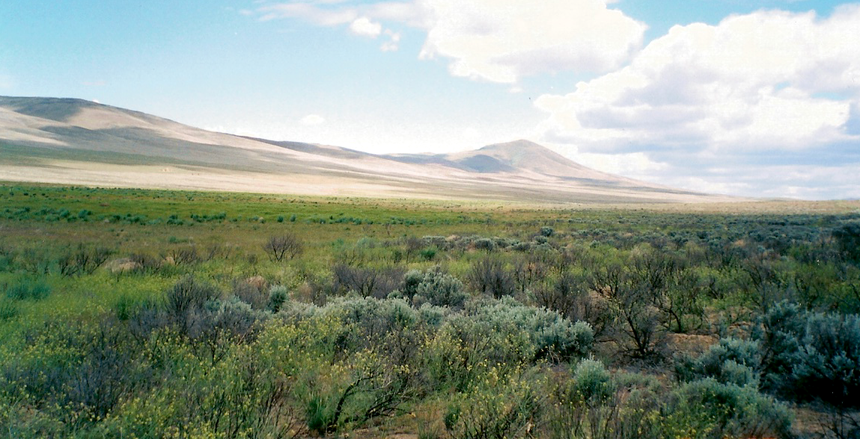

Figure 15. Umtanum Ridge, Corral Canyon north facing slope are steep.
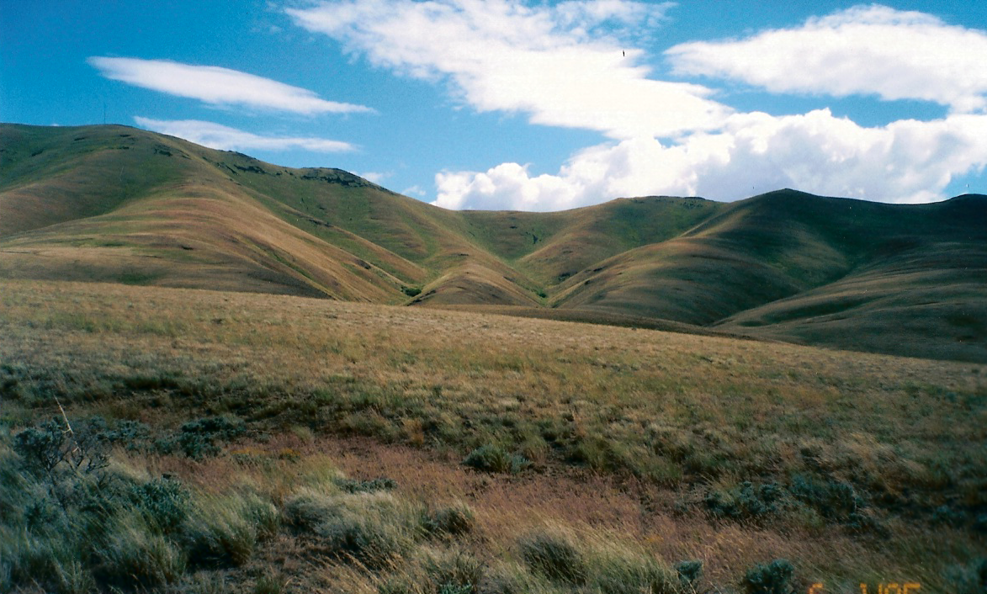

Size and Continuity
The potential habitat area is slightly less than the 540 mi² (1,401 km²) size of the study area.
Even in the sites used for intensive military exercises may be utilized by pronghorn. The habitat area is large and maintains excellent continuity. Approximately 530 mi² or 98% of the area is in the shrub land (4) and grassland/herbaceous (5) categories. The top three categories where slope was less than 10º totaled 324 mi² (829 km²) representing about 60% of the study area but even here the mountainous areas may be used.

Figure 16. Upper Hanson Creek looking west towards Manastash Ridge.
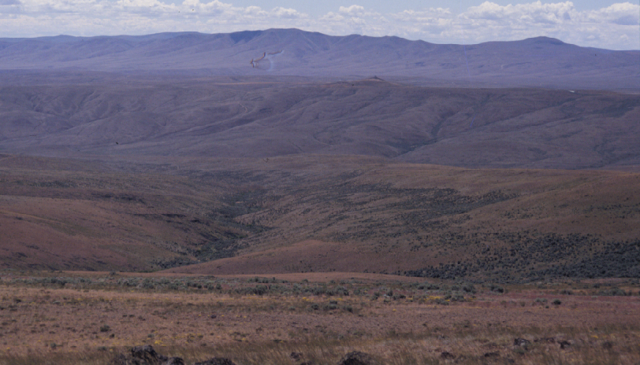

Climate
The Yakima Valley region is an area of dry, hot summers and cool winters with light snow
accumulations that are generally not persistent for extended days (Figure 17). The persistent westerly winds have a drying affect over the region. This area lies in the rain shadow of the Cascade Range and receives less than 8 inches of precipitation annually (Table 15). Typically, the months of November, December and January receives the highest precipitation. The average maximum and minimum temperatures recorded at the Moxee Station for a 56 year record is 61.3ºF and 36.6ºF; however extremes occur as shown in Figure 18.

Limitations
The entire area is under U.S. Military control. Public access is limited by permit through the main gate. The John Wayne Trail is an established trail that allows recreation horseback riding, hiking, and mountain biking by permit. This trail follows the Johnson Creek drainage along its entire length and follows an abandoned railroad bed.

Table 15. MOXEE CITY 10 E, WASHINGTON (455688)
Period of Record Monthly Climate Summary 6/ 1/1948 to 3/31/2005
 | Jan | Feb | Mar | Apr | May | Jun | Jul | Aug | Sep | Oct | Nov | Dec | Annual
Average Max. Temperature (F) | 36.0 | 44.2 | 53.1 | 61.6 | 70.2 | 78.0 | 85.7 | 84.4 | 76.1 | 62.5 | 46.5 | 36.8 | 61.3
Average Min. Temperature (F) | 21.8 | 26.6 | 30.1 | 34.6 | 40.8 | 47.6 | 51.9 | 51.3 | 45.3 | 36.3 | 29.1 | 23.5 | 36.6
Average Total Precipitation (in.) | 0.94 | 0.61 | 0.66 | 0.69 | 0.66 | 0.72 | 0.26 | 0.39 | 0.39 | 0.62 | 0.99 | 1.02 | 7.95
Average Total SnowFall (in.) | 4.9 | 1.7 | 0.9 | 0.1 | 0.0 | 0.0 | 0.0 | 0.0 | 0.0 | 0.1 | 1.4 | 4.9 | 13.8
Average Snow Depth (in.) | 1 | 0 | 0 | 0 | 0 | 0 | 0 | 0 | 0 | 0 | 0 | 1 | 0
Percent of possible observations for period of record.
Max. Temp.: 94.1% Min. Temp.: 94% Precipitation: 94.1% Snowfall: 93.4% Snow Depth: 89.1%
Western Regional Climate Center, wrcc@dri.edu

Figure 17. Maximum daily snow depth extremes at Moxee City, Yakima Co., WA.
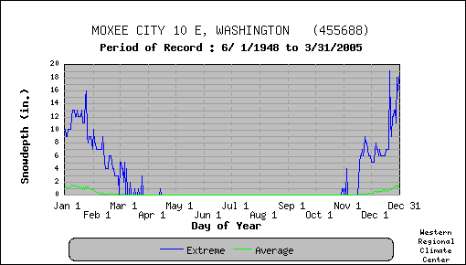

Figure 18. Maximum and minimum temperature extremes at Moxee City, YakimaCo.,WA
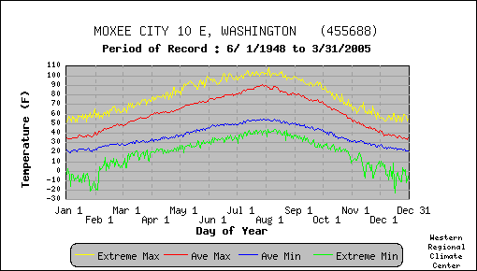

The habitat area is impacted mostly by military operations and there are several areas where access is not available. These sites have received some adverse impacts to native vegetation. Ground surface has been disturbed and will continue to be in a flux of change when military exercises occur. The most severely impacted areas are in the Lmuma Valley.
There are undoubtedly some areas where water limitations will preclude use by pronghorn during the summer season unless artificial sites are developed. Notably the driest areas are upper Lmuma Creek, Selah Creek and Alkali/Corral canyon areas.
The Badger Gap area is an established agricultural area (Figure 19). The area is supplied with

Figure 19. Badger Gap agriculture area with Boylston Mountain in the background.
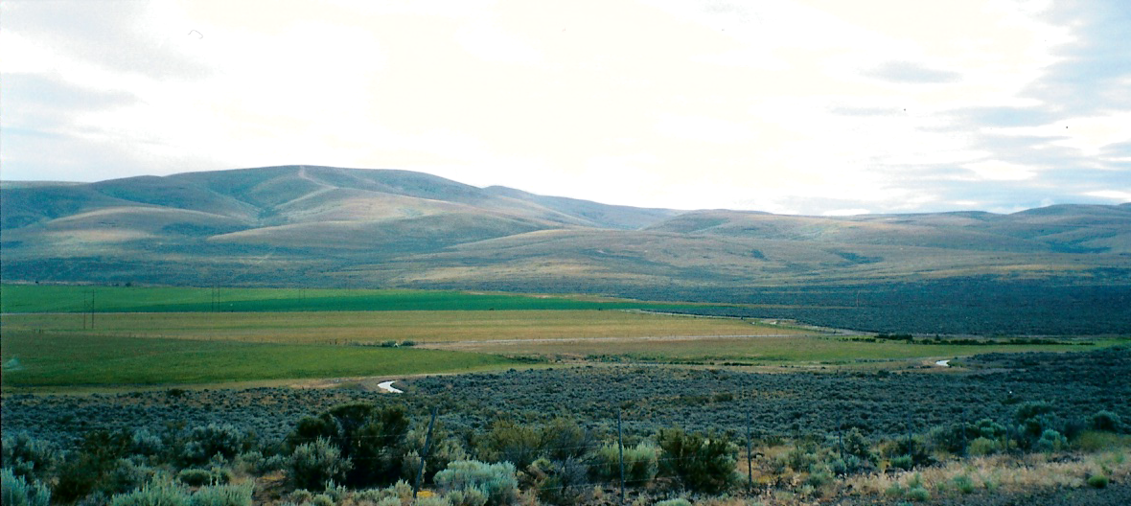

water for crops from several dirt canals and wells with pivot circle irrigation. Crops include pasture, orchards, grain crops, alfalfa and grass hay. Apparently, when pronghorn were introduced on YTC previously, they were observed using this agricultural area. I could find no record of damage other than a reference to this event (Moreland 1969).

Habitat Evaluation Score
Lmuma (Squaw) Creek (Figure 20) was the first pronghorn transplant site in Washington State. Thirty-eight mature animals bottle-raised from a total of 150 kids captured on the Charles Sheldon Refuge in Nevada and Hart Mountain Refuge in Oregon were released over a period of 3 years (1938-1940). Ten years later the transplant was deemed a success with an estimated population of 100 animals. Parsons (1976) stated that, “While initial success was achieved with all four pronghorn plants, by 1976 only 50 antelope had maintained a precarious position in four different locations within the state.”

Figure 20. Lmuma Creek Valley from Umtanum Ridge looking north to Manastash ridge
in foreground and Boylston Mountain and Saddle Mountain in background.
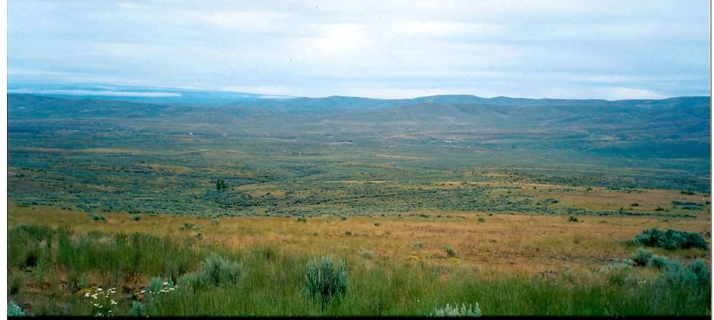

The GIS evaluation of vegetative cover, topography, aspect, snow depth, and water availability resulted in a normalized-weighted rating of 7.05 (Appendix D8), which ranked number 2 of 8 areas.
Six sub areas were evaluated using the field Habitat Evaluation Form. The evaluation focused on the Lmuma (Squaw) Creek and Hanson Creek areas of YTC. Both of these sub areas held the highest scores (Table 16). The Selah/Umtanum and Selah/Yakima Ridge sub areas scored significantly lower because of lower vegetative quality and diversity, conflict with military operations and frequent and ongoing physical disturbances to the habitat. The Selah/Umtanum and Selah/Yakima Ridge areas received identical marks of 4.8; which is at the low end of the fair pronghorn habitat score. The score for the area was also influenced by the potential conflicts with agriculture in the Badger Pocket Area. The overall score of 5.5 places this site in the mid-fair habitat category (Table 16).
The potential habitat area of approximately 323 mi² (1,401 km²) could accommodate a density of 1 pronghorn per mi² for an estimate of 300-350 pronghorns. The area includes sufficient winter, yearlong and summer ranges. During severe climatic events there are areas where the pronghorn could migrate to lower elevations and remain on the YTC. It is likely however that pronghorn will move to higher elevation habitats during the summer season or when displaced by military activity on the area. Unrestricted movement corridors between the YTC and Quilomene areas could enhance both areas. The YTC is the only area out of the 8 areas visited during the onsite field assessment that scored above the mean in all criteria.

Table 16. Yakima Training Center pronghorn habitat evaluation scoring summary
Criteria  Location | Vegetation Forb | Vegetation Shrub | Vegetation Grass | Vegetation Quantity | Vegetation Height | Water Distribution | Topography | Size & Continuity | Land Ownership & use | Limitations &  Obstructions | Total Score
1. T17N, R20-23 Rye Grass Coulee | .4 | .5 | .3 | .4 | .7 | .4 | .6 | .7 | .7 | .8 | 5.5
2. T15N, R19-20E Badger/Manastash | .6 | .6 | .3 | .8 | .6 | .8 | .4 | .3 | .3 | .3 | 5.0
3. T16N, R21-23E Saddle Mt./Hanson Cr | .6 | .4 | .3 | .6 | .7 | .4 | .6 | .8 | .8 | .8 | 6.0
4. T15N, R20-21E Lmuma/Umtanum | .6 | .6 | .3 | .8 | .7 | .8 | .5 | .8 | .8 | .5 | 6.4
5. T14N, R19-21E Umtanum/Selah | .3 | .3 | .3 | .3 | .7 | .5 | .3 | .8 | .8 | .5 | 4.8
6. T14N, R22-23E; T15N, R22-23E East  Side. | .4 | .5 | .3 | .5 | .7 | .6 | .5 | .8 | .8 | .7 | 5.8
7. T12N, R21E; T13N, R20-21E Yakima  Ridge/Selah | .4 | .4 | .3 | .4 | .8 | .5 | .3 | .7 | .6 | .4 | 4.8
8. T13N, R22/23E; T12N, R22-23E  Yakima Ridge East side | .4 | .5 | .3 | .5 | .7 | .6 | .5 | .8 | .8 | .7 | 5.8
Total | 3.7 | 3.8 | 2.4 | 4.3 | 5.6 | 4.6 | 3.7 | 5.7 | 5.6 | 4.7 | 44.1
Criteria Score | .46 | .48 | .30 | .54 | .70 | .58 | .46 | .71 | .70 | .59 | 5.52

Swanson Lakes

Location/Landownership
The Swanson Lakes pronghorn habitat assessment area is located on the channeled scablands of Lincoln County and encompasses those lands north of Interstate Highway 90, south of the Columbia and Spokane rivers and east of Highway 17 (Appendix A). Within this geographic area the only remaining natural vegetation occurs within the scabland channels and shallow soils of the uplands where dry land wheat farming is economically unproductive. The evaluation was focused on the Swanson Lakes, Lake Creek and Marlin Hollow areas. The size of the area is approximately 326 mi.² (845 km²).
The largest block of public lands occur on the Swanson Lakes Wildlife Area administered by the WDFW, and lands administered by the U.S. Bureau of Land Management on the Twin Lakes and Coffee Pot Recreation Areas, and additional scattered parcels on Marlin Hollow, Crab, Canniwai and Duck creeks. Small acreage of state owned lands administered by the Department of Natural Resources occur as isolated sections throughout the area. The Swanson Lakes Wildlife Area is approximately 19,000 acres (7,695 ha) and Federal lands in the area total about 18,500 acres (7,493 ha).
Most of the channeled scablands in Lincoln and Grant counties are in private ownership and primarily used for livestock grazing. In many cases wheat fields abut the narrow channels and most of the shrub steppe habitats are surrounded by a sea of wheat. Channels are generally narrow, rarely exceeding 4 to 5 miles (2.5-3.1km) in width with the exception of the Swanson Lakes area where the shrub steppe habitat exceeds 10 miles (6.2km) in width.

Vegetation
The major habitat types within the area are shrub-steppe, riparian/wetlands and agricultural lands. This areas natural vegetation is typically shrub steppe habitat as described by Daubenmire (1970). The Swanson Lakes Wildlife Area is a sagebrush/bunchgrass vegetative community (Figure 21). Typical shrubs include sagebrush (Artemesia spp.), antelope bitterbrush (Purshia tridentate), rabbitbrush (Chrysothamnus spp), snowberry, service berry, (Amelanchier alnifolia) and current (Ribies spp). The understory is composed of bunch grasses and herbaceous vegetation. Just north of the wildlife area the shrub steppe merges with ponderosa pine (Pinus ponderosa), the only significant tree species in the area (Figure 22).
Some of the more common species of grasses include Festuca idahoensis, Agropyron spicatum Poa sandbergii, squirrel tail (Sitanion hystrix), giant rye grass (Elymus cinereus), needle and thread grass (Stipa spp.), and annual cheat grass (Figure 23). CRP lands are mostly exotic grasses with slow recovery of shrubs (Figure 24).
Typical forbs include Hooker’s balsamroot (Balsamorhiza hookeri), yarrow (Achillea millefolium), fiddleneck (Amsinckia menziesii), hawksbeard (Crepis spp.), daisey (Erigeron spp.)
bitterroot (Lewisia rediviva), desert parsley (Lomatium spp.), primrose (Oenothera spp.) penstemon (Penstemon spp.), and phlox (Phlox spp.).
The land cover classes from the National Land Cover data base (NLCD 2000) for the Swanson Lakes area and their approximate size and percentage makeup is shown in (Table 17).
Shrub lands represent 74 percent of the land cover classes listed. Interestingly, fallow ground represented the next highest percentage at 8.6.

Figure 21. Shrub steppe habitat on the Swanson Lakes Wildlife Area.
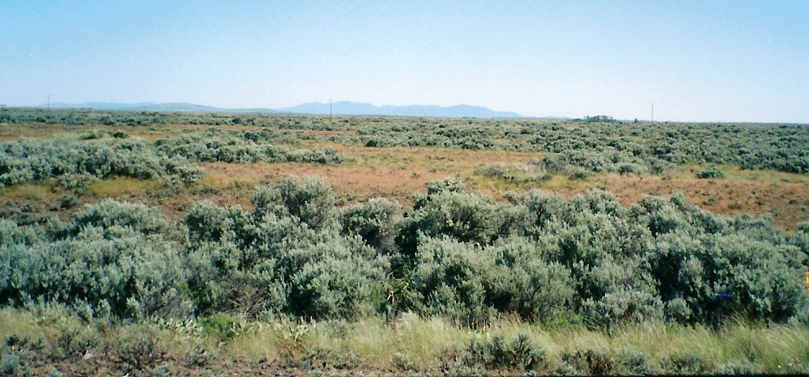

Figure 22. Ponderosa pine tree line on the Swanson Lakes W. M. A. north boundary.
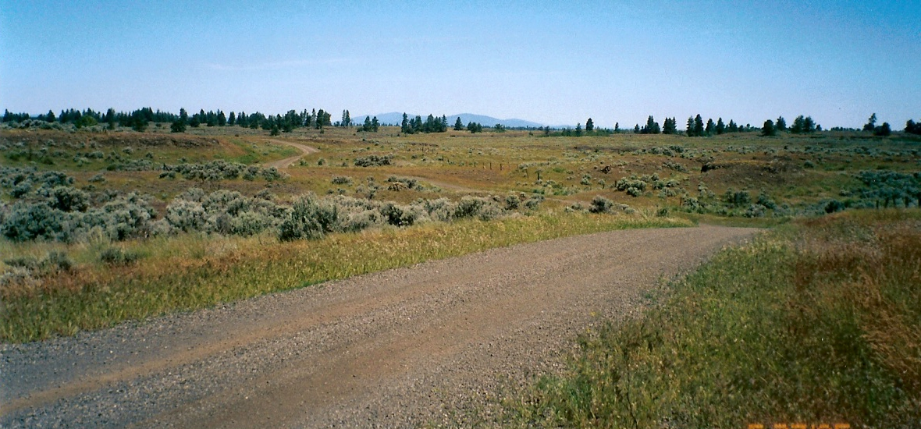

Figure 23. Shrub grassland habitat in the Twin Lakes area.
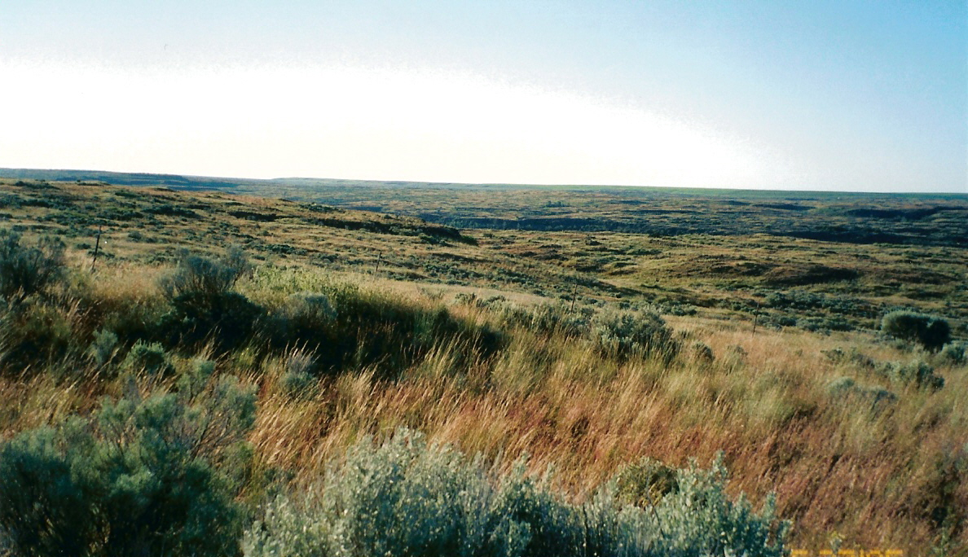

Figure 24. CRP lands in the Swanson Lakes Area of Lincoln Co., WA
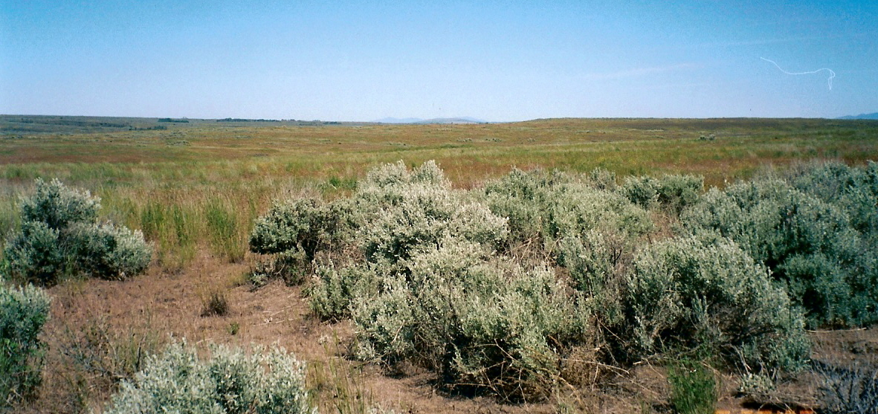

Table 17. NLCD Land Cover Classes in the Swanson Lakes Area/Sub Areas.
Classes (mi²) | Area  1 | Area  2 | Area  3 | Area  4 | Area  5 | Area  6 | Total  (mi²) | %
bare (rock/sand/clay), com./industrial/trans.,  deciduous/evergreen/or mixed forest, emergent herbaceous wetlands, urban/recreational grass, open water, row crops, high & low intensity residential, orchards & vineyards. (0) | 0.63 | 2.18 | 0.50 | 1.26 | 0.58 | 0.53 | 5.68 | 1.75%
pasture/hay, woody wet-lands, fallow, small grain, transitional. (1) | 1.14 | 6.99 | 12.17 | 4.50 | 18.32 | 18.37 | 61.49 | 18.99%
exotic grasses & weeds, stiff sagebrush. (2) | 0.16 | 0.74 | 0.13 | 1.39 | 0.04 | 0.20 | 2.66 | 0.82%
shrub steppe on shallow soils, native grasslands with herbaceous species. (3) | 2.01 | 0.45 | 0.06 | 0.10 | 0.04 | 0.02 | 2.68 | 0.82%
grassland/herbaceous (4) | 24.10 | 57.09 | 36.28 | 57.30 | 34.97 | 30.78 | 240.52 | 74.31%
shrub land (5) | 0.12 | 2.70 | 1.93 | 2.89 | 2.34 | 0.71 | 10.69 | 3.30%
grand total | 28.16 | 70.15 | 51.07 | 67.44 | 56.29 | 50.61 | 323.72 | 99.99%

Topography
The land increases in elevation from about 1,640 feet (500m) in the southwest to about 2,461 feet (750m) in the northeast. At a distance the appearance is flat but the terrain is often rolling hills or within the channels is extremely rough and broken with basalt cliffs and depressions (Figure 25). Basalt domes and mounds are a feature of the landscape in much of the area. The channels narrow to the south and the terrain becomes even more broken and deepens (Figures 26).

Figure 25. Depressions that hold water during the wet season on Swanson Lakes
Wildlife Area.
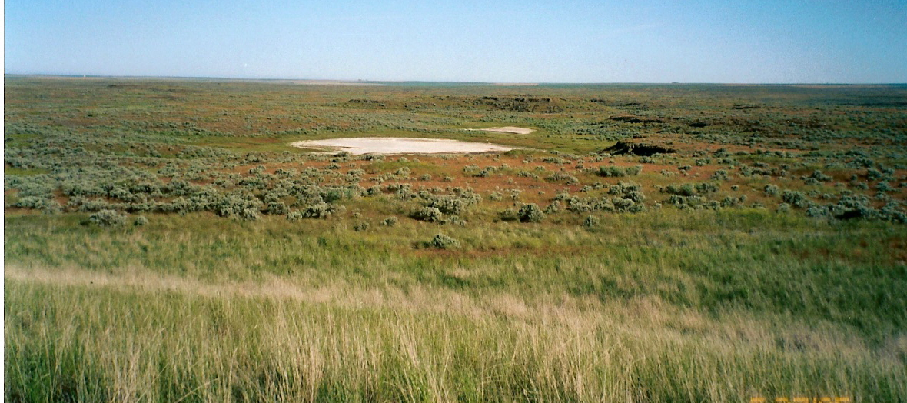

Figure 26. Basalt cliffs form a stair step down Lake Creek Canyon to Twin Lakes.
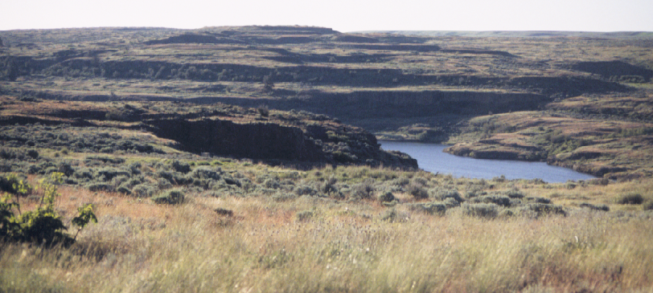

Size and Continuity
The potential habitat in this area is less than the 326 mi.² (845 km²) size of the study area. Approximately 251 mi² or 78% of the potential habitat area is in the shrub land (4) and grassland/herbaceous (5) categories. The top three categories where slope was less than 10º totaled 311 mi² (803 km²) representing about 96% of the study area. It is estimated that >96% of the area or 311 mi² (803 km²) can be considered potential habitat for pronghorn.

Water
Water is well distributed throughout the channeled scablands of this area. Access to some of the waters in the deeper channels and ravines may be restrictive to pronghorn. In some situations water may be unavailable to pronghorn during high human recreational use of waters in the area. Water was not determined to be a limiting factor in this assessment because of the numerous lakes, ponds, shallow depressions holding water and springs in the area.

Climate
The Swanson Lakes area receives an average of 12.69 inches (32.2cm) of precipitation annually (Table 18). Most of the precipitation is received during the winter; however, some moisture falls during the driest summer months as well. About twenty-five percent of the time the skies are clear with warm summers and cold winters. The average snowfall at Harrington (453515) is 28.5 inches (72.4cm) annually; however, at Davenport (452007), which is located only12 miles (12.8km) north of Harrington, the average annual snowfall is significantly higher at 39.4 inches (100cm). Total annual precipitation at Davenport (14.82 in [37.6cm]) is also higher by over 2 inches (5.1cm). Further south at Odessa (456039) the climatic conditions are milder in winter and warmer in summer. Annual precipitation totals also decrease by more than 2 inches (5.1cm) annually compared to Harrington (WRCC 2005). Maximum snow depth extremes (Figure 27) indicate that persistent snow in combination with cold temperature extremes may present a

Table 18. HARRINGTON 4 ENE, WASHINGTON (453515)
Period of Record Monthly Climate Summary 12/1/1961 to 3/31/2005
 | Jan | Feb | Mar | Apr | May | Jun | Jul | Aug | Sep | Oct | Nov | Dec | Annual
Average Max. Temperature (F) | 32.1 | 39.4 | 49.2 | 58.8 | 67.8 | 75.7 | 84.0 | 83.3 | 74.0 | 59.7 | 42.2 | 32.8 | 58.3
Average Min. Temperature (F) | 20.6 | 25.0 | 29.4 | 32.8 | 38.5 | 44.2 | 48.2 | 48.2 | 41.5 | 32.9 | 27.7 | 21.6 | 34.2
Average Total Precipitation (in.) | 1.39 | 1.08 | 1.17 | 0.99 | 1.15 | 0.88 | 0.54 | 0.48 | 0.56 | 0.88 | 1.68 | 1.88 | 12.69
Average Total SnowFall (in.) | 9.0 | 3.9 | 1.6 | 0.2 | 0.0 | 0.0 | 0.0 | 0.0 | 0.0 | 0.1 | 3.7 | 9.9 | 28.5
Average Snow Depth (in.) | 4 | 2 | 0 | 0 | 0 | 0 | 0 | 0 | 0 | 0 | 0 | 2 | 1
Percent of possible observations for period of record.
Max. Temp.: 99.6% Min. Temp.: 99.6% Precipitation: 99.6% Snowfall: 99.8% Snow Depth: 99.6%
Western Regional Climate Center, wrcc@dri.edu

problem at times for pronghorn. This area doesn’t have an abundance of south facing exposures where snow melt and wind action maintain accessibility to forage.

Figure 27. Maximum daily snow depth extremes at Harrington, Lincoln Co., WA.
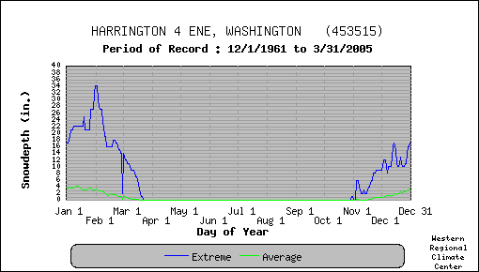

The average annual maximum temperature is 58.3ºF and average minimum just above freezing at 34.2ºF. Extreme minimum temperatures below zero degrees F. occur from November through March (Figure 28). Davenport and Harrington have recorded extreme temperature episodes of -20ºF to -30ºF from November through February (WRCC 2005).

Figure 28. Maximum & minimum temperature extremes at Harrington, Lincoln Co., WA.
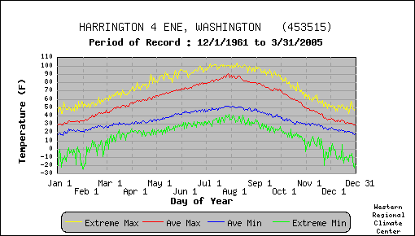

Limitations
The habitat in the Swanson Lakes area has some limitations for pronghorn. The fragmented nature of the remaining shrub steppe habitat is principal among them. The channeled scablands are not always favorable for pronghorn habitation. The natural vegetation occurs in narrow strips rather than continuous blocks of habitat. Furthermore, agriculture production areas are in close proximity to potential habitat.
Ponderosa pine encroach shrub steppe habitat at the northern limits of the Swanson Lakes Wildlife Area. These timber stands become larger and tree density increase northward. North of Highway 2 forested areas limit the value of the habitat for pronghorn.
Persistent snow is a concern for this area, especially in combination with extreme low temperatures. The area is deficient in adequate southern exposures where snowmelt and wind action would expose forage. Pronghorn would probably do well here during the spring, summer and fall seasons; however during the most severe winter conditions a migration to the southwest may be required. Movements of this magnitude would be hindered by obstacles such as range and farm field fences that don’t meet wildlife standards (O’Gara and Yoakum 2004). The Burlington Northern and Santa Fe Railroad right of way fencing along Crab Creek may also be an obstacle to movement of pronghorn. Most of the fences in this area are constructed of barbed wire; however, there are areas where the bottom third of the fence is net wire.
The Burlington Northern Railroad that parallels Highway 2 could present a hazard to movement north and south. This hazard would be magnified where the railroad right of way is directly adjacent to the Highway right of way. Highway 2 is the main east-west corridor between Spokane and Wenatchee, WA and receives heavier use during the summer.

Table 19. Swanson Lake/Crab Creek pronghorn habitat evaluation scoring
summary
Criteria  Location | Vegetation  Forbs | Vegetation  Shrubs | Vegetation  Grass | Vegetation  Quantity | Vegetation  Height | Water  Distribution | Topography | Size & Continuity | Land Ownership  and Use | Limitations &  Obstructions | Total  Score
1. T26N, R34-35E; T25N, R35-36E  Bachelor Prairie | .5 | .3 | .2 | .4 | .2 | .9 | .4 | .4 | .3 | .4 | 4.0
2. T25N, R33-35E Swanson Lakes | .6 | .6 | .35 | .7 | .6 | .9 | .5 | .8 | .8 | .5 | 6.35
3. T24N, R32-33E Canniwai Creek | .4 | .45 | .35 | .7 | .6 | .8 | .5 | .3 | .3 | .4 | 4.8
4. T24N, R34-35E Twin Lakes | .6 | .5 | .35 | .7 | .6 | .9 | .4 | .8 | .8 | .5 | 6.15
5. T23N, R32-33E; T22N, R33E Odessa | .6 | .6 | .35 | .7 | .6 | .8 | .4 | .4 | .3 | .4 | 5.15
6. T23N, R34-35E; T22N, R34E Coffee  Pot/Duck Creek | .4 | .4 | .3 | .6 | .4 | .5 | .4 | .3 | .1 | .4 | 3.8
Total | 3.1 | 2.85 | 1.9 | 3.8 | 3 | 4.8 | 2.6 | 3 | 2.6 | 2.6 | 30.35
Criteria score | .52 | .48 | .32 | .63 | .50 | .80 | .43 | .50 | .43 | .43 | 5.04

Habitat Evaluation Score
Six sub areas of habitat were evaluated using the field Habitat Evaluation Form. The Swanson Lakes State Wildlife Area and the Twin Lakes BLM Recreation Area was the focus of the field evaluation. Both of these areas held the highest field scores (Table 19). The peripheral areas scored significantly lower because of poor vegetative quality and diversity, a preponderance of private lands and lack of continuity and size of habitat. The overall score for the area was influenced by the inclusion of the Duck Creek Channel area; which recorded a significantly lower score.
The field score of 5.04 placed this site in the overall fair habitat category. Duck Lake sub area scored below 4; which is classified as poor pronghorn habitat. The highest score of 6.35 was recorded for the Swanson Lakes sub area followed closely by the Twin Lakes sub area. The field

score for the area was influenced by below average scores for topography and vegetation. The comparative field ranking places this area at number 3 of 8.
The GIS evaluation of vegetative cover, topography, aspect, and water distribution resulted in a normalized-weighted rating of 6.84 (Appendix D7), which ranked number 4 of 8 areas.
The potential pronghorn habitat in this area is estimated to be about 311mi² (805km²). Based on the size of the area and a density of .75/mi², it is estimated that a population of approximately 200 - 250 pronghorn could be established in this area.

Cow and Rock Creek

Location/Landownership
The area is described as that portion of Adams County south of Interstate Highway 90, west of Highway 23 and the Cherry Creek, Lancaster and Winona South Roads, north of Highway 26 and east of Highway 261 (Appendix A). Potential pronghorn habitat was surveyed along the channeled scablands of Adams County and the entire length of Cow Creek. A small portion of western Whitman County along Rock Creek from Rock Lake to the Palouse River south to the confluence of Cow Creek was also investigated. The study area is approximately 523mi² (1355km²).
The area has been heavily impacted by agricultural activities for more than a century. The conversion of most of the tillable lands has left the landscape with two major vegetative communities; shrub steppe/grass lands and agricultural lands. Dry land wheat production is the main agricultural activity in the area and where the land is not tillable in the channeled scablands, livestock are grazed.
Most of the area is in private ownership. The WDFW owns 2,290 acres (Revere property) on Rock Creek in Whitman County (Figure 29). The Washington Department of Natural Resources administers scattered parcels of state owned lands throughout the region. Adams County is a sparsely populated area of the State with 16,600 residents according to the 2003 census (OFM 2003). The land area of Adams County is 1,925 mi² (4,986km²).
A large block of natural vegetation remains on the channeled scablands in the upper Cow Creek drainage from Sprague south to Harder Road. This is the widest part of the channel, stretching over twelve miles (19.3km) in places (Figure 30). Some irrigated and dry land farming occurs within the area of the scablands. The channel is bisected by two railroad right of ways; the Union Pacific line follows Cow Creek and the abandoned Burlington Northern follows McElroy Creek on the eastern side of the channel. Both lines meet on Cow Creek approximately 3 miles west of Benge, WA.

Vegetation
The vegetation on the channeled scabland of this area lacked the density of shrubs (sagebrush, rabbitbrush, bitterbrush, etc) typical of Lincoln County to the north. Here the shrubs are quite limited, consisting mostly of rabbit brush, rigid sagebrush, three-tip sagebrush (Artemesia
tripartita), gooseberry (Ribes spp.) and rose (Rosa spp.).
The NLCD land cover classes found in Table 20 indicates a much higher percentage of shrubland vegetation than what was observed. My observations suggest that grassland/ herbaceous vegetation was the dominant cover and even here the quality of vegetation was less than desirable. Shrubs were most prominent in the roughest terrain of the channeled scablands and diversity was lacking.

Much of the area has been repeatedly burned and or grazed heavily and is now dominated by annual cheat grass and weeds. Climate, livestock grazing and other factors such as fire, brush removal, agricultural practices have significantly changed the character of the vegetation. There is no doubt that dry land wheat farming and livestock grazing has been responsible for a dramatic change in the vegetative landscape of the area. Heavy grazing by cattle has changed the

Figure 29. Revere Ranch property on Rock Creek, Breeden Road access, Whitman Co.
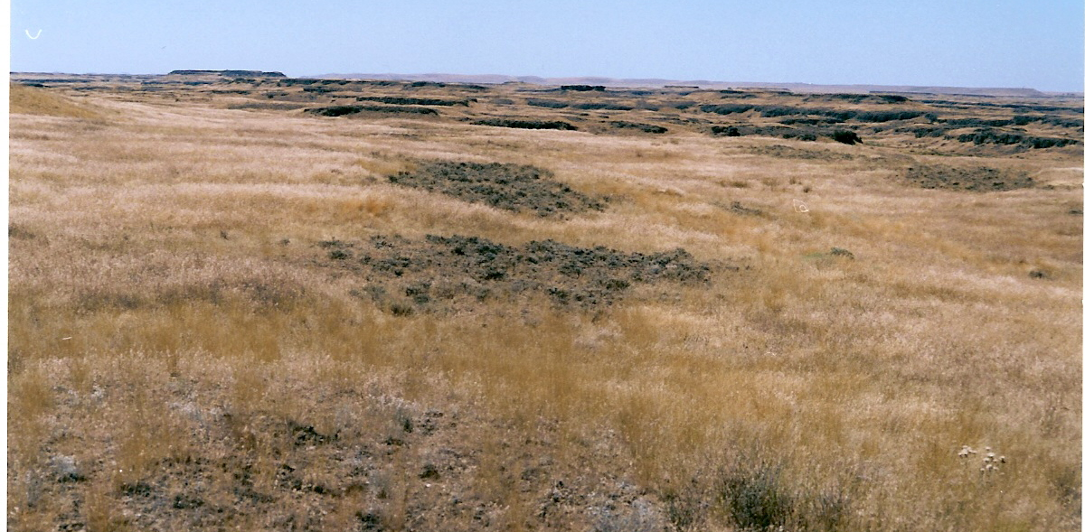

Figure 30. Berry Lake on the channeled scabland along Lamont Road, Adams Co.
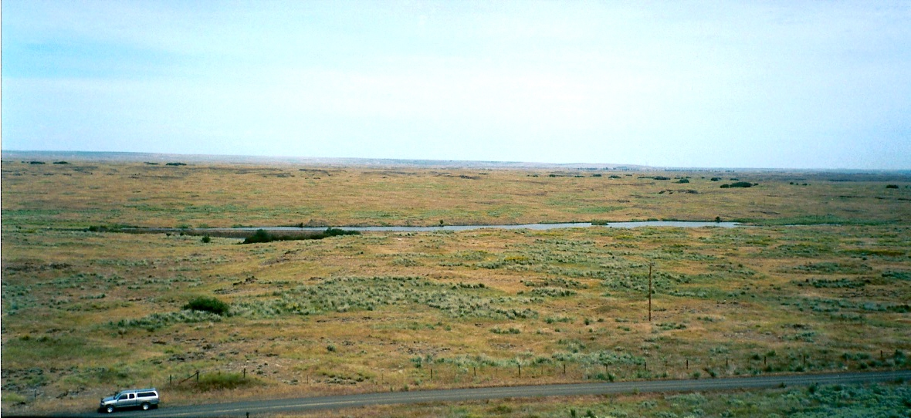

vegetative cover in some places where now the most prominent grass is cheat grass (Bromus tectorum), wild rye, (Elymus cinereus), blue bunch wheat grass (Agropyron spicatum), (Sitanyon spp.) and blue grass (Poa spp.). In some localized areas such as Lower Cow Creek, wildfire and intense livestock grazing has replaced native shrub vegetation with noxious weeds such as rush skeleton weed (Chondrilla juncea), yellow star thistle (Centaurea solstitialis), medusahead (Taeniatherum caput-medusae), bulbous bluegrass (Poa bulbosa), cheat grass and other (Bromus spp.), (Figure 31). Native grasses have all but disappeared from some locals.
Herbaceous vegetation includes such species as daises (Erigeron spp.), Balsamhoriza spp., yarrow (Achiullea millefolium), lupine (lupinus spp.), yellow sweet clover (Melilotus indica), buckwheat (Eriogonum spp.), parsley (Lomatium spp.), tansy mustard (Descurainia spp.), and plantain (Plantago spp.).

Table 20. NLCD Land Cover Classes in the Cow and Rock Creek Area/ Sub Areas.
Classes (mi²) | Sub  Area  1 | Sub  Area 2 | Sub  Area  3 | Sub  Area  4 | Sub  Area 5 | Sub  Area  6 | Sub  Area  7 | Sub  Area  8 | Sub  Area  9 | Sub  Area  10 | Sub  Area  11 | Area  Total  (mi²) | %
bare (rock/sand/clay), com./industrial/trans.,  deciduous/evergreen/or mixed forest, emergent herbaceous wetlands, urban rec. grass, open water, row crops, high & low intensity residential, orchards & vineyards. (0) | 2.19 | .53 | .29 | .41 | .24 | .25 | .47 | .23 | .34 | .30 | .48 | 5.73 | 1.1%
Pasture/hay, woody wet lands, fallow, small grain, transitional. (1) | 2.30 | .90 | .76 | .69 | 9.73 | 4.95 | 4.18 | 9.43 | 17.92 | 4.94 | 23.84 | 79.64 | 15.2%
Exotic grasses & weeds,  stiff sagebrush. (2) | .79 | .67 | .19 | .41 | .08 | .17 | .13 | .08 | .18 | .05 | .02 | 2.77 | 0.5%
shrub steppe on shallow soils, native grasslands with herbaceous species (3) | .14 | .10 | .02 | .05 | .03 | .04 | .30 | .03 | .04 | 0.0 | 0.0 | 0.75 | 0.1%
grassland/herbaceous (4) | 52.16 | 28.14 | 26.19 | 29.33 | 43.88 | 27.83 | 31.13 | 44.61 | 30.80 | 43.81 | 45.89 | 403.77 | 77.3%
shrub land (5) | 1.40 | .50 | 4.81 | 1.78 | 3.19 | 2.89 | 3.10 | 3.11 | 2.50 | 3.64 | 3.12 | 30.04 | 5.7%
grand total | 58.98 | 30.84 | 32.26 | 32.67 | 57.15 | 36.13 | 39.31 | 57.49 | 51.78 | 52.74 | 73.35 | 522.7 | 100.%

Figure 31. Native shrub steppe has been replaced by noxious weeds in the area south
of Thavis and west of Cow Creek.
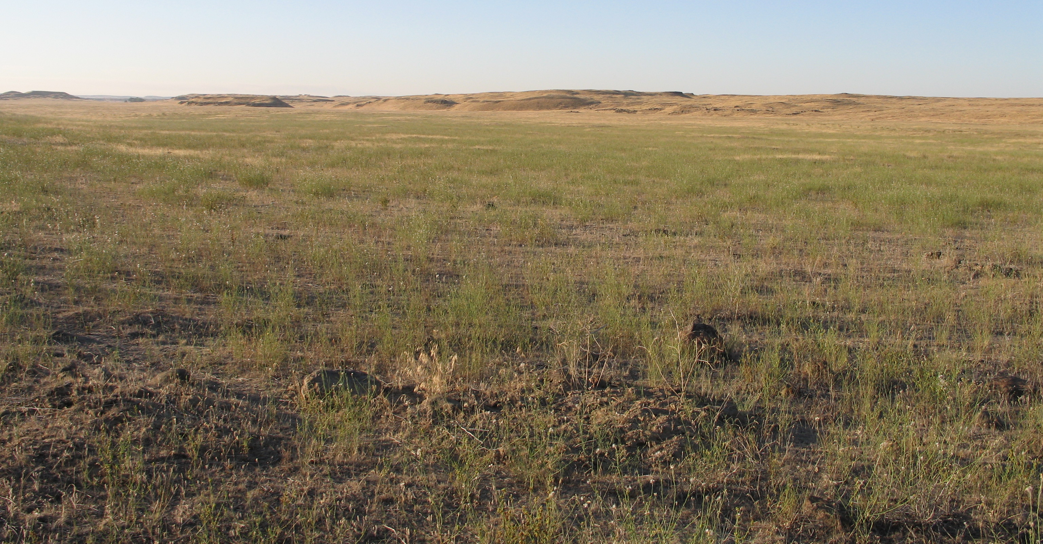

Topography
The elevation along Cow Creek varies from 1,640 ft to 2,295 ft (500m to 700m.). In general the channeled scablands of this area have a gentler slope and aspect. Some areas are rough in places with the channels forming a broken landscape with numerous parallel channels that have exposed basalt ledges and tables (Figure 32 - 33). Other areas form a relatively flat valley bottom with surface ripples and large gravel deposits laid down during the glacial floods (Figure 34).

Figure 32. Rock Creek channeled scablands from George Knott Rd looking
north, Whitman Co.
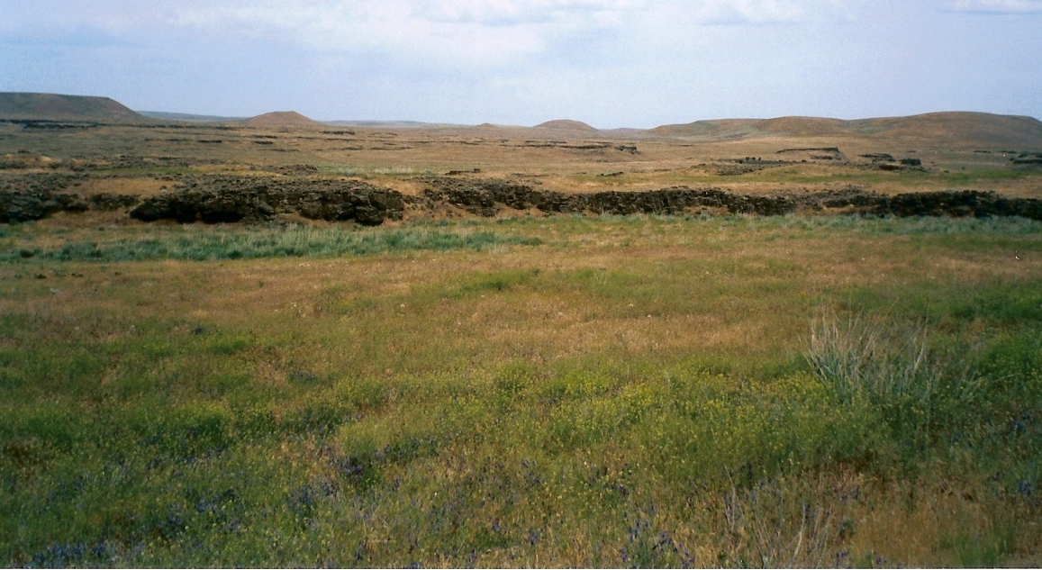

Figure 33. Lower Cow Creek at Thavis looking south.
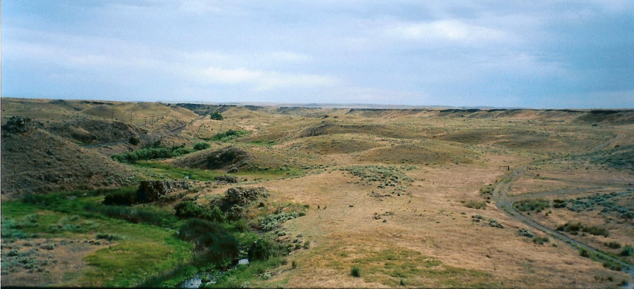

Figure 34. Channeled scablands in some areas are fairly flat with ripple mounds from
glacial flooding.
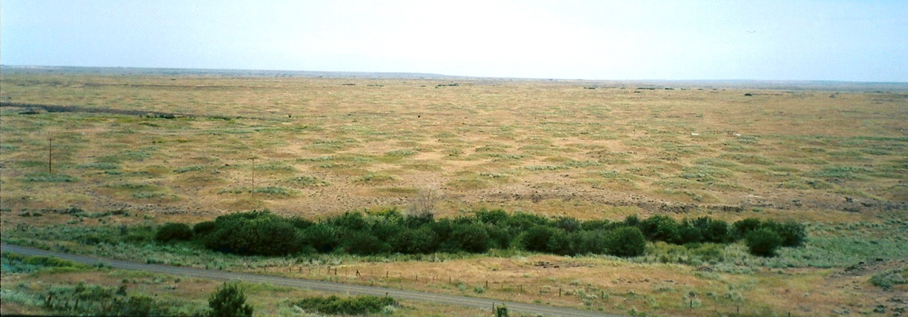

Size and Continuity
The potential habitat based on topography alone indicates that the area suitable for pronghorn total about 473mi² or about 90% of the study area. The vegetation potential of the area (shrub land (4) and grassland/herbaceous (5) categories) was somewhat less, estimated to be about 433mi² (1,122km²) or 83% of the area. It is estimated that most (<90%) of the area is potential pronghorn habitat; however, there was great difference in the quantity and quality of shrubs, grasses and herbaceous vegetation identified in the GIS modeling effort versus the on site field analysis. As a result potential densities of pronghorn will most likely be less than expected.

Water
Water is well distributed and readily available in the channeled scabland from Sprague Lake to McCall Road. South of McCall Road water is available along the entire length of Cow and Rock creeks. Water is not well distributed or as available a mile or two on either side of Cow Creek from Thavis to Highway 26. There are private wells that supply water to livestock when they are present otherwise much of this area is dry.

Climate
The climate in the Cow Creek/Rock Creek area is characterized by mild winters and warm, dry summers. Average annual precipitation totals 11.80 inches (30cm) and is received during every month of the year, although the largest amounts arrive between November and March (Table 21).

Table 21. RITZVILLE, WASHINGTON (457059)
Period of Record Monthly Climate Summary 6/ 1/1948 to 3/31/2005
 | Jan | Feb | Mar | Apr | May | Jun | Jul | Aug | Sep | Oct | Nov | Dec | Annual
Average Max. Temperature (F) | 34.0 | 41.7 | 51.0 | 60.5 | 69.2 | 77.6 | 86.6 | 85.7 | 76.7 | 62.3 | 45.0 | 35.8 | 60.5
Average Min. Temperature (F) | 21.0 | 25.7 | 29.5 | 33.7 | 40.2 | 46.8 | 52.2 | 51.9 | 45.0 | 35.6 | 28.5 | 23.2 | 36.1
Average Total Precipitation (in.) | 1.40 | 1.11 | 1.08 | 0.85 | 0.94 | 0.82 | 0.45 | 0.41 | 0.54 | 0.94 | 1.56 | 1.69 | 11.80
Average Total SnowFall (in.) | 6.9 | 3.0 | 1.1 | 0.1 | 0.0 | 0.0 | 0.0 | 0.0 | 0.0 | 0.0 | 2.2 | 6.1 | 19.3
Average Snow Depth (in.) | 2 | 1 | 0 | 0 | 0 | 0 | 0 | 0 | 0 | 0 | 0 | 1 | 0
Percent of possible observations for period of record.
Max. Temp.: 99.5% Min. Temp.: 99.5% Precipitation: 99.7% Snowfall: 99.5% Snow Depth: 98.2%
Western Regional Climate Center, wrcc@dri.edu

Total annual snowfall measures 19.3 inches (23.3cm) and is received mostly during December through February. There are occasional periods of extreme conditions in temperatures and snow depth in the winter (Figures 35 & 36). Winter low temperatures have been known to dip to -20ºF and July-August temperatures have exceeded 100ºF (WRCC 2005).

Limitations
The majority of this area is under private ownership and has resulted in a highly fragmented landscape. There are some large blocks of channeled scablands that are owned by a few individuals. The primary use of these lands is for livestock grazing. Where soil conditions permit, within the scablands, irrigated pastures and hay production occurs. During the summer these isolated tracts of agriculture stand out in the midst of a parched landscape.

Figure 35. Maximum and minimum temperature extremes Ritzville, Adams Co., WA.
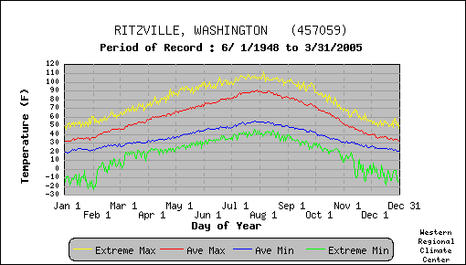

Figure 36. Daily Average and Extreme snow depths at Ritzville, Adams Co., WA.
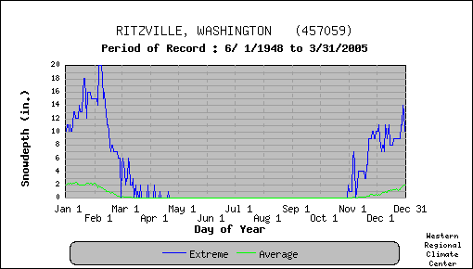

There is a lack of quality shrub vegetation in this area. The prominent shrub found in the areas with the best topography was stiff sagebrush and rabbit brush. The areas that remain uncultivated have been impacted by fire and intense livestock grazing. The invasion of weedy species such as skeleton weed, knapweed (Centaurea spp), cheat grass and other species have replaced native shrubs, grasses and forbs.
The Union Pacific Railroad line traverses the Cow Creek drainage and may be an obstacle to free movement of pronghorn. Accidental mortalities along railroad right of ways are known to occur especially during winter conditions and concentrations (O’Gara and Yoakum 2004).
A significant portion of the scabland topography is highly irregular with shallow to deep depressions and channels, and basalt intrusions and rims. Even in areas where the aspect looks relatively flat the ripples and mounds could easily conceal predators and be less suitable for pronghorn.

Habitat Evaluation Score
Eleven geographic sub areas were evaluated and recorded using the field Habitat Evaluation model and GIS modeling effort. The sub areas that scored the highest include Cow Creek and McElroy channels. Both of these areas scored above 5.0 total points (Table 22). The remaining areas scored significantly lower because of poor vegetative quality and diversity, a preponderance of private lands and lack of continuity and size of habitat.
The field score of 4.72 places this area in the fair habitat category. Lower Cow Creek and the Palouse areas scored below 4.0, while the upper Cow Creek sub areas scored above 5.0. The field score for the area overall was influenced by below average scores for topography and vegetation. The comparative field ranking places this area at number 4.
The GIS modeling of vegetative cover, topography, aspect, and water distribution resulted in a

Table 22. Cow Creek pronghorn on site habitat evaluation scoring summary
Criteria  Location | Vegetation  Forbs | Vegetation  Shrubs | Vegetation  Grass | Vegetation  Quantity | Vegetation  Height | Water  Distribution | Topography | Size and  Continuity | Land Owner-  Ship and Use | Limitations &  Obstructions | Total Score
1. T20N, R37&38E; T21N, R38E Sprague | .5 | .5 | .3 | .6 | .5 | .9 | .7 | .7 | .31 | .4 | 5.41
2. T20&21N, R39E McElroy Creek | .6 | .4 | .3 | .5 | .5 | .9 | .5.5 | .7 | .31 | .5 | 5.71
3. T19N, R36&38E Cow Lake and Creek | .5 | .4 | .3 | .5 | .5 | .8 | .6 | .7 | .31 | .5 | 5.11
4. T19N, R38E McElroy | .5 | .4 | .3 | .5 | .5 | .8 | .6 | .7 | .31 | .5 | 5.11
5. T18N, R36&37E Marengo | .5 | .3 | .3 | .5 | .6 | .6 | .7 | .7 | .31 | .5 | 5.01
6. T18N, R38E Harder | .4 | .3 | .3 | .5 | .5 | .4 | .6 | .7 | .5 | .6 | 4.8
7. T19N, R39-40E; T18N, R39-40E Rock Cr | .3 | .3 | .3 | .5 | .4 | .7 | .4 | .2 | .35 | .6 | 4.05
8. T17N, R36&37E Thavis | .4 | .3 | .3 | .5 | .6 | .9 | .65 | .7 | .31 | .4 | 5.06
9. T17N, R38&39E Lower Rock Cr. Revere | .3 | .3 | .3 | .5 | .5 | .7 | .35 | .4 | .35 | .4 | 4.1
10. T15&16N, R37E; T16N, R38E L. Cow Cr | .3 | .25 | .3 | .5 | .5 | .4 | .4 | .4 | .35 | .4 | 3.8
11. T15&16N, R38&39E; T16N Palouse | .4 | .3 | .3 | .6 | .4 | .5 | .45 | .3 | .2 | .3 | 3.75
Total | 4.7 | 3.75 | 3.3 | 5.7 | 5.5 | 7.6 | 6.45 | 6.2 | 3.61 | 5.1 | 51.91
Criteria Score | .43 | .34 | .30 | .52 | .50 | .69 | .59 | .56 | .33 | .46 | 4.72

normalized-weighted rating of 6.89 (Appendix D2), which ranked number 4 of 8 areas. The two methods of habitat analysis were not totally comparable but provided valuable insight into the potential for the area. Both methods placed this area at number 4 of 8 areas evaluated.
Based on the estimate of 433 mi² (1,122km²) of potential pronghorn habitat, it is probable that a population of approximately 200 – 250 animals could be established. This estimate used a base density of .5/mi² of habitat.

Rattlesnake Hills, Hanford, Wahluke Slope

Location/Landownership
This area encompasses several government ownerships including the Hanford Site, Hanford Reach National Monument, Rattlesnake Slope State Wildlife Area, and alternate sections of Bureau of Land Management lands west of Highway 241 on the Rattlesnake Hills and scattered sections of State Department of Natural Resource lands (Appendix A). The North (Wahluke) Slope occupies 89,000 acres of land on the Hanford Site, managed in part by U.S. Fish and Wildlife Service as a National Wildlife Refuge, and under lease agreement with the Washington State Department of Fish and Wildlife as the Wahluke Slope Wildlife Management Area. This area includes Saddle Mountain east of the Columbia River. The area includes a large geographic area of Yakima County east and north of Interstate Highway 82 excluding the YTC, Benton County north of I-82, and Grant and Franklin counties within the Hanford Reach National Monument.
In 1997, U.S. Department of Energy (DOE) entered into a co-management agreement with the U.S. Fish and Wildlife Service to administer the Arid Lands Ecology (ALE) Reserve. The ALE is 77,000 acres of former shrub-steppe habitat on Rattlesnake Mountain that was ravaged by wildfire between June 27th and July 2nd, 2000 (Tiller et al 2000). The fire started as a result of a vehicle collision on Highway 24 near Cold Creek. Over a 4 day period the fire burned virtually all the vegetation on the ALE Reserve, the Rattlesnake Slope Wildlife Area and a large portion of the Central Hanford site adjacent to Highway 240.
The potential habitat area is surrounded by private lands that have been converted to agriculture production. The lower reaches of the south facing slope of the Rattlesnake Hills are under intensive agriculture including orchards, vineyards, alfalfa, grass hay, and cereal crop production. Above the irrigated cropland, dry land wheat farming is practiced. Other significant agriculture production areas border the Hanford Reach National Monument in Mattawa, Basin City, and Cold Creek areas.
The Central Hanford site is off limits to the general public and access is tightly controlled. The ALE is closed to all public access. The Hanford Reach is a 51 mile stretch of the Columbia River and is the last remaining free flowing non-tidal section of the Columbia River in the U.S. (Evans et al. 2003).
This area is near two major population areas including the city of Yakima, and Tri-cities (Richland, Kennewick and Pasco). Sunnyside, Benton City, Prosser, Moxie, Mabton, and Grandview are other agriculture based communities located along the Yakima River.

Vegetation
There are a number of different native plant associations in this area. The largest of these is the big sagebrush (Artemisia tridentata) / bluebunch wheatgrass (Agropyron spicatum) association.
The big sagebrush / bluebunch wheatgrass association has an over story of big sagebrush and an understory of bluebunch wheatgrass, and Sandberg’s bluegrass (Poa sandbergii). Perennial forbs and annual forbs also occur in the understory layers. Other shrubs that may be present include rabbitbrush (Chrysothamnus spp.), bitterbrush (Purshia tridentata), spiny hopsage (Grayia spinosa), and three-tip sagebrush (Artemisia tripartita). Other bunchgrasses include needle-and -thread (Stipa comata), Indian ricegrass (Oryzopsis hymenoides), bluegrass (Poa spp), and Idaho fescue (Festuca idahoensis).
The dominant shrub in all of the plant associations is either big or three-tip sagebrush at the higher elevations. On stony soils or extremely shallow soils, various buckwheat (Eriogonum spp) and/or stiff sage (Artemisia rigida) dominate the shrubs and Sandberg’s bluegrass is the dominant grass. Table 23 shows the land cover classes for this area and the approximate percentage makeup from the National Land Cover data base (NLCD 2000). This data represents habitat conditions prior to the occurrence of the 24 Command wildfire in the year 2000.
Following the 24 Command Fire in June/July 2000, the shrub steppe vegetation on the ALE reserve changed dramatically and is now dominated by annual cheat grass (Bromus tectorum), (Evans and Lih 2005). The cheat grass abundance post fire was not uniform across the ALE landscape being less abundant at elevations above 1400 ft. (427m). Indian rice grass (Achnatherum hymenoides), Sandberg’s bluegrass (Poa secunda), and needle-and-thread grass (Hesperostipa comata) declined in abundance, while species such as yarrow, Russian thistle (Salsola kali) and species of invasive noxious weeds increased. Wyoming big sagebrush and
spiny hopsage (Atriplex spinosa) was nearly eliminated within the fire area and have not

Table 23. NLCD Land Cover Classes in the Rattlesnake Hills, Arid Lands
Ecology Reserve, Hanford, Wahluke Slope Area/ Sub Areas.
Classes (mi²) | Sub  Area  1 | Sub  Area  2 | Sub  Area  3 | Sub  Area  4 | Sub  Area  5 | Sub  Area  6 | Area  Total  (mi²) | %
bare (rock/sand/clay), com./industrial/trans.,  deciduous/evergreen/or mixed forest, emergent herbaceous wetlands, urban/recreational grass, open water, row crops, high & low intensity residential, orchards & vineyards. (0) | 0.07 | 0.35 | 1.23 | 0.23 | 11.30 | 1.53 | 14.71 | 2.10%
Pasture/hay, woody wetlands, fallow, small grain, transitional. (1) | 1.66 | 4.18 | 3.77 | 0.91 | 0.00 | 0.06 | 10.58 | 1.51%
Exotic grasses and weeds, stiff sagebrush. (2) | 0.0 | 0.00 | 0.0 | 0.0 | 0.04 | 0.07 | 0.11 | 0.02%
Shrub steppe on shallow soils, native grasslands with herbaceous species. (3) | 0.01 | 0.03 | 0.06 | 0.03 | 0.09 | 0.07 | 0.29 | 0.04%
Grassland/herbaceous (4) | 30.28 | 22.85 | 53.68 | 80.05 | 213.34 | 84.62 | 484.82 | 69.33%
Shrub land (5) | 27.24 | 22.13 | 46.77 | 29.47 | 46.22 | 16.97 | 188.8 | 27.00%
Grand Total | 59.26 | 49.54 | 105.51 | 110.69 | 270.99 | 103.32 | 699.31 | 100.00%

recovered four years after the fire (Figure 37). Furthermore, it is not expected that the big sagebrush/hopsage habitats on the ALE reserve will recover without restoration efforts (Evans and Lih 2005).
Winterfat (Erotia lanata) is excellent forage for pronghorn and other herbivores. Stands of winterfat in the ALE have declined significantly post 24 Command Fire and will not likely recover soon because of the invasion and dominance of cheat grass, tumble mustard and other annuals.
The higher elevations of Rattlesnake Mountain on the ALE reserve and the privately owned south facing slopes was also ravaged by the 24 Command Fire (Figure 38); however, these sites support relatively productive native perennial plant communities compared to the lower elevations (Evans and Lih 2005).

Figure 37. A few remaining sagebrush stands following the wildfire in June of 2000.
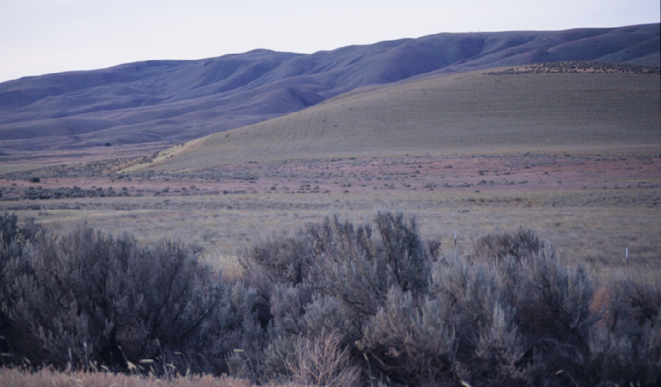

The vegetation along the Rattlesnake Hills west of Highway 241 is much drier and has been impacted by frequent fires and intense livestock grazing over a long period. Cheat grass along with other invasive noxious weeds dominate much of the area vegetation. The shrub vegetation in this area has been nearly eliminated.

Figure 38. Vegetation on the Arid Lands Ecology Reserve changed significantly following
the wildfire of 2000.
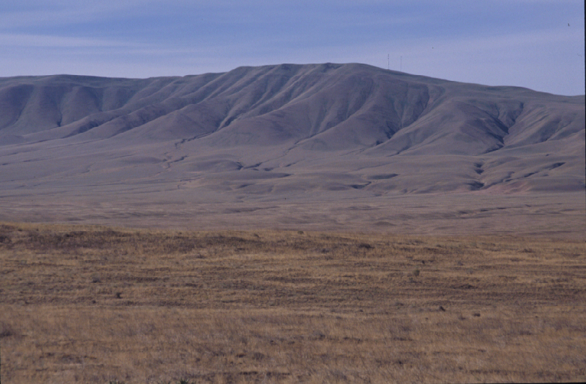

Topography
The most prominent feature is Rattlesnake Hills, an east-west trending range located south of YTC in Yakima and Benton counties. The highest point is Rattlesnake Mountain 3,524 ft. (1,074m) located on the east end of the range and the lowest elevation of 400 ft. (122m) along the Columbia River. The south facing slopes of the Rattlesnake Hills extend to the Yakima River and the north slopes drop into Black Rock Valley (Figure 39). The east slopes of Rattlesnake Mountain rises abruptly from the Cold Springs Valley at an elevation of approximately 450 ft. (137m).
Saddle Mountain is a prominent east-west ridge rising to 822 ft (250m) on Wahatis Peak sloping down to the Columbia River.
The area for the most part is gentle slopes with shallow ravines. Cold Springs Valley is a broad Valley extending to the Columbia River from the tow of Rattlesnake Mountain. The landscape is nearly flat and in places there are significant areas of sand dunes.

Figure 39. The Rattlesnake Hills east of Highway 241 at Wautoma.
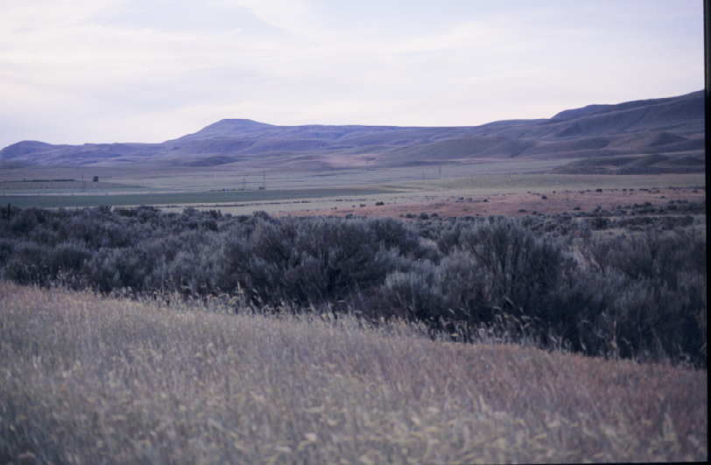

Size and Continuity
The size of the study area totaled 699 mi.² (1748 km²). Topographically the site scored well as potential pronghorn habitat. The top three categories showing less than 10º slope totaled 601 mi² (1557 km²) representing about 86% of the study area. It is estimated that about 93% of the area or 649 mi² (1681 km²) meets the minimum topography requirement considered as potential habitat for pronghorn in this area.
In terms of the vegetation potential approximately 673 mi² or 96% of the area is in the shrub land (4) and grassland/herbaceous (5) vegetation categories. While much of the vegetation has changed since recent wildfires in the area the long term potential is still favorable. Recovery of the desirable shrub community may not be possible without some rehabilitation effort. The natural recovery of vegetation in the area will still provide sufficient forage to meet at least the minimum needs of pronghorn. The area is of sufficient size and represents the largest block of existing potential habitat in Washington.

Water
Water is well distributed except in Central Hanford, west Rattlesnake Hills and Wahluke Slope. The Rattlesnake Mountain has ample water at the mid elevations where there are numerous and well distributed springs. The lower elevations of ALE reserve are dry except for the north portion. Cold Creek is a permanent stream that provides a reliable source of water in the northern portion of the ALE and the Columbia River provides water along its course.

Climate
This area lies in the heart of the Columbia Basin and is the driest and hottest area of eastern Washington. The average maximum temperature (Table 24) is 63.9ºF and the average minimum temperature is 38.6ºF. Temperature extremes are highest during the months of June – August reaching well above 100ºF. The coldest temperatures occur during the months of January and February (Figure 40). Climate at the higher elevations are quite different from the valley

Table 24. BENTON CITY 2 NW, WASHINGTON (450628)
Period of Record Monthly Climate Summary 6/ 1/1948 to 1/31/1964
 | Jan | Feb | Mar | Apr | May | Jun | Jul | Aug | Sep | Oct | Nov | Dec | Annual
Average Max. Temperature (F) | 37.3 | 45.9 | 54.5 | 65.6 | 73.8 | 81.6 | 89.0 | 87.8 | 79.1 | 61.9 | 49.9 | 40.7 | 63.9
Average Min. Temperature (F) | 21.0 | 27.3 | 31.2 | 36.8 | 44.9 | 51.2 | 55.2 | 53.7 | 47.8 | 36.8 | 31.5 | 26.2 | 38.6
Average Total Precipitation (in.) | 1.02 | 0.95 | 0.75 | 0.53 | 0.74 | 0.76 | 0.15 | 0.15 | 0.29 | 0.89 | 0.95 | 1.01 | 8.19
Average Total SnowFall (in.) | 4.3 | 1.7 | 0.3 | 0.0 | 0.0 | 0.0 | 0.0 | 0.0 | 0.0 | 0.0 | 0.3 | 2.5 | 9.0
Average Snow Depth (in.) | 1 | 0 | 0 | 0 | 0 | 0 | 0 | 0 | 0 | 0 | 0 | 0 | 0
Percent of possible observations for period of record.
Max. Temp.: 91.6% Min. Temp.: 91.6% Precipitation: 98.6% Snowfall: 98.3% Snow Depth: 97.6%
Western Regional Climate Center, wrcc@dri.edu

Figure 40. Maximum and minimum temperature extremes Benton City, Benton Co., WA.
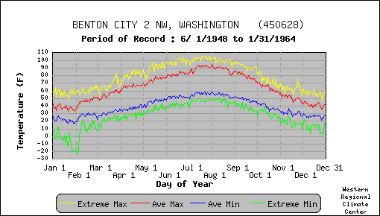
lowlands. The crest of Rattlesnake Mountains maintains cooler temperatures and higher precipitation levels than the bottom lands (WRCC 2005). Most precipitation occurs during the winter months of November through February, with the least amount of precipitation recorded in August. Annual snow fall accumulation averages 9.0 inches (22.9cm) annually. Snow depths are not a concern for this area (Figure 41) where there is rapid snow melt and moderate temperatures. Overall climatic conditions in this area are quite moderate and present no concern for winter survival of pronghorn.

Figure 41. Daily Average and Extreme snow depths at Benton City, Benton Co., WA.
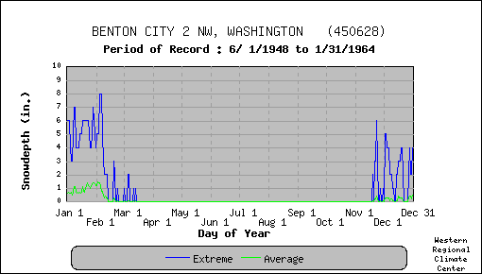

Limitations
Public access onto the ALE Reserve and Central Hanford is restricted. Currently there is no hunting allowed on either of these two areas. A comprehensive plan for the Hanford Reach National Monument is considering controlled hunting on the ALE to manage elk populations (USFWS 2005).
The wildfire of 2000 on ALE has had a negative impact on the wildlife of the area. The dramatic change in vegetation composition on this site reduces the value of the habitat for pronghorn. Much of the ALE has burned repeatedly over time. The vegetation following the wildfires result in fewer desirable shrub and herbaceous plant species and an increase in noxious weeds and other undesirable exotic invaders. Repeated range fires will no doubt occur as highly volatile fuels such as cheat grass become increasingly present.
Fire and livestock grazing has also impacted the character of vegetation on the Rattlesnake Hills outside the ALE. The amount of shrub vegetation has been significantly reduced and occurs in isolated patches. Cheat grass and alien annual forbs such as tumble mustard (Sisymbrium altissimum), Russian thistle (Salsola kali) and redstem filaree (Erodium cicutarium) are significant invaders, especially where soils have been disturbed and native vegetation removed or burned. Noxious weeds such as knapweed (Centaurea spp.), white top (Cardaria draba), salt cedar (Tamarix parviflora) diminish the value of habitat and are particularly troublesome.
There is an ongoing conflict concerning elk and crop damage between agriculture producers, USFWS, WDFW, Tribes and DOE (USFWS 2005). The introduction of pronghorn would no doubt exacerbate this situation. While pronghorn are generally less destructive to agriculture, pronghorn damage to crops such as alfalfa and wheat is well documented throughout their range (O’Gara and Yoakum 2004). There is no documentation of pronghorn damage to orchards or vineyards. The areas most vulnerable to crop damage are the isolated alfalfa and wheat production lands bordering the range lands within the Rattlesnake Hills and the agricultural lands in Yakima Valley, Black Rock Valley and Mattawa.
There are several state highways that traverse the area. Highway 24, 240 and 241 are high speed, hard surface roads that maintain low to moderate volume of traffic. Highway 240 is the major commute route from the Tri Cities to Central Hanford and beyond. Highway 240 crosses the Rattlesnake Hills and has a relatively low volume of use. All of the highways have fenced right of ways that may present an obstacle for movement by pronghorn. Highway 241 has a history of road mortalities for elk crossing from the ALE to Central Hanford.
Range land fences can be an obstacle to free movement of pronghorn. Rangeland fences in this area should not pose a problem; however, where fences constructed of woven wire occur they are effective barriers to pronghorn.
Livestock will compete with pronghorn for forage and water. The concentration of livestock at watering places may be an effective deterrent to use of that source by pronghorn during the most demanding season.

Habitat Scores and Ranking
The field assessment model resulted in an overall score of 3.93, which placed the area in the lower end of the fair category (Table 25). The best habitat remaining in this area is on Rattlesnake Mountain. The results of the devastating fire in 2000 resulted in a dramatic change in vegetative cover over a large area that is not accurately reflected in the GIS modeling effort.
The sub areas of Hanford, Wahluke, and the west end of the Rattlesnake Hills scored poorly, while Cold Creek, ALE and the middle portion of the Rattlesnake Hills scored in the lower end of the fair range even though this was the area where the fire occurred in 2000. The lack of shrubs and the increase in cheat grass and other exotic invasive weed species is on going.

Table 25. Rattlesnake Hills, Arid Lands Ecology Reserve, Hanford, Wahluke Slope
pronghorn habitat field evaluation scoring summary
Criteria  Location | Vegetation  Forbs | Vegetation  Shrubs | Vegetation  Grass | Vegetation  Quantity | Vegetation  Height | Water  Distribution | Topography | Size and  Continuity | Land  Ownership  and Use | Limitations &  Obstructions | Total Score
1. T11N, R21-23; T12N, R23E West end | .2 | .3 | .3 | .5 | .4 | .3 | .5 | .4 | .5 | .5 | 3.9
2. T13N, R23-24E Cold Creek | .3 | .35 | .3 | .6 | .5 | .4 | .4 | .3 | .6 | .4 | 4.2
3. T11N, R22-23E; T10N, R24E; T12N,  R23-24E Rattlesnake Hills middle | .2 | .3 | .3 | .5 | .5 | .5 | .4 | .5 | .4 | .5 | 4.1
4. T10N, R26-27E; T11N, R25-27E;  T12N, R25E Arid Lands Ecology Reserve | .3 | .2 | .2 | .5 | .4 | .5 | .3 | .7 | .6 | .5 | 4.2
5. T10N, R27-28E; T11N, R27-28E;  T12N, R25-28E; T13N, R25-28E; T14N,  R25-28E; T14N, R26-28E Hanford | .3 | .3 | .2 | .5 | .5 | .4 | .6 | .3 | .1 | .2 | 3.4
6. T14N, R25-28E; T15N, R26-28E  Wahluke | .3 | .3 | .2 | .5 | .3 | .4 | .4 | .3 | .6 | .5 | 3.8
Total | 1.6 | 1.75 | 1.5 | 3.1 | 2.6 | 2.5 | 2.6 | 2.5 | 2.8 | 2.6 | 23.6
Crieteria Score | .27 | .29 | .25 | .52 | .43 | .42 | .43 | .42 | .47 | .43 | 3.93

The GIS model yielded a normalized weighted rating of 7.21 (Appendix D6), which ranked this area the highest of all 8 areas surveyed. As explained earlier this model was based on vegetation classification prior to the 24 Command Fire and as a result provides a false vegetative rating than conditions now present. The highest scores recorded under both habitat evaluation models occurred in the ALE and Middle Rattlesnake Hills sub areas.
Based on the 699 mi.² (1748 km²) of potential pronghorn habitat and a density of .5/mi², it is estimated that a population of approximately 300 – 350 animals could be established here.

Moses Coulee, Badger Mt., Mansfield

Location/Landownership
The Moses Coulee, Badger Mt., Mansfield area includes that portion of Douglas County south of Highway 2 from Orando to Farmer, Moses and Grand coulees east and south of Highway 172, and from Sims Corner directly east to Banks Lake; and that portion of Grant County north of Highway 28 and west of Highway 17 (Appendix A). The area described is mostly private lands with relatively small areas of state and federal ownership. The largest blocks of public land are administered by BLM on Badger Mountain, Moses Stool and Sulphur Canyon. State owned lands are administered by the DNR and WDFW (Sagebrush Flats Wildlife Area) in the Sagebrush Flat area of Moses Coulee. The primary use of the lands in this area is for farming, mainly dry land wheat and livestock production. This is a rural area and agriculture is a major economic industry.

Vegetation
The historical vegetation of this area was shrub-steppe habitat (Daubenmire 1970). Today, the shrub steppe has largely been converted to agriculture while the vegetation in the shallow lithosols soil in the channel scablands remains shrub steppe/grassland. The quality of shrub steppe habitat, however, has been impacted by livestock grazing, introduced vegetation, and wild fires. The greatest change in the remaining shrub steppe habitat from historic conditions is the reduction of bunchgrass cover in the understory, invasion of exotic plants, and an increase in sagebrush cover (NPCC 2004). A significant amount of former shrub steppe has now changed to mostly grassland with a relatively sparse shrub component. Fire and intense livestock grazing is probably responsible for this condition. Perennial grasses have been replaced by cheatgrass (Bromus tectorum), thread-leaved sedge (Carex filifolia), and/or gray rabbitbrush (Chrysothamnus nauseosus). In recent years, noxious weedy species such as diffuse knapweed (Centaurea diffusa) and Dalmation toadflax (Linaria dalmatica) have spread through this area (NPCC 2004). Table 26 shows the land cover classes for this area and their approximate percentage makeup from the National Land Cover data base (NLCD 2000).
The Badger Mountain sub area (Figure 42) habitat is shrub dominated with a mixture of perennial grasses and forbs. Higher annual moisture provides a healthy shrub community. Some of the draws and canyons on north facing slopes have a well developed shrub component of mostly big sagebrush, bitterbrush, and snowberry. The shrub height exceeds desirable limits for pronghorn in some locale. The Ponderosa pine tree line extends into the shrub community above the 3,300 ft. (1000m) elevation. The drainages with perennial water form a rich riparian zone. Much of this area can be described as typical mule deer habitat and would provide summer habitat for pronghorn. Climatic conditions during normal winters would require movements to lower elevations.
Some big sagebrush stands in deeper soils of the scablands are above the maximum height to be classified as good pronghorn habitat (Figure 43). The Lynch Creek Coulee/Beezley Hills area is now primarily grasslands with the removal of shrubs for farming. The CRP lands in the areas are primarily crested wheat grass plantings (Figure 44).
The remaining natural vegetation in this area is impacted by mans activities. Most of the productive sites have been converted for agricultural production, livestock grazing, or bisected by roads, rural developments and many other permanent changes. The potential pronghorn habitats occur in patches (Figures 45).

Table26. NLCD Land Cover Classes in the Moses Coulee, Badger Mt., Mansfield
Area by sub area.
Classes (mi²) | Sub  Area  1 | Sub  Area 2 | Sub  Area 3 | Sub  Area  4 | Sub  Area  5 | Sub  Area  6 | Sub  Area  7 | Area  Total  (mi²) | %
Bare (rock/sand/clay), com./industrial/trans.,  deciduous/evergreen/or mixed forest, emergent herbaceous wetlands, urban/recreation. grass, open water, row crops, high & low intensity residential, orchards & vineyards. (0) | 0.30 | 0.88 | 2.28 | 0.13 | 0.54 | 0.28 | 2.84 | 7.25 | 1.49%
Pasture/hay, woody wetlands, fallow, small grain, transitional. (1) | 12.36 | 6.60 | 2.61 | 6.72 | 3.10 | 7.27 | 9.69 | 48.35 | 9.96%
Exotic grasses & weeds, stiff sagebrush. (2) | 0.0 | 0.00 | 0.0 | 0.0 | 0.00 | 0.0 | 0.01 | 0.01 | 0.0%
Shrub steppe on shallow soils, native grasslands with herbaceous species. (3) | 0.07 | 0.02 | 0.21 | 1.87 | 0.02 | 0.02 | 0.13 | 2.34 | 0.48%
Grassland/herbaceous. (4) | 74.21 | 51.18 | 38.05 | 31.17 | 50.69 | 32.50 | 70.28 | 348.08 | 71.69%
Shrubland. (5) | 14.35 | 10.87 | 17.83 | 18.67 | 5.67 | 4.37 | 7.77 | 79.53 | 16.38%
Grand total | 101.29 | 69.55 | 60.98 | 58.56 | 60.02 | 44.44 | 90.72 | 485.56 | 100.00%

Figure 42. Duffy Creek on Badger Mountain, Douglas County, WA.
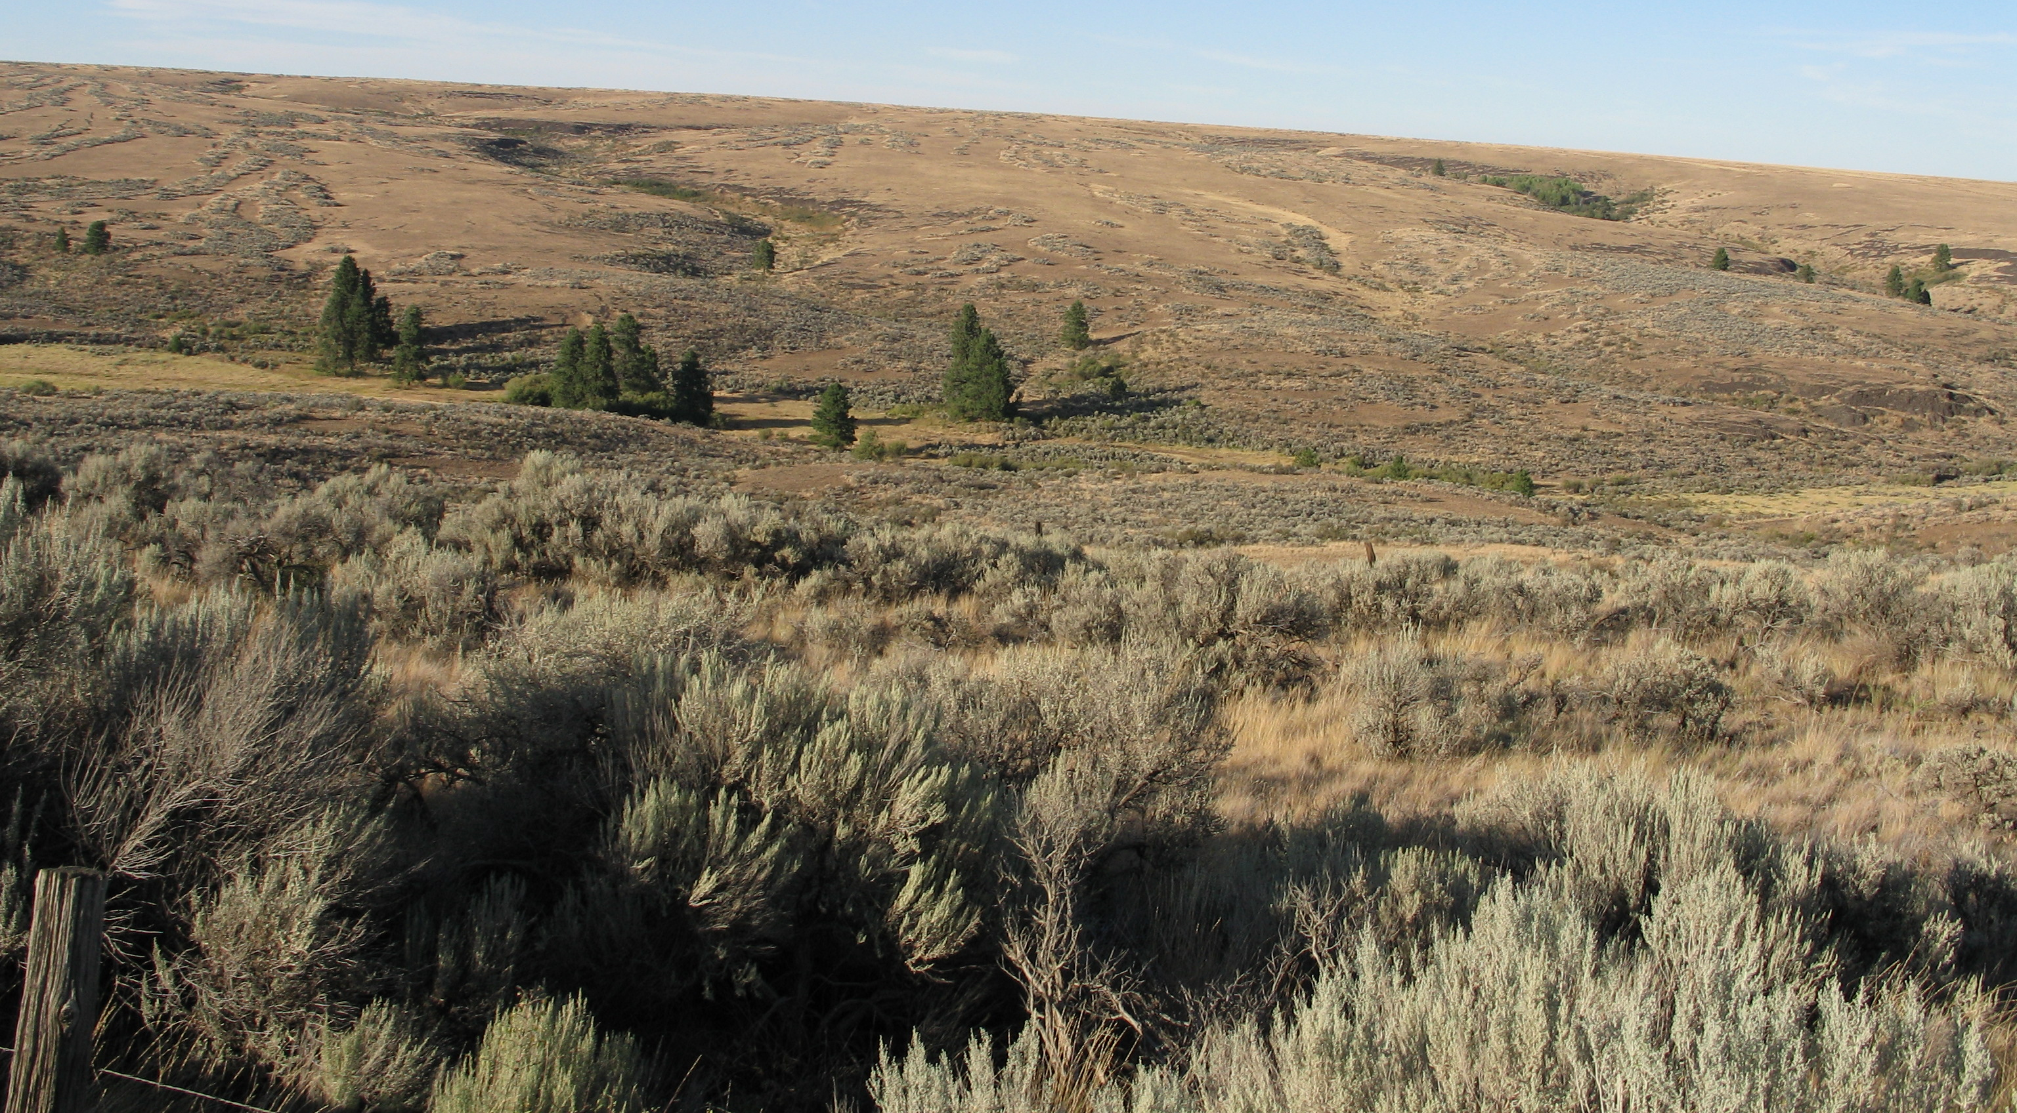

Figure 43. Dense and high sagebrush in Moses Coulee just north of Highway 2.
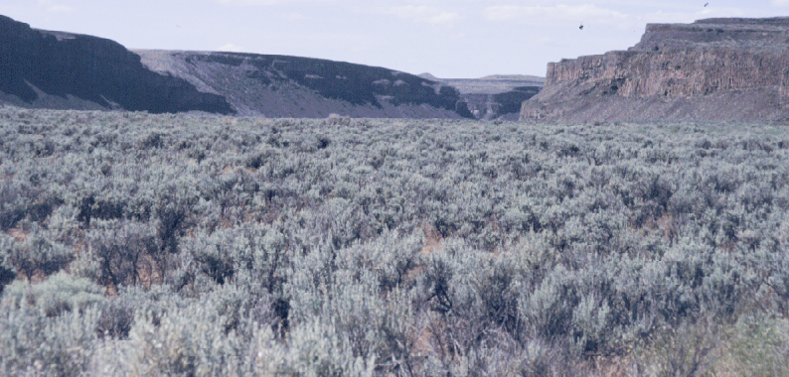

Figure 44. Sagebrush Flats area across Rattlesnake Creek, Douglas County, WA.
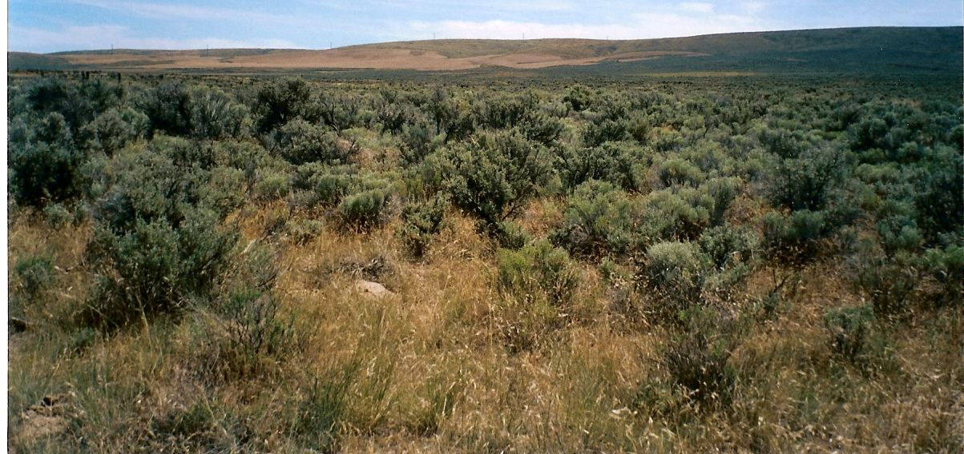

Topography
The elevation rises abruptly from 700ft. (215m) on the Columbia River to 4,100ft. (1,250m) on Badger Mountain. Further east is a large plateau region bisected by Moses Coulee. Here the landscape has the appearance of rolling hills rather than mountains. Some of the channeled areas are rough with exposed basalt forming a series of ledges and steps to the bottom. Soils are mostly shallow and rocky except where farming has been developed.
The canyon walls of Moses Coulee are very steep with sheer cliffs and extremely rocky surfaces and talus slopes. Some areas along the length of Moses Coulee are effective barriers to movement by ungulates. The same condition is also present along the Lower Grande Coulee.

Size and Continuity
The size of the study area totaled 486 mi.² (1259 km²). Topographically the site scored well as potential pronghorn habitat. The top three rating categories showing less than 10º slope totaled 334 mi² (865 km²) representing about 70% of the study area. It is estimated that about 84% of

Figure 45. Moses Coulee agricultural fields near McCarteney, Douglas Co., WA.
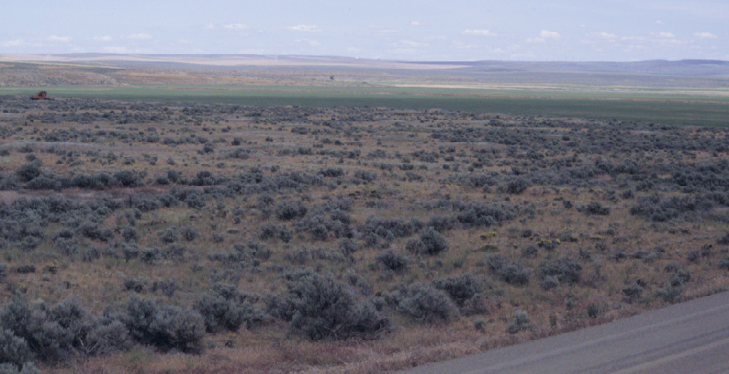

the area or 402 mi² (1041 km²) meet the minimum topography requirement considered as potential habitat for pronghorn in this area.
In terms of the vegetation potential approximately 427 mi² or 88% of the area is in the shrub land (4) and grassland/herbaceous (5) vegetation categories
This area lacks continuity even though it represents a sizeable area. The habitat is severely disconnected because of dry land wheat farming and other obstructing man made restrictions combined with natural barriers.

Water
Surface water is available at the higher elevations on Badger Mountain and along the bottom of Moses Coulee. In the plateau regions, water is less available and poorly distributed. The Beezley Hills is mostly dry with only a few springs offering limited surface water.

Climate
This area is in the rain shadow of the Cascade Mountain Range, and is described as arid to semiarid with low levels of annual precipitation, cold winters and hot, dry summers. Precipitation can vary widely in relation to elevation and area. There is a significant difference in climate in Ephrata (Table 27) compared to Waterville (Table 28) in the northwestern Douglas County. The Ephrata weather station receives an average of 8.04 inches of precipitation annually, mostly during the winter months, while Waterville records an average of 11.21 inches annually. Another significant difference is the annual snow fall between the two stations. Waterville receives an average of 42 inches while Ephrata records an average total snowfall of 17.9 inches (WRCC 2005).
Temperatures vary widely depending on location. Summertime air temperatures can exceed 100 ºF for several days each year. July has the highest average temperature while the lowest average minimum temperatures occur in January. Winter temperatures can drop below 0 ºF. The minimum extreme temperatures (Figure 46) are well below zero degrees F and can occur December through February. Snow accumulations can be significant at times (Figure 47), although snow depths usually are minimal except at the higher elevations and in the northern portions of the area.

Table 27. EPHRATA, WASHINGTON (452609)
Period of Record Monthly Climate Summary 1/ 1/1931 to 3/25/1971
 | Jan | Feb | Mar | Apr | May | Jun | Jul | Aug | Sep | Oct | Nov | Dec | Annual
Average Max. Temperature (F) | 34.3 | 42.2 | 54.1 | 65.0 | 74.7 | 81.9 | 90.2 | 88.0 | 79.3 | 64.8 | 46.7 | 37.3 | 63.2
Average Min. Temperature (F) | 21.2 | 26.5 | 33.2 | 40.5 | 48.4 | 55.6 | 61.6 | 59.9 | 52.6 | 42.1 | 31.3 | 25.0 | 41.5
Average Total Precipitation (in.) | 0.98 | 0.71 | 0.60 | 0.62 | 0.68 | 0.77 | 0.22 | 0.27 | 0.42 | 0.64 | 1.00 | 1.16 | 8.04
Average Total SnowFall (in.) | 6.1 | 2.5 | 0.6 | 0.0 | 0.0 | 0.0 | 0.0 | 0.0 | 0.0 | 0.1 | 1.8 | 6.7 | 17.9
Average Snow Depth (in.) | 3 | 2 | 0 | 0 | 0 | 0 | 0 | 0 | 0 | 0 | 0 | 1 | 0
Percent of possible observations for period of record.
Max. Temp.: 95.2% Min. Temp.: 95.2% Precipitation: 95.4% Snowfall: 95.1% Snow Depth: 93.9%

Table 28. WATERVILLE, WASHINGTON (459012)
Period of Record Monthly Climate Summary, 1/ 3/1931 to 3/31/2005
 | Jan | Feb | Mar | Apr | May | Jun | Jul | Aug | Sep | Oct | Nov | Dec | Annual
Average Max. Temperature (F) | 30.9 | 36.7 | 46.2 | 57.5 | 66.3 | 73.3 | 82.2 | 81.2 | 72.4 | 58.3 | 41.0 | 32.1 | 56.5
Average Min. Temperature (F) | 15.8 | 19.9 | 27.2 | 34.3 | 41.4 | 47.5 | 52.8 | 52.4 | 45.1 | 35.0 | 25.3 | 18.2 | 34.6
Average Total Precipitation (in.) | 1.42 | 1.00 | 0.82 | 0.71 | 0.94 | 1.04 | 0.34 | 0.53 | 0.52 | 0.73 | 1.47 | 1.69 | 11.21
Average Total SnowFall (in.) | 11.5 | 6.8 | 2.7 | 0.5 | 0.0 | 0.0 | 0.0 | 0.0 | 0.1 | 0.4 | 6.1 | 14.1 | 42.2
Average Snow Depth (in.) | 6 | 4 | 1 | 0 | 0 | 0 | 0 | 0 | 0 | 0 | 1 | 4 | 1
Western Regional Climate Center, wrcc@dri.edu

Figure 46. Maximum and minimum temperature extremes Ephrata, Grant Co., WA.
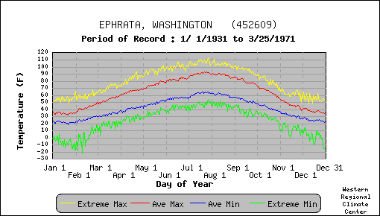
Figure 47. Daily Average and Extreme snow depths at Ephrata, Grant Co., WA.
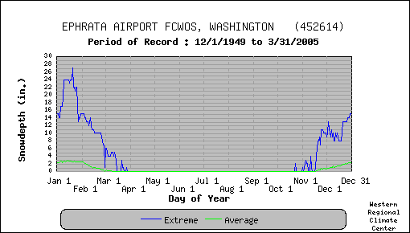

Limitations
The potential pronghorn habitats in this area are severely fragmented and often occur in narrow strips that are adjacent to dry land wheat or irrigated crop production areas. Some potential habitats are completely isolated and encircled by dry land wheat fields. Travel corridors are narrow or beset with obstacles. Some potential habitat areas, such as Badger Mountain and the Mansfield area would provide good summer range for pronghorn but in winter snow depths would require animals to migrate to lower elevations. Travel corridors to accomplish seasonal movements are mostly bisected by dry land wheat production areas, steep canyon walls (lower Moses Coulee and Grand Coulee), fences and highways.
Water is well distributed and available on Badger Mountain but in the plateau region and the Beezley Hills areas surface water is not as widespread. The Beezley Hills is particularly dry with only a few springs and no impoundments or streams. This area can provide winter range for pronghorn but is not otherwise considered to be a high potential habitat area for pronghorn.
There are several state and county highways that bisect or border the area. These hard surface roads can be an obstacle to animal movement and result in vehicle/animal collisions and mortalities. The most vulnerable areas would be along highway 2.
Fencing can be an obstacle to pronghorn depending upon design and construction. Woven wire fences present a barrier to pronghorn, while barbed wire fences will allow easy crossing dependent upon the height of the lower strand of wire. Fences may be problematic along highway right of ways in this area.

Habitat Evaluation Score
The field evaluation score for this area was 4.05 (Table 29) and ranked 6th overall. The score places this area in the upper end of the poor habitat rating. The major problem identified was the lack of quality and quantity of good pronghorn forage. The most limiting factors identified were the size and continuity of the habitat and conflicting land uses. The GIS model habitat scoring resulted in a normalized weighted rating of 6.83 (Appendix D4). Overall, the site ranked number 5 based on the estimated 486 mi.² (1259 km²) of potential pronghorn habitat and an estimated animal density of .5/mi², it is likely that a population of approximately 250 – 300 animals could be established.

Table 29. Moses Coulee/Beezley pronghorn field habitat evaluation scoring summary
Criteria  Location | Vegetation Forbs | Vegetation Shrubs | Vegetation  Grass | Vegetation  Quantity | Vegetation  Height | Water  Distribution | Topography | Size and  Continuity | Land Owner –ship & Use | Limitation &  Obstructions | Total Score
1. T21N, R23-24E Beezley | .2 | .3 | .2 | .5 | .45 | .3 | .6 | .4 | .3 | .4 | 3.65
2. T23N, R24-25E Sagebrush Flat | .4 | .5 | .3 | .5 | .5 | .3 | .6 | .5 | .5 | .5 | 4.6
3. T22N R22-23E; T23N, R23E Airplane  Canyon | .4 | .4 | .3 | .5 | .5 | .5 | .2 | .4 | .5 | .5 | 4.2
4. T23N, R22E; T24N, R21-22E Duffy  Creek | .5 | .5 | .3 | .5 | .5 | .5 | .3 | .3 | .45 | .45 | 4.3
5. T25N, R25-27E; T24N, R25E Jameson  Lake | .3 | .4 | .3 | .5 | .4 | .4 | .4 | .3 | .3 | .4 | 3.7
6. T26N, R25-27E; T27N, R26-27E  Mansfield | .4 | .3 | .3 | .6 | .4 | .4 | .5 | .3 | .4 | .5 | 4.1
7. T21N, R25-26E; T22N, R26E, T23N,  R26E; T24N, R26-27E; T25N, R27-28E;  T26N, R28E. Grand Coulee west | .3 | .4 | .3 | .5 | .45 | .4 | .25 | .2 | .3 | .5 | 3.6
Total | 2.5 | 2.8 | 2 | 3.8 | 3.2 | 2.8 | 2.85 | 2.4 | 2.75 | 3.25 | 28.5
Criteria Score | .36 | .40 | .29 | .54 | .46 | .40 | .41 | .34 | .39 | .46 | 4.05

Grand Coulee, Wilson Creek, Black Rock Coulee

Location/Landownership
The Grand Coulee/Wilson Creek area is located in Grant and Lincoln counties east of Highway 17, south of Highway 2, west of Highway 21, and north of Highway 28 including lands in Townships 21 and 22N, Range 29E south of Highway 28 (Appendix A). Major drainages include Grand Coulee, Dry Coulee, Wilson Creek, Crab Creek, Black Rock Coulee, and the southern terminus of Marlin Hollow and Lake Creek.
The majority of land in this area is in private ownership and used primarily for dry land wheat production or livestock grazing. Most of the deep soil sites have been converted to agriculture use. The channeled scablands provide the remaining shrub steppe vegetation. In the area south of Coulee City and the two townships south of Wilson Creek and Highway 28 there is a significant amount of State owned lands managed by the Department of Natural Resources and Washington State Parks. Some federal lands administered by the Bureau of Land Management and Bureau of Reclamation are also found in this area.
The most promising pronghorn habitat was found on the upper reaches of Dry and Trail Lake coulees, the Wilson Creek channel, Pacific/Sullivan lakes area, and the Black Rock Coulee area. All of these areas are surrounded by dry land or irrigated crop farming.

Vegetation
Dry Coulee-Arbuckle Draw is mostly shrub/grasslands (Figure 48). In places there are healthy stands of big sagebrush (Artemesia tridentata) and bitterbrush (Purshia tridentata); however, a significant change in vegetative composition has occurred compared to historical conditions.
Wilson Creek, Canniwai Creek, Martin Hollow and Lake Creek are channel scablands that maintain shrub steppe with an under story of perennial grasses such as blue bunch wheatgrass (Agropyron sp), needle and thread grass (Stipa comata), basin wild rye (elymus spp), Idaho fescue (Festuca idahoensis), and blue grass (Poa segunda) (Figure 49 & 50). The width of the shrub-steppe habitat varies from 1 mile to more than six miles in places. The Lakeview Ranch area is shrub steppe habitat with good topographical features; however further south and east the topography becomes very broken within the Lake Creek channel (Figure 51).

The vegetation here is similar to the Swanson Lakes area except that this area is slightly lower in elevation with a dryer environment. Livestock grazing, fire and invasion of exotic weeds has changed the vegetative character of the area. Cheat grass is the major invader along with other exotic invaders such as tansy mustard, lambs quarter, Russian thistle, knapweed, and star thistle. CRP lands have been planted with exotic wheat grasses, slowing the recovery of native species.
The channel scablands south of Crab Creek is an extension of Wilson and Canniwai channels in T21 & 22N, R29E. The Black Rock Coulee enters from the east. This area has a significant block of shrub steppe habitat that is relatively intact. Big sagebrush, stiff sagebrush, rabbitbrush and bitterbrush are the dominant shrubs. An understory of perennial grasses and forbs are present. The Black Rock Coulee area is the largest block of sagebrush habitat in the area forming an area of approximately 72 mi² (6 X 12 miles) (Figure 52).

Figure 48. The sagebrush grassland habitat in the Arbuckle Draw area
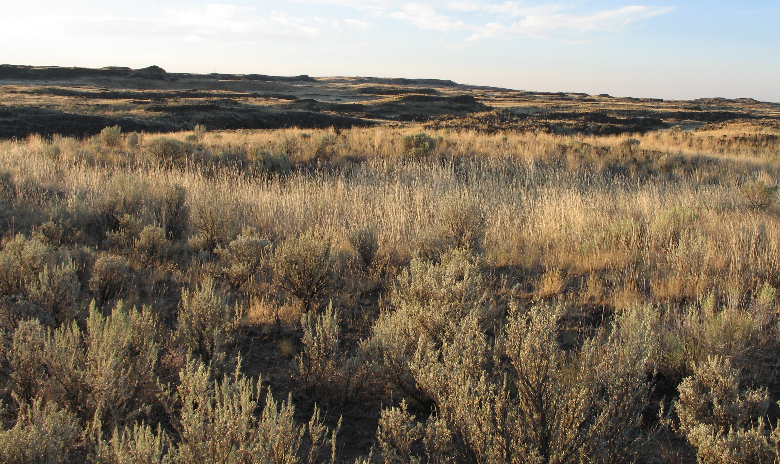

Figure 49. CRP along Wilson Creek (foreground) looking south east off Road 29 NE.
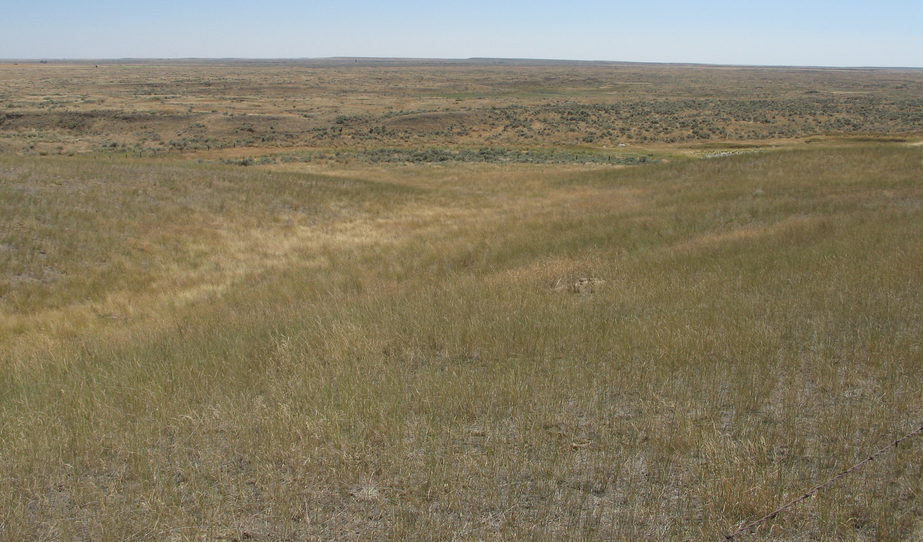

Figure 50. Lakeview Ranch area looking northwest towards Pacific Lake on BLM lands.
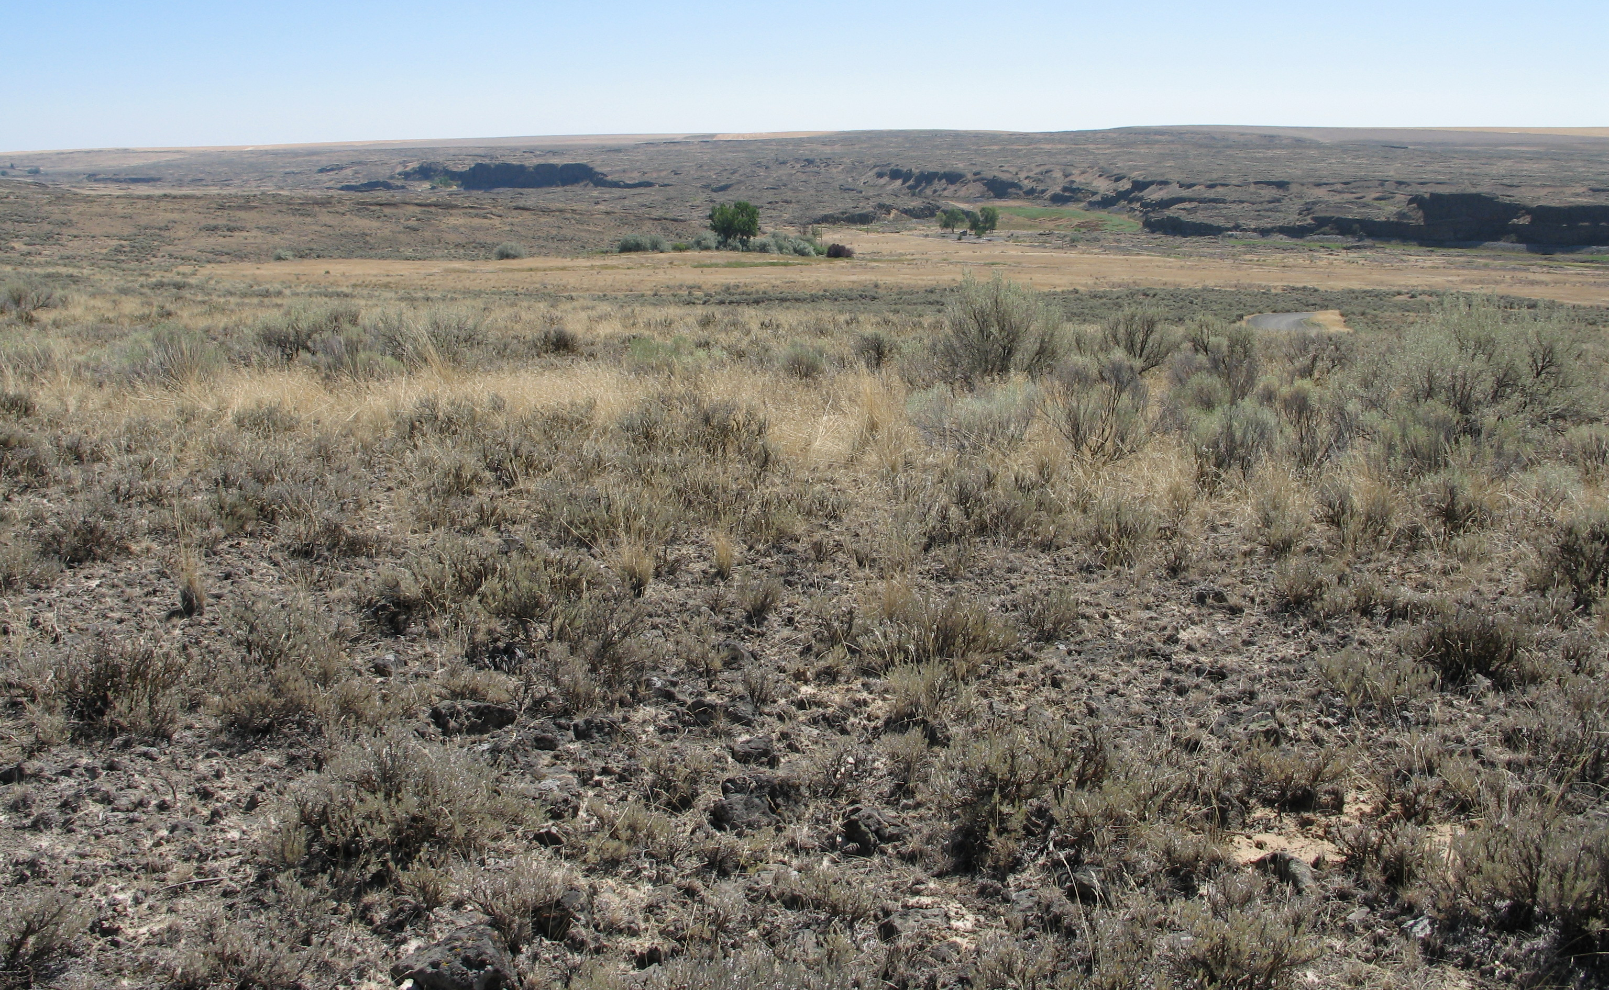

Figure 51. Lakeview Ranch on the extreme left looking southwest
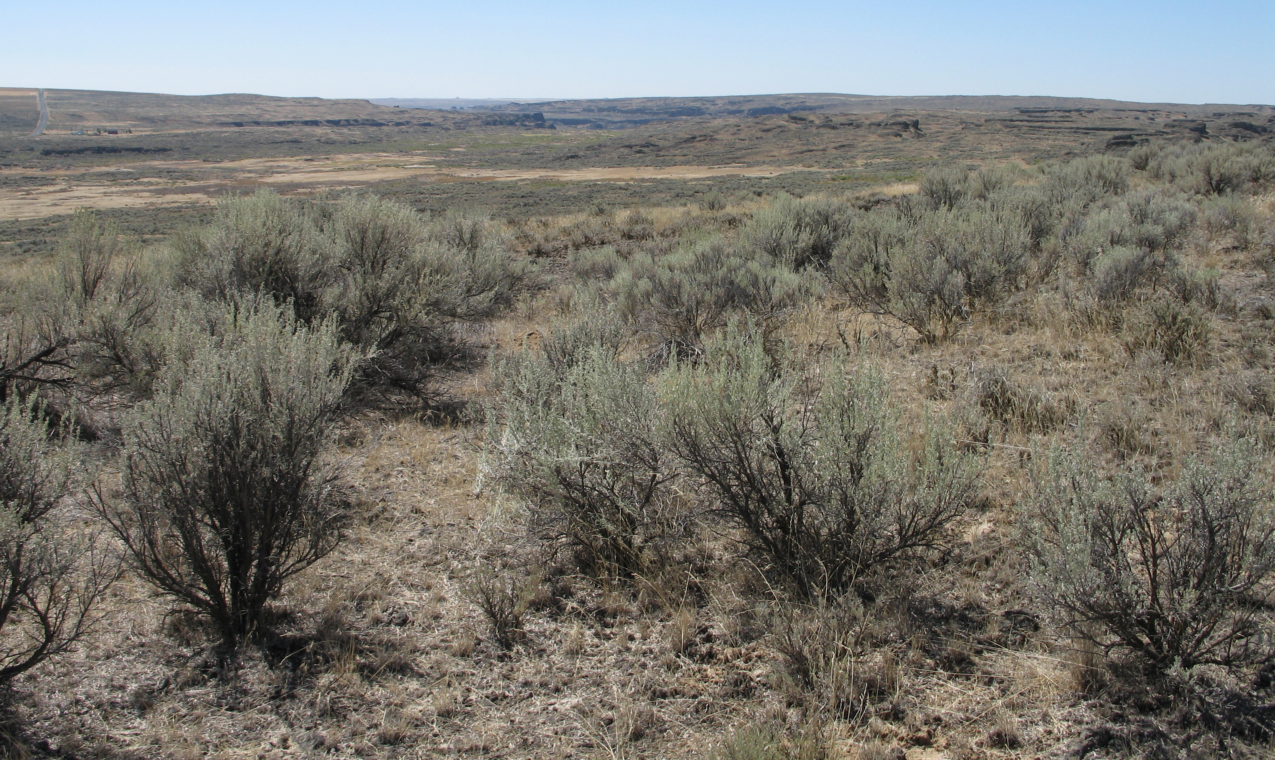

The percentage of vegetative land cover in the area is shown in Table 30. The majority (63%) of the area maintains shrubland of varying species composition, quality and density. Shrub height is of little concern in this area although in some places it reaches the upper limits.

Topography
Grand Coulee is the western boundary of this area and is the largest of many. Immediately south of Coulee City is an area that is largely public lands including Dry, Hudson, and Trail Lake coulees and Arbuckle Draw. This is typical channeled scabland with exposed basalt walls forming cliffs and small ledges. The sub-channels are numerous and vary in width and depth. Much of the area is extremely rough and broken but not mountainous. Arbuckle Draw is flatter and has an open aspect.
The elevation varies from about 1,400ft (427m) in Black Rock Coulee to 2,100ft (640m) on

Figure 52. Black Rock Coulee area south of Wilson Creek.
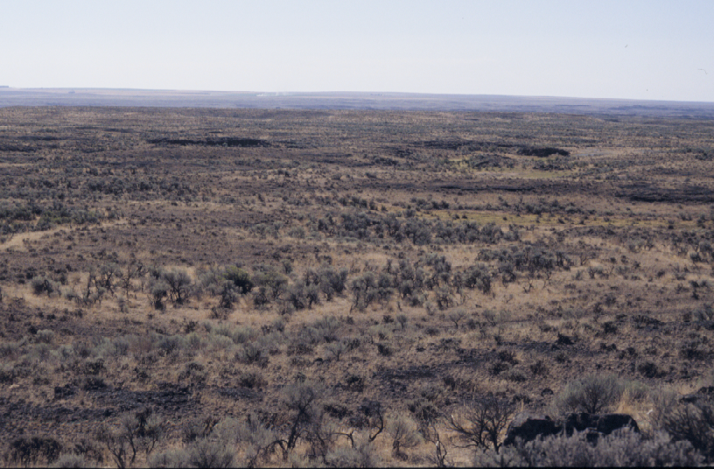

Wilson Creek. The area has a gentle slope from the northeast to the southwest. The general appearance of the area is of rolling hills with terraced basalt intrusions along the main and side channels.

Size and Continuity
The size of the study area totaled 630mi.² (1632 km²). The top three topography rating categories showing less than 10º slope totaled 588 mi² (1523 km²) representing about 93% of the study area. It is estimated that about 97% of the area or 612 mi² (1585 km²) meet the minimum topography requirement considered as potential habitat for pronghorn in this area.
The vegetation potential is approximately 427 mi² or 68% in the shrub land (4) and grassland/herbaceous (5) vegetation categories. The potential for this area based on vegetation and topography values alone is adequate to support a population of 350 – 400 pronghorn.
One of the major concerns for the area is the fragmented nature of the habitat. The connectivity between habitat areas is compromised by highways, railroad, irrigation canals, crop production areas and existing natural barriers.
Wilson Creek, Canniwai Creek, Martin Hollow and Lake Creek channels flow into Crab Creek between the communities of Wilson Creek and Odessa. All of these channels have shallow soils

Table 30. NLCD Land Cover Classes in the Grand Coulee/Wilson Creek Area.
Classes (mi²) | Sub  Area  1 | Sub  Area  2 | Sub  Area  3 | Sub  Area  4 | Sub  Area  5 | Sub  Area  6 | Sub  Area  7 | Area  Total  (mi²) | %
Bare (rock/sand/clay), com./industrial/trans.,  deciduous/evergreen/or mixed forest, emergent herbaceous wetlands, urban/recreation grass, open water, row crops, high & low intensity residential, orchards & vineyards. (0) | 2.77 | 0.84 | 0.25 | 0.70 | 2.30 | 0.40 | 1.47 | 8.73 | 1.38%
Pasture/hay, woody wetlands, fallow, small grain, transitional. (1) | 34.54 | 13.94 | 55.75 | 42.43 | 10.73 | 20.36 | 15.82 | 193.57 | 30.71%
Exotic grasses & weeds, stiff sagebrush. (2) | 0.04 | 0.02 | 0.00 | 0.00 | 0.01 | 0.00 | 0.02 | 0.09 | 0.02%
Shrub steppe on shallow soils, native grasslands with herbaceous species. (3) | 0.09 | 0.04 | 0.09 | 0.17 | 0.24 | 0.02 | 0.18 | 0.83 | 0.13%
Grassland/herbaceous. (4) | 79.59 | 46.06 | 30.89 | 56.81 | 54.17 | 47.24 | 84.78 | 399.54 | 63.39%
Shrub land. (5) | 2.34 | 2.96 | 2.39 | 4.50 | 4.19 | 4.24 | 6.91 | 27.53 | 4.36%
Grand total | 119.37 | 63.86 | 89.37 | 104.61 | 71.64 | 72.26 | 109.18 | 630.29 | 99.99%
and a rough landscape and broken appearance. There are exceptions where deep soils are found at the bottom of the channels. These sites have been converted to growing irrigated alfalfa crops (Figure 53). Most of the tillable ground on the upland sites has been converted to dryland wheat

Figure 53. Alfalfa production on the bottom lands of Wilson Creek along Bennett Road.
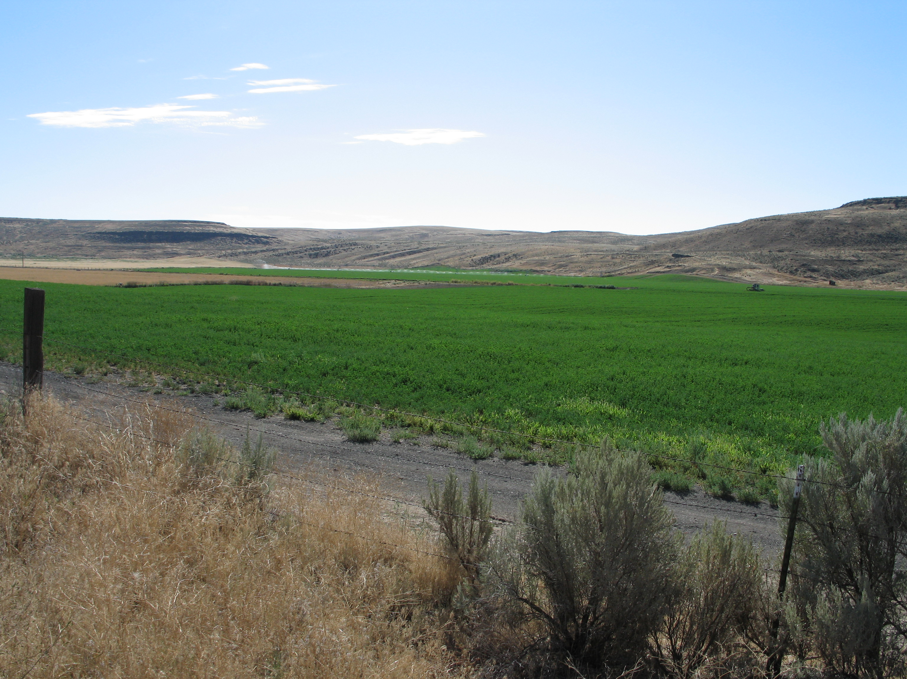

production. Some of these areas are currently out of production and under CRP.
Wilson Creek is a narrow channel typical of the area. The northern reaches, are extremely rough, with steep canyon walls and ledges. Beginning in T23N and continuing to the south, the channel widens and the landscape appears flatter with gentler slopes. Smaller basalt out crops line the channel in an irregular and broken chain.
Canniwai Creek channel flattens and widens considerably at the confluence of Crab Creek. In general this channel is not as steep and rough as the others in this area.
Martin Hollow and Lake Creek channels are very rough, with steep ledges and cliffs south of Lakeview Ranch. In places the canyon walls are vertical. There is a series of ledges and depressions that can be described as “badlands.” Outside the immediate channel the landscape maintains its rough characteristics with an abundance of basalt ledges and cliffs exposed by the rushing waters of the Spokane floods. The soil is very shallow and rocky. In places the texture of the landscape takes on a smoother appearance even though the surface is actually very irregular.
South of Crab Creek and Highway 28 in T21 & 22N, R29E there is an area where the channeled scablands widen. The area has a flat appearance; however, the shallow channels and depressions have numerous basalt outcroppings that form a rough surface similar to some pronghorn habitats in eastern Oregon, southern Idaho and northwestern Nevada.

Water
Water is available to pronghorn throughout the area although in some places travel in excess of two miles may be required. Water availability during the summer months may become a problem in the area south of Crab Creek and Black Rock Coulee. Some waters are located in the steep canyons and draws of the channels and may be avoided by pronghorn.

Climate
The area climate is typical of the Columbia Basin (Table 31). The summers are hot and dry and winters are cold with temperatures dipping below the 0ºF (Figure 54). The mean temperature recorded at Coulee Dam 1 SW (WA 451767) is 60ºF. The hottest months are July and August

Table 31. COULEE DAM 1 SW, WASHINGTON (451767)
Period of Record Monthly Climate Summary 6/ 1/1948 to 3/31/2005
 | Jan | Feb | Mar | Apr | May | Jun | Jul | Aug | Sep | Oct | Nov | Dec | Annual
Average Max. Temperature (F) | 32.0 | 39.8 | 50.2 | 61.2 | 70.3 | 78.4 | 86.8 | 85.8 | 76.4 | 60.9 | 43.6 | 34.1 | 60.0
Average Min. Temperature (F) | 21.2 | 25.8 | 31.2 | 38.0 | 45.6 | 52.6 | 58.1 | 57.5 | 50.0 | 40.1 | 31.4 | 24.4 | 39.7
Average Total Precipitation (in.) | 1.10 | 0.90 | 0.86 | 0.77 | 1.11 | 0.89 | 0.52 | 0.49 | 0.50 | 0.65 | 1.28 | 1.46 | 10.55
Average Total SnowFall (in.) | 6.6 | 2.3 | 0.8 | 0.0 | 0.0 | 0.0 | 0.0 | 0.0 | 0.0 | 0.0 | 1.4 | 5.2 | 16.4
Average Snow Depth (in.) | 2 | 1 | 0 | 0 | 0 | 0 | 0 | 0 | 0 | 0 | 0 | 1 | 0
Percent of possible observations for period of record.
Max. Temp.: 98.7% Min. Temp.: 98.8% Precipitation: 98.7% Snowfall: 92.4% Snow Depth: 90.6%
Western Regional Climate Center, wrcc@dri.edu

and the coldest occur in January and February. Precipitation is received every month of the year with the most occurring from November - February and the least in August – September. Extreme average daily snow depths have exceeded 10 in. or more on occasion during December through February (Figure 55). Normally, average daily snow depth during these months is 2 inches (WRCC 2005).
Mule deer inhabit this area as yearlong residents and are joined in the winter by migrants from areas further north and east (Mark Quinn, personal communication). If pronghorn are established here, some movement may occur to escape adverse climatic conditions similar to patterns established by mule deer in the area.

Figure 54. Maximum and minimum temperature extremes, Coulee Dam, Grant Co., WA.
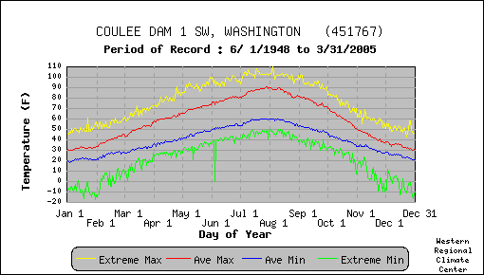

Figure 55. Average and daily snow depth extremes at Grand Coulee, Grant Co., WA.
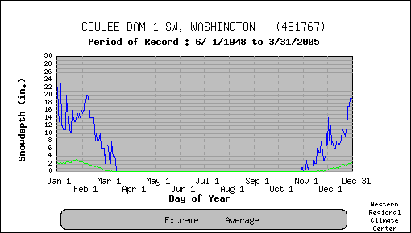

Limitations
As is typical of eastern Washington, dry land farming has converted most of the lands adjacent to the channeled scablands. The proximity of agriculture production areas may present a problem to successful establishment of pronghorn. The areas of irrigated alfalfa are vulnerable to use by pronghorn and could result in potential crop damage complaints. The potential habitat is severely fragmented by agriculture development over the last century. Associated with agriculture are fences, canals and secondary roads, which further reduced the value of potential habitat. Numerous livestock range fences in the area are not built to allow easy passage by pronghorn. Woven wire fences protecting crops such as alfalfa is an effective action to prevent damage by pronghorn. However, when woven wire fence construction is used on a railroad or highway right-of-way, seasonal movements of pronghorn may be hampered. There is risk of pronghorn mortality on hard surface roads, the Burlington Northern and the Burlington Northern Santa Fe railroad lines. Highway 28 is currently a low volume highway that bisects potential pronghorn habitat in the area.
The Main Canal flowing south from Banks Lake to Billy Clapp Lake is concrete lined and poses a threat to any big game trying to cross it. The Main Canal flows out of Billy Clapp Reservoir, and connects with the West Canal west of Stratford. The East Canal flows southeasterly towards Moses Lake. All of these canals may pose a danger to pronghorn.
The largest block of potential pronghorn habitat occurs south of Crab Creek (T21 & 22N, R29E) in an area that contains alternate sections of DNR administered public lands. The Arbuckle area south of Coulee City has some State and Federal administered public lands but the majority of potential habitat is under private ownership. The channeled scabland of Crab Creek between Marlin and Odessa has approximately 26 mi² of BLM administered public lands. Some of the channeled scabland in this area is not potential pronghorn habitat because of the rough terrain, deep channels and basalt cliffs.

Habitat Evaluation Score
The field habitat evaluation scores for this area are found in Table 32. The area scored 4.13 overall, which is at the low end of the fair habitat rating. The sub area scores ranged from 3.6 to 4.8.

Table 32. Grand Coulee/Wilson Creek pronghorn field habitat evaluation scoring
summary
Criteria  Location | Vegetation  Forbs | Vegetation  Shrubs | Vegetation  Grass | Vegetation  Quantity | Vegetation  Height | Water  Distribution | Topography | Size and  Continuity | Land Owner- ship and Use | Limitations &  Obstructions | Total Score
1. T24N, R27-29E; T25N, R28-29E  Arbuckle - Dry Coulee | .4 | .4 | .2 | .5 | .5 | .5 | .35 | .35 | .4 | .5 | 4.1
2. T23N, R26-29E; T22N, R26-27E Billy  Clapp | .3 | .4 | .2 | .5 | .6 | .5 | .7 | .3 | .2 | .3 | 4
3. T24N, R30-31E; T25N, R30-31E  Upper Wilson Cr. | .3 | .4 | .2 | .4 | .5 | .4 | .4 | .2 | .3 | .5 | 3.6
4. T23N, R30-32E; T24N, R32E Lower  Wilson & Canniwai | .4 | .6 | .2 | .5 | .6 | .3 | .5 | .35 | .3 | .35 | 4.1
5. T22N, R29-30E Crab Creek | .4 | .5 | .2 | .5 | .5 | .4 | .5.5 | .5 | .4 | .4 | 4.8
6. T22N; R29-30E Black Rock Coulee | .3 | .6 | .2 | .5 | .5 | .4 | .6 | .5 | .4 | .4 | 4.4
7. T22N, R31-32E; T21N, R31-32 E  Marlin Hollow and Lake Creek | .3 | .4 | .2 | .5 | .5 | .5 | .2 | .4 | .45 | .45 | 3.9
Total | 2.4 | 3.3 | 1.4 | 3.4 | 3.7 | 3 | 3.75 | 2.6 | 2.45 | 2.9 | 28.9
Criteria Score | .34 | .47 | .20 | .49 | .53 | .43 | .54 | .37 | .35 | .41 | 4.13

Pronghorn habitat values such as grasses, forbs, size and continuity of habitat, and landownership and use received poor values resulting in the lower score. The field ranking modeling effort placed this area at number 5.
The GIS analysis resulted in a normalized weighted rating of 6.45 (Appendix D3). The area ranked number 8 overall, and in last place.
Based on the estimated 630 mi.² (1632 km²) of potential pronghorn habitat and a density of .4/mi², it is estimated that a population of approximately 250 – 300 animals might be established.

Bickelton/Six Prong

Location/Landownership
The Bickelton/Six Prong area is located in Klickitat County east of Highway 97, and south of the Goldendale-Bickleton Road (Appendix A). Goldendale is the County seat and the largest city in the county with a population of approximately 3,650. The county is rural in nature with approximately 20,000 residents. The southern boundary of the county borders the Columbia River. The primary industry in the area is timber and agriculture production. There is a growing agriculture presence in the Alderdale area where orchards and vineyards are coming into production. In Klickitat County it is estimated that approximately 59,321 acres (24,025ha) of CRP have been authorized. Tourism, aluminum production and solid waste disposal are the major industries in the county.
The area surveyed is approximately 423 mi² (1,096 km²) at an elevation of 266ft (81m) on lake Umatilla (Columbia River) to approximately 700-800ft ( 214-244m) along the southeast slope of the Simcoe Mountains where the forested environment begins. The area has a healthy mule deer population that utilizes the shrub steppe habitats, particularly in the winter.

Vegetation
Shrub-steppe is the major vegetation in this region and is found intermingled and below the Ponderosa pine forest and oak woodland habitats. It forms a mosaic landscape with these woodland habitats and the drier eastside habitats. Livestock grazing is the primary land use in the shrub-steppe although much has been converted to irrigated or dry land agriculture.
Like most of eastern Washington, much of the shrub-steppe habitat has been eliminated or fragmented since the arrival of European settlers. Livestock grazing and conversion of lands to farmland have eliminated native vegetation and aided invasion of non-native species such as cheatgrass, Russian thistle (Salsola kali), and mustard (Sisymbrium altissimum). Wildfire and poor land use practices create problems with soil erosion, further reducing native vegetation.
NPCC (2004) report estimated that approximately 55% of grassland habitat and 87% of shrub-steppe habitat have been lost due to irrigated and dry land agricultural conversion, or to inundation of the Columbia River and associated urban expansion in the Columbia Gorge Subbasin area.
Most native vegetation in upland areas of the subbasin is classified as steppe or shrub-steppe. These are: Artemisia-Agropyron, Agropyron-Poa, and the Festuca-Koeleria zone (Poulton 1955). The Artemisia-Agropyron zone occupies the driest lower reaches of the subbasin and is dominated by big sagebrush (Artemisia tridentate), bluebunch wheatgrass (Pseudoregnia spicatum), and bluegrass (Poa secunda).
There is a sharp contrast between the more vigorus shrub steppe vegetation found along a band between 2,950 – 2,460 ft (900m - 750m) elevation (Figures 56 – 58) compared to the dryer and sparse habit of vegetation below 2,460ft (750m) down to the Columbia River (Figure 59).
Shrub habitat includes the following common species; bitterbrush, big sagebrush, gooseberry, willows, chokecherry (Prunus virginiana), Saskatoon serviceberry (Amelanchier alnifolia), rose
(Rosa spp). Herbs are dominated by non-native mustard, dock (Rumex spp.), pigweed (Chenopodium spp.), Russian thistle (Salsola tragus) and many other species. Where livestock grazing and range fires have combined to change the vegetative character of the landscape species such as rabbitbrush (Chrysothamnus nauseosus) and cheatgrass (Bromus tectorum) invade and dominate.
The Festuca-Koeleria zone is wetter still, with prairie June grass (Koeleria cristata), Idaho fescue (Festuca idahoensis), and bluebunch wheatgrass dominating the grassland areas (Poulton 1955).

Figure 56. Grass/shrub mix near Wood Cr., Klickitat Co., WA.
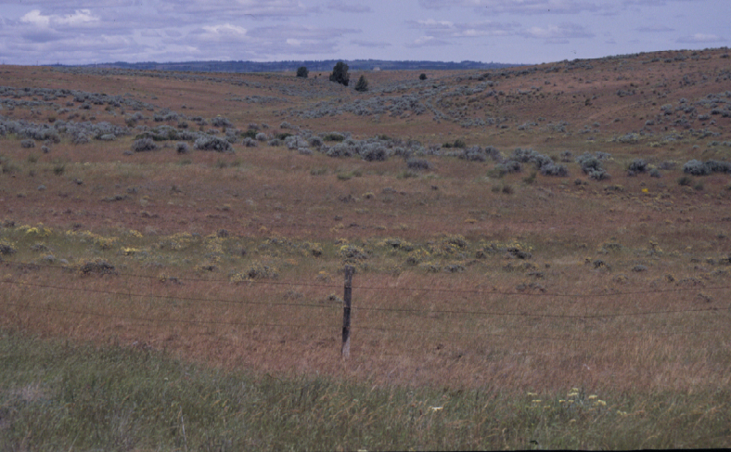

Figure 57. Juniper and shrub habitat off of Middle Rd., Klickitat Co., WA.
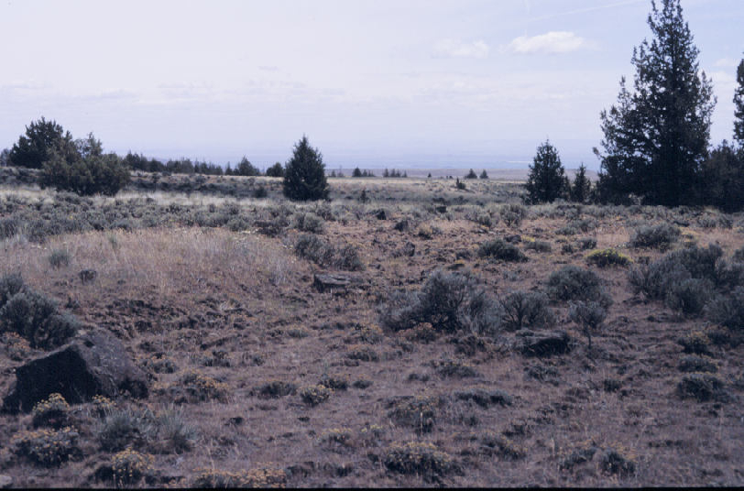
Figure 58. Shrub steppe habitat on Alder Creek, Hale Rd., Klickitat Co., WA.
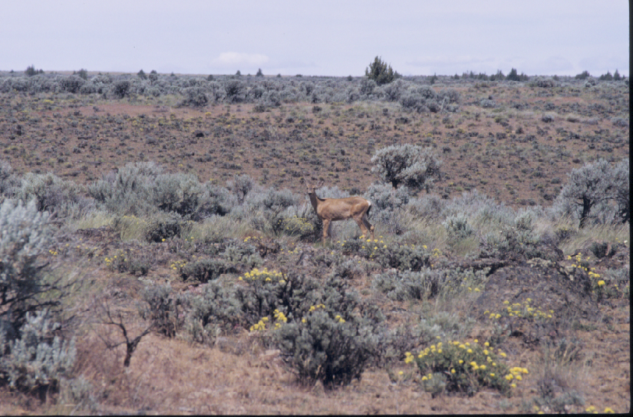

Figure 59. Glass Canyon Gulch north of North Roosevelt, WA.
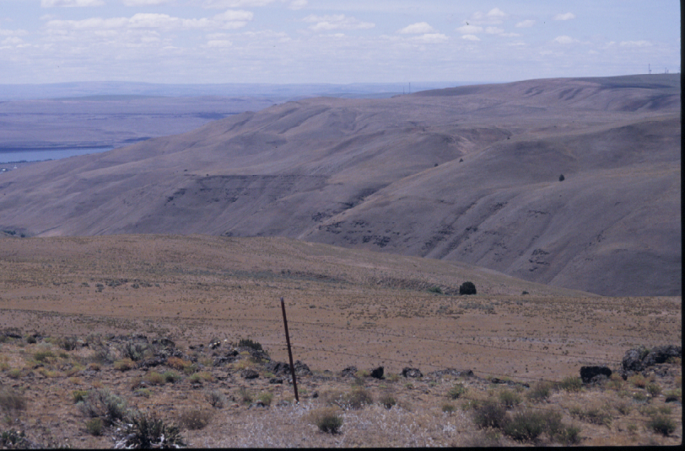

Black hawthorn (Crataegus douglasii) and common snowberry (Symphoricarpos albus) occur along streams and in concave areas on north-facing slopes.
Because of the predominance of private land ownership in this are, one of the major problems is the fragmented habitat. The shrub steppe community has been severely impacted from agriculture and residential development. Additionally, frequent wild fire and intense livestock grazing has changed the vegetation composition (Figure 60). At the lower elevations there are many private parcels under CRP, most of which have been planted with crested wheat grass. Restoration of agriculture lands to native vegetation may offer some relief over the long term in reducing the fragmentation of important wildlife habitats (NWPCC 2004).
The land cover statistics for pronghorn habitat in the Bickelton/Sixprong evaluation area using the National land cover data set (NLCD 2000) showed the following results as displayed in Table 33. The occurrence of evergreen forest is relatively small and presents no concerns because of their location at the higher elevations and on steep slopes or as stringers of riparian along the major drainages flowing into the Columbia River.

Figure 60. Willow Creek, Klickitat Co. showing affects of a recent burn.
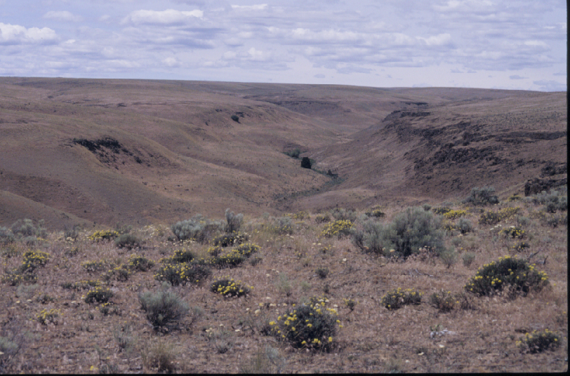

Topography
The entire area is part of the south facing slopes of the Columbia River Gorge. Elevation varies from approximately 900 ft. (274m) at Bickleton to 266 ft. (81m) on the Columbia River. The south facing slope declines an average of about 60ft. per linear mile. The steepest gradients occur along the Columbia River (Figure 59) and the following tributaries; Rock Creek, Bighorn, Pine Creek and Alder Creek. Typically, these canyons have a narrow riparian zone with deciduous trees and ponderosa pine. The upper reaches of the canyons are steep walled and very rough, while the lower areas generally flatten out and have a more open aspect. Some of the steepest canyons will be barriers to pronghorn antelope movement.

Table 33. NLCD Land Cover Classes in the Bickelton Area/Sub Areas.
Classes (mi²) | Sub  Area  1 | Sub  Area  2 | Sub  Area  3 | Sub  Area  4 | Area  Total  (mi²) | Percent
Bare (rock/sand/clay),  com./industrial/trans.,  deciduous/evergreen/or mixed  forest, emergent herbaceous  wetlands, urban/recreation grass,  open water, row crops,  high & low intensity residential,  orchards & vineyards. (0) | 0.67 | 0.21 | 0.76 | 0.64 | 2.27 | 0.54%
Pasture/hay, woody wetlands,  Fallow, small grain, transitional. (1) | 4.96 | 32.13 | 2.81 | 18.31 | 58.21 | 13.89%
Exotic grasses & weeds,  Stiff Sagebrush. (2) | 0.0 | 0.00 | 0.00 | 0.00 | 0.00 | 0.00%
Shrub steppe on shallow  soils, native grasslands with  herbaceous species. (3) | 9.64 | 0.66 | 0.40 | 5.65 | 16.34 | 3.90%
Grassland/herbaceous. (4) | 44.93 | 60.58 | 48.52 | 69.02 | 223.05 | 53.22%
Shrub land. (5) | 21.63 | 44.86 | 28.89 | 23.86 | 119.25 | 28.45%
Grand Total | 81.83 | 138.44 | 81.38 | 117.48 | 419.13 | 100.00%

Size and Continuity
The size of the study area totaled 419 mi.² (1085 km²). The top three topography rating categories showing <10º slope totaled 305 mi² (790 km²) representing about 73% of the study area. It is estimated that about 84% of the area or 348 mi² (901 km²) meet the minimum topography requirement considered as potential habitat for pronghorn in this area.
In terms of the vegetation potential approximately 342 mi² or 82% of the area is in the shrub land (4) and grassland/herbaceous (5) vegetation categories.
The potential for this area based on the size of the area, vegetation, and topography values, and if all other criteria were adequate, a population of 300 – 350 pronghorn could be established.

Water
Water is well distributed throughout the area; however, it may not necessarily be available to pronghorn because of its location in rough terrain or in riparian vegetation. Access to water along the Columbia River may be difficult for pronghorn because of a hard surface highway with right of way fencing and an adjacent railroad right of way. High recreational boating use may also present a problem for pronghorn access to the river at times.

Climate
The Columbia gorge climate is moderated by the river system. The area has hot summer and mild winter temperatures (Table 34). Precipitation is received every month of the year with the
largest amounts occurring during the winter months. Snow accumulations at Bickelton do not represent conditions at lower elevations where snow depths are lower and climate is significantly warmer. Snow depth is not considered to be a deterrent to pronghorn establishment in this area even though the Bickelton station shows some very high maximum daily snow depth accumulations (WRCC 2005). With good south exposures and readily available access to lower elevation along the Columbia River, animals can escape extreme climatic conditions. Temperature extremes and snow depth extremes are shown for Bickelton weather station in Figures 61 and 62.

Table 34. BICKLETON 3 ESE, WASHINGTON (450668)
Period of Record Monthly Climate Summary 1/ 1/1931 to 3/31/2005
 | Jan | Feb | Mar | Apr | May | Jun | Jul | Aug | Sep | Oct | Nov | Dec | Annual
Average Max. Temperature (F) | 35.2 | 40.1 | 47.1 | 55.5 | 64.4 | 72.2 | 81.5 | 81.0 | 72.0 | 59.6 | 44.0 | 36.8 | 57.5
Average Min. Temperature (F) | 22.0 | 25.7 | 30.0 | 34.3 | 40.4 | 46.3 | 52.7 | 53.1 | 47.0 | 38.2 | 29.0 | 23.9 | 36.9
Average Total Precipitation (in.) | 1.97 | 1.54 | 1.19 | 0.79 | 0.76 | 0.79 | 0.24 | 0.32 | 0.43 | 0.90 | 2.00 | 2.37 | 13.30
Average Total SnowFall (in.) | 9.0 | 4.5 | 2.4 | 0.6 | 0.0 | 0.0 | 0.0 | 0.0 | 0.0 | 0.2 | 4.0 | 8.9 | 29.7
Average Snow Depth (in.) | 2 | 1 | 0 | 0 | 0 | 0 | 0 | 0 | 0 | 0 | 0 | 1 | 0
Percent of possible observations for period of record.
Max. Temp.: 91.9% Min. Temp.: 92.1% Precipitation: 93.2% Snowfall: 92.3% Snow Depth: 83.3%
Western Regional Climate Center, wrcc@dri.edu

Figure 61. Maximum and minimum temperature extremes at Bickleton, Klickitat Co., WA.
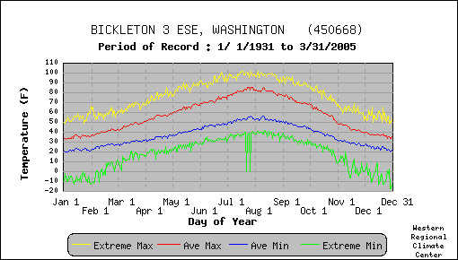

Limitations
This area has some excellent patches of habitat for pronghorn; however, the size of the habitat is relatively small and fragmented. Development of agriculture, urban areas and transportation corridors in the area has partitioned habitats into isolated islands. Approximately 92% of the area is under private ownership with only a few sections of State and Federal lands totaling about 5% and 3% respectively.

Figure 62. Average and daily snow depth extremes at Bickleton, Klickitat County, WA.
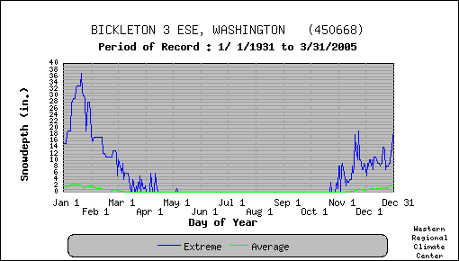

A more recent agriculture development in the Lower Alder Creek area of southeastern Klickitat County has changed the vegetative make up of the area. Even though orchards and vineyards have not presented an attraction to pronghorn other crops such as alfalfa hay could present damage conflicts if pronghorns were introduced into the vicinity. There are many dry land wheat production areas currently enrolled in CRP. These lands are in varying stages of reversion but mostly they are crested wheat grass plantings.
Fences are numerous and most do not meet the standards for safe passage of pronghorn. Most problematic are woven wire fences and barbed wire fences with more than 4 stands of wire with the lower wire below 16 inches from ground level.
Highway and railroads present hazards to big game animals including pronghorn. The combination of a highway and railroad running adjacent to each other can present a serious hazard to pronghorn. Access to the Columbia River for water would be difficult because of two such transportation corridors running parallel along the river.
Livestock are grazed heavily in portions of the area. Competition for forage and water between pronghorn and livestock and other big game can be expected.

Habitat Evaluation Score
Results of GIS mapping and analysis of the Bickelton Area gave a normalized weighted rating of 6.30. The normalized weighted rating placed this area as number 3 overall. The high rating received for this area using the GIS model is reflective of the high values in vegetation and water availability. This area placed very high in the shrub land vegetation class because it represented 28% of the vegetative cover. The high placement was also enhanced by the grassland/ herbaceous cover category representing 53% of the area.
The area received high GIS values for slope and aspect compared to the field evaluation rating for topography. The lower values from the field assessment were based on the character of the deep cut canyons with sheer walls and talus slopes. In addition the riparian vegetation in the canyon bottoms was well developed creating a formidable barrier to pronghorn movement.
The field assessment score for this area was 3.83 as shown in Table 35. This score ranked the area as number 8, the lowest of the 8 areas surveyed. The major reason was in the lower overall scores given to the quantity, quality and height of vegetation variables.
The areas potential pronghorn habitat is fragmented, limited in size and continuity. Much of the high value score obtained through GIS modeling included a significant amount of CRP lands that are in various stages of reversion to grasslands and exotic weedy species. For these reasons the value of the area was adjusted downward in my field analysis.
A population of pronghorn currently exists on the Umatilla Army Depot in Morrow and Umatilla counties, Oregon, which is across the Columbia River and approximately 25 miles east of the Bickelton study area. This is the closest free roaming wild population of pronghorn to Washington State.

Table 35. Bickelton/Six Prong pronghorn habitat field evaluation scoring summary
Criteria  Location | Vegetation  Forbs | Vegetation  Shrubs | Vegetation  Grass | Vegetation  Quantity | Vegetation  Height | Water  Distribution | Topography | Size and  Continuity | LandOwner-  ship and use | Limitation &  Obstructions | Total Score
1. T5N, R19-20E Glass Canyon | .4 | .4 | .3 | .5 | .35 | .7 | .2 | .3 | .3 | .3 | 3.75
2. T5N, R21-23E; T6N, R21-23E Alder  Creek. | .25 | .5 | .2 | .5 | .5 | .6 | .4 | .2 | .3 | .3 | 3.95
3. T3N, R21E; T4N, R21-22E Sixprong | .25 | .3 | .2 | .4 | .5 | .3 | .4 | .4 | .3 | .3 | 3.35
4. T4N, R19-20E: T3N, R19-20E  Chapman | .25 | .2 | .2 | .4 | .6 | .3 | .3 | .4 | .35 | .4 | 3.4
Total | 1.15 | 1.4 | 0.9 | 1.8 | 1.95 | 1.9 | 1.3 | 1.3 | 1.25 | 1.3 | 16.5
Criteria Score | .29 | .35 | .23 | .45 | .49 | .48 | .33 | .33 | .31 | .33 | 3.59

The potential pronghorn habitat in this area is estimated to be about 423 mi² (1,096 km²). Based on the size of the area and an estimated potential density of .40/mi², it is estimated that a population of approximately 150 - 200 pronghorn could be established in this area.

CONCLUSIONS AND RECOMMENDATIONS

The basic habitat needs for pronghorn are food, water and escape from predators. All three of these needs were analyzed using available resources with considerable dependence upon professional judgment and knowledge on pronghorn populations in the United States and Canada.
All of the areas studied and visited in eastern Washington have qualities thought to be essential for the support of an introduced population. An effort was made to determine and evaluate the best habitats from existing data and where data was lacking, insufficient or inaccurate conduct a field survey and utilize professional judgment to quantify potential pronghorn habitat. The two modeling methods used provided insight into the quality and quantity of potential pronghorn habitat, helped identify deficiencies and positive components of the habitat and helped weight the components for the final decision making process.
The on site field habitat modeling effort only provided a snap shot of potential pronghorn habitat for the late spring and summer seasons. Winter and fall conditions were inferred by applying available climatological data.
From the ten values measured in this study, half were associated with the vegetation component, which placed a higher importance on this criterion. Topography was also an important criterion in the habitat evaluation process. Less tangible components were also taken into account and included size and continuity of habitat, landownership and use, and a “catch all” criteria entitled limitations and obstructions.

Ranking
Table 36 provides a summary of the field evaluation for the eight areas studied in ranked order from the highest to the lowest. Table 37 provides a summary of the GIS normalized weighted scoring in similar ranked order.

Table 36. Pronghorn habitat field evaluation summary for eight areas of eastern WA.
Criteria  Area | Vegetation  Forbs | Vegetation  Shrubs | Vegetation  Grass | Vegetation  Quantity | Vegetation  Height | Water  Distribution | Topography | Size & Continuity | Land Owner-  Ship & Use | Limitation &  Obstructions | Total Score | Rank
Yakima Training Center | .46 | .48 | .30 | .54 | .70 | .58 | .46 | .71 | .70 | .59 | 5.52 | 1
Quilomene | .46 | .44 | .29 | .58 | .66 | .73 | .33 | .53 | .63 | .50 | 5.15 | 2
Swanson Lakes | .52 | .48 | .32 | .63 | .50 | .80 | .43 | .50 | .43 | .43 | 5.04 | 3
Cow and Rock Creek | .43 | .34 | .30 | .52 | .50 | .69 | .59 | .56 | .33 | .46 | 4.72 | 4
Grand Coulee, Wilson Cr.,  Black Rock Coulee | .34 | .47 | .20 | .49 | .53 | .43 | .54 | .37 | .35 | .41 | 4.13 | 5
Moses Coulee, Badger  Mountain and Mansfield | .36 | .40 | .29 | .54 | .46 | .40 | .41 | .34 | .39 | .46 | 4.05 | 6
Rattlesnake Hills, Wahluke,  Hanford | .27 | .29 | .25 | .52 | .43 | .42 | .43 | .42 | .47 | .43 | 3.93 | 7
Bickelton | .29 | .35 | .23 | .45 | .49 | .48 | .33 | .33 | .31 | .33 | 3.59 | 8
Mean | .39 | .33 | .27 | .53 | .53 | .57 | .44 | .42 | .45 | .45 | 4.51

Table 37. GIS Analysis of Pronghorn habitat normalized weighted rating (topography, aspect, vegetation & distance to water).
Area | Normalized  Weighted  Rating | Rank
Rattlesnake Hills, Hanford, Wahluke | 7.21 | 1
Yakima Training Center | 7.05 | 2
Bickelton | 6.96 | 3
Cow & Rock Cr. | 6.88 | 4
Mosses Coulee, Badger Mt., Mansfield | 6.83 | 5
Swanson Lakes | 6.84 | 6
Quilomene | 6.73 | 7
Grand Coulee, Wilson Creek, Black Rock Coulee | 6.45 | 8

There is a significant difference in the ranking between the two methods applied. In an effort to identify the specific differences in the two methods the numerical scores were noted for each criteria and a mean score was calculated and ranked (Table 38). It is important to keep in mind that the habitat assessment for the eight areas in eastern Washington resulted in scores in the mid-range of the 10 point scale. The range of scoring was between a high of 6.37 to a low of 5.0, placing all of the areas in the fair habitat group.
In this study the Yakima (6.37) and Quilomene (5.91) areas ranked number 1 and 2 respectively, scoring at the higher end of the fair range of 7 – 4.1. The Swanson Lakes and Cow/Rock Creek areas scored 5.63 and 5.52 respectively. These scores might indicate habitats that closely resemble each other; however, this is not necessarily the case. Both areas scored strongly in specific categories but also had some significant weaknesses that were quite different, which played into the overall scoring. The remaining four areas scored very closely ranging from 5.33 to 5.00. All eight areas will provide some potential for developing pronghorn populations but it is believed that density potential will be 1/mi² or less compared to optimum habitat areas in Wyoming and Montana where densities may approach or exceed 2 per mi². In estimating the potential population numbers for each area the highest scoring areas were designated a density value of 1/mi² with lower values for lower scoring areas as shown in Table 39.
It has been my experience that some introduced populations of large ungulates show a rapid spurt in growth the first 5 to 10 years and subsequently settles to a lower population number and growth rate. If the Yakima and Quilomene areas were to receive a transplant of pronghorn it would probably take 5 to 10 years to establish a viable self sustaining herd. A conservative estimate of herd size for the Yakima area might approach 300 animals. If all areas were transplanted an estimate of population might be about 1780 animals (Table 39). These numbers are somewhat speculative and only provided to show an optimistic potential.

In conclusion pronghorn habitat potential is present in eastern Washington although much of the potential areas occur as fragmented islands of habitat. Most of the areas were adjacent to intensive agriculture use, primarily in dry land wheat production.

Table 38. Scores of each variable by method and mean score by area
Area | GIS Model |  |  |  | Field Assessment Model |  |  |  |  | Score
 | Aspect | Water | Topography | Vegetation Cover | Vegetation  Quantity | Vegetation  Height | Area Size & Continuity | Land use & Ownership | Limits &  Obstructions | TOTAL | MEAN | RANK
Yakima Training Center | 1.27 | 9.99 | 5.35 | 8.36 | 5.4 | 7.0 | 7.1 | 7.0 | 5.9 | 57.37 | 6.37 | 1
Quilomene | 1.88 | 9.99 | 4.33 | 8.05 | 5.8 | 6.6 | 5.3 | 6.3 | 5.0 | 53.25 | 5.91 | 2
Swanson Lakes | 1.38 | 9.97 | 7.69 | 6.74 | 6.3 | 5.0 | 5.0 | 4.3 | 4.3 | 50.68 | 5.63 | 3
Cow and Rock Creek | .95 | 9.89 | 7.44 | 7.09 | 5.2 | 5.0 | 5.6 | 3.3 | 4.6 | 49.07 | 5.52 | 4
Rattlesnake Hills, ALE, Hanford, Wahluke | 1.46 | 8.38 | 7.17 | 8.28 | 5.2 | 4.3 | 4.2 | 4.7 | 4.3 | 47.99 | 5.33 | 5
Mosses Coulee, Badger Mt.,  Mansfield | 1.43 | 9.98 | 5.88 | 7.60 | 5.4 | 4.6 | 3.4 | 3.9 | 4.6 | 46.79 | 5.20 | 6
Grand Coulee, Wilson Creek,  Black Rock Coulee | 1.30 | 9.74 | 7.48 | 6.13 | 4.9 | 5.3 | 3.7 | 3.5 | 4.1 | 46.15 | 5.13 | 7
Bickelton | 2.00 | 9.98 | 6.10 | 7.61 | 4.5 | 4.9 | 3.3 | 3.1 | 3.3 | 44.79 | 5.00 | 8

Table 39. Estimated potential pronghorn population by area and estimated density
(pronghorn/mi²).
Area | Density estimator | Habitat size  (mi²) | Estimated population (Range)
Yakima Training Center | 1.0/mi² | 323 | 323 (300 – 350)
Quilomene | 1.0/mi² | 113 | 113 (100 – 150)
Swanson Lakes | .75/ mi² | 311 | 233 (230 – 300)
Cow and Rock Creek | .50/ mi² | 433 | 216 (200 – 250)
Grand, Wilson, and Black Rock Coulee’s | .50/ mi² | 630 | 252 (250 – 300)
Moses Coulee, Badger Mt, Mansfield | .50/ mi² | 486 | 243 (250 – 300)
Rattlesnake Hills, Wahluke, Hanford | .50/ mi² | 699 | 349 (300 – 350)
Bickelton | .40/ mi² | 423 | 169 (150 – 200)
Total |  | 3,418 | 1,898 (1780 – 1930)

LITERATURE CITED

Allen, Arthur W. and Michael J. Armbruster. 1982. Preliminary evaluation of a habitat suitability model for the pronghorn. Pronghorn Antelope Workshop Proc. 10:93-105.

Allen, A. W., J. G. Cook, and M. J. Ambruster. 1984. Habitat suitability index models: Pronghorn. U.S. Fish Wildl. Serv. FWS/OBS-82/10.65. 22 pp.

Clausing, Theodore. 2005. Personal communications on July 27, 2005, concerning pronghorn observations on West Bar, Colockum Wildlife Area. WDFW, Yakima, WA.

Daubenmire, R. 1970. Steppe Vegetation of Washington. Technical Bulletin 62, Washington Agricultural Experiment Station, Washington State University, Pullman, Washington, 102pp.

Dobler, Frederick C. and James R. Eby. 1990. An introduction to the shrub steppe of eastern Washington – A brief appraisal of current knowledge and need. Wildlife Management Division, Washington Department of Wildlife. 4pp.

Einarsen Arthur S. 1948. The Pronghorn Antelope and its management. The Wildlife Management Institute. Washington D. C.

Evans, James R., Marita P. Lih and Peter W. Dunwiddie Editors. 2003. Biodiversity studies of the Hanford site 2002-2003. The Nature Conservancy. Seattle, WA. 170pp

Evans, James R. and Marita P. Lih. 2005. Recovery and rehabilitation of vegetation on the Fitzner-Eberhardt Arid Lands Ecology Reserve, Hanford Reach National Monument, following the 24 Command Fire. Final Report 2001-2004. The Nature Conservancy of Washington. Seattle, WA.

Franklin and Dyrness. 1973. Natural vegetation of Oregon and Washington. U.S.D.A. For. Serv. Gen. Tech. Rep. PNW-8 417pp.

Graham, R. W. and Lundelius, E. L. Jr. 1994. Faunmap. A database documenting Quaternary distributions of mammal species in the United States. Illinois State Museum, Springfield. Scientific Papers 25(1):1:287.

Hoover, R. L., C. E. Till, and S. Ogilvie. 1959. The antelope in Colorado. Colo. Dep. Game and Fish, Denver. 110pp.

McCarthy, Clinton and Jim Yoakum. 1984. An interagency approach to evaluating pronghorn transplant sites in Mono County, California. Proceedings of the Eleventh Pronghorn Antelope Workshop. Corpus Christi, TX. pp134-143.

Moreland, Raleigh. 1969. Antelope Introductions Status Report – 1969, Big Game Status Report. Washington Department of Game Federal Aid Wildlife Restoration Project W-81-D-1. pp 181-186.
National Operational Hydrologic Remote Sensing Center (NOHRC). 2004. Snow Data Assimilation system (SNODAS) data products at NSIDC. Boulder Colorado: National Snow and Ice Data Center. Digital media.

Nelson, Edward W. 1925. Status of the Pronghorned Antelope, 1922-1924. United States Department of Agriculture, Department bulletin No. 1346. Washington D.C. 64pp

Northwest Power and Conservation Council. 2004. Subbasin Planning 2004 Columbia Gorge and Salmon/Snake plans on Compact Disk.

O’Gara, Bart W. and J. D. Yoakum. 2004. Pronghorn Ecology and Management, University Press of Colorado, Wildlife Management Institute. 903pp.

Office of Financial Management. 2005. Washington State Data Book. Population Density and Land Area by County. State of Washington.

Poulton, C. 1955. Ecology of the Non-Forested Vegetation in Umatilla and Morrow Counties, Oregon. PhD dissertation, State College of Washington.

Rice, David G. 1969. Archaeological salvage in the Moses Coulee of North-central Washington. WSU Laboratory of Anthropology, Archaeological Reconnaissance Program, Archaeological salvage at site 45D0171 A report to the Washington State Hwy. Com.

The Olympian. 2005. Gregoire OKs wind farm in Kittitas County. The Olympian newspaper Wednesday, July 27, 2005. Section B4. Olympia, WA.

U.S. Bureau of Land Management. 1980. Manual supplement 6630−Big game studies: Guidelines for the evaluation of pronghorn antelope habitats. U.S. Bur. Land Manage., Reno, Nevada. 3pp.
U.S. Fish and Wildlife Service. 2005. Elk in and around the Hanford Reach National Monument an editorial. Hanford Reach National Monument web site http://www.fws.gov/pacific/hanfordreach/documents/elk-editorial.pdf.
Richland, WA.

Ward, D. 2001. Mainstem Columbia Basin Subbasin Summary. Prepared for the NPPC.
Washington State Energy Facility Site Evaluation Council. 2004a. Wild horse wind power project, Final State Environment Policy Act (SEPA) Environmental Impact Statement (EIS), Olympia, WA.

______2005b. Site certification agreement between the State of Washington and Wind Ridge Power Partners, LLC for the Wild Horse Wind Power Project, Kittitas Co., WA.

Western Regional Climate Center. 2005. Washington climate summaries. Available on line at http://www.wrcc.dri.edu/index.html, 2215 Raggio Parkway. Reno, NV 89512. Accessed July 2005.
Yoakum, James D. 1968. A review of the distribution and abundance of American pronghorn antelope. Antelope States Workshop Proc. 3:4-14.

_______, James D. 1974. Pronghorn habitat requirements for sagebrush-grasslands. Proc. Pronghorn Antelope Workshop 6:16-24.

______, 1978. In Big Game of North America Ecology and Management, edited by John L. Schmidt and Douglas L. Gilbert. Wildlife Management Institute. Stackpole Books. 493pp.

______, James D. 1980. Habitat management guides for the American pronghorn antelope. U.S. Bur. Land Manage. Tech. Note 347, Denver, Colo. 78pp.

Zilkah Renewable Energy. 2005. News release, Gov. Gregoire Gives the Go-Ahead for Wild Horse Wind Farm. July 26, 2005. Olympia, WA

APPENDIX A. Pronghorn Feasibility Study Areas

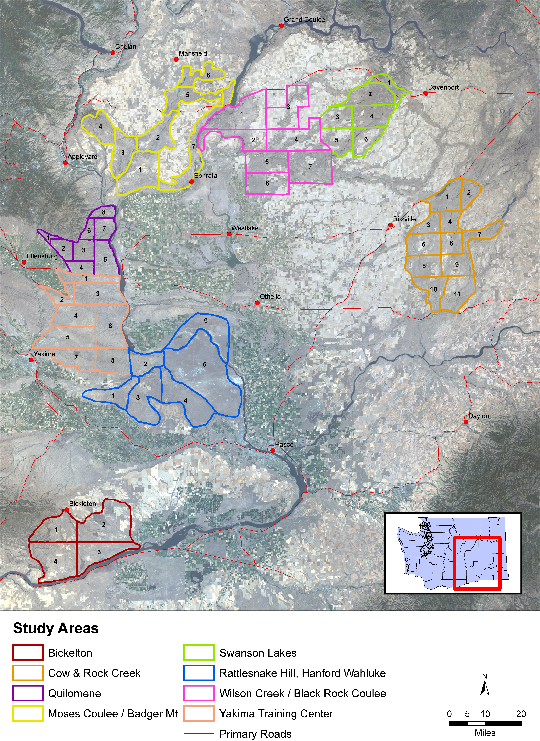

APPENDIX B
PRONGHORN HABITAT EVAUATION FORM

Date:______________ Location:___________________________________________________ CO._______________ T_____ R______ Sec___________________________.
Elevation:______________________ Investigator:______________________________

 | CRITERIA | NUMERICAL WEIGHT | SUBTOTAL | RATING
1 | Vegetation Quality/Diversity | Forbs (0 – 15)
1 | Vegetation Quality/Diversity | Shrubs (0 – 10)
1 | Vegetation Quality/Diversity | Grass (0 – 5)
1 | Vegetation Quality/Diversity | Maximum of 30 pts.
2 | Vegetation Quantity | (1 – 10) Maximum of 10 pts.
3 | Vegetation Height | 11” – 25” = (7.0 – 10.0)
3 | Vegetation Height | 5” – 10” = (3.1 – 6.9)
3 | Vegetation Height | 0” – 5” or 25+” = (0 – 3.0)
3 | Vegetation Height | Maximum of 10 pts.
4 | Water Availability | (0 – 10.0) Maximum of 10 pts.
5 | Topography | Level/flat (8.1 – 10.0)
5 | Topography | Level/broken (6.1 – 8.0)
5 | Topography | Rolling (4.1 – 6.0)
5 | Topography | Rolling/mountainous (2.1 – 4.0)
5 | Topography | Mountainous >25% slope (0 – 2.0)
5 | Topography | Maximum of 10 pts.
6 | Size & Continuity | (1.0 – 10.0) Maximum of 10 pts.
7 | Landownership/use | Mostly public (6.1 – 10.0)
7 | Landownership/use | Mostly private rangeland (3.1 – 6.0)
7 | Landownership/use | Private – CRP (1.1 – 3.0)
7 | Landownership/use | Private intense use (<1)
7 | Landownership/use | Maximum of 10 pts.
8 | Limitations/obstructions  (fences, canals, railroads, highways, urban areas, etc.) | (0.0 – 10.0) Maximum of 10 points when free of limitations.
 | TOTAL POINTS | Maximum 100 pts.

NOTES:

APPENDIX C
Meta Data References

National Land Cover Data Set
http://edc.usgs.gov/products/landcover/nlcd.html

DNR Major Public Lands (MPL)
http://www3.wadnr.gov/dnrapp5/website/cadastre/links/other_dnr_gis_data/NonDNR_Major_%20Public_Lands.htm

30 meter Digital Elevation Model (DEM) data
http://www3.wadnr.gov/dnrapp5/website/cadastre/links/other_dnr_gis_data/DEM30.html

National Wetlands Inventory (NWI)
http://www.fws.gov/nwi/downloads/metadata/nwi_meta.txt

StreamNet (str100)
http://www.streamnet.org/pnwr/PNWNAR.html

APPENDIX D

Maps

D1 Bickelton

D2 Cow and Rock Creek

D3 Grand Coulee, Wilson Creek, Black Rock Coulee

D4 Moses Coulee, Badger Mt. and Mansfield

D5 Quilomene

D6 Rattlesnake Hills, Wahluke, Hanford

D7 Swanson Lakes

D8 Yakima Training Center

