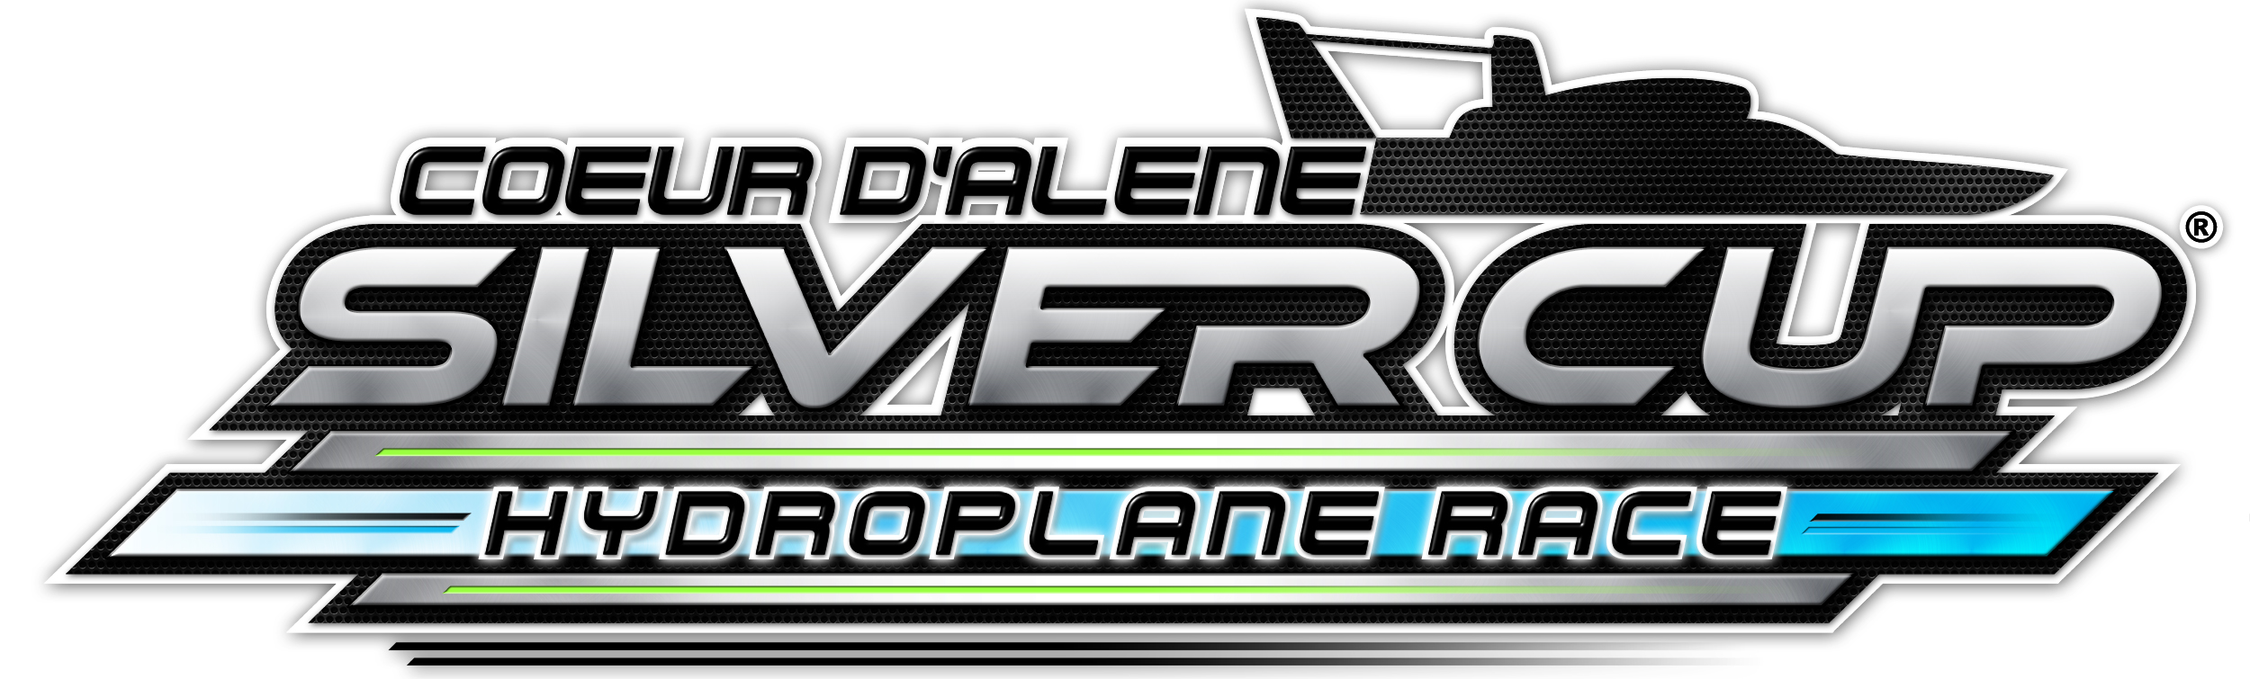

Coeur d’Alene Plans For 2017, Will Not Hold Race In 2016
Coeur d Alene Silver Cup General Manager Keith Allen has announced the Coeur d’Alene Silver Cup H1 Unlimited Hydroplane race will work towards hosting a race in 2017 but not in 2016.
“We have been working with our sponsors and local community representatives’ right up until the 11th hour to add the Silver Cup to the H1 2016 schedule,” said Allen. “With it now being 90 days until our event was to take place and being only one-third of the way from our fundraising goal, we felt it was in the best interest of our organization, the community of Coeur d Alene and the sport of hydroplane racing to proceed in a manner that ensures a successful event and continue our work for 2017.”
Coeur d Alene Silver Cup, Inc. has already obtained the primary permit from Idaho Department of Lands necessary to run the unlimited race in 2017, but the Silver Cup organization is still working to distance itself from the Diamond Cup group’s image that left considerable unpaid debts from the 2013 race.
Coeur d’Alene has a strong history in boat racing. The first inboard race was in 1913 with the first unlimited hydroplane race taking place in 1958 with Bill Stead in the Maverick grabbing the win. The unlimited hydroplanes continued to race on Lake Coeur d'Alene, in the Idaho panhandle, until 1968. Billy Schumacher and the "Checkerboard Comet" Miss Bardahl won the 10th and final race until the boats returned in 2013 when Jimmy Shane in the Graham Trucking won the title.
“We started planning the 2016 race with plenty of time and some money. We now have some strong financial commitments but we do not have enough time to put on the race on the weekend of July 16 and 17, this year” said Allen. “We promised those that have supported us we would not jeopardize the integrity of their brand or businesses and canceling the event now allows us to fulfill that promise and keep those important relationships in good standing.”
“Keith and his organization pledged from the beginning to the fans, the teams, to H1 Unlimited, the sponsors and the community that they would only run the event if they could do it right,” said H1 Unlimited Hydroplane Chairman Steve David. “They just ran out of time to do it properly, and they committed to upholding their pledge to everyone. And for that reason alone, I know we have the right people in place to bring unlimited hydroplane racing back to Coeur d’Alene in 2017.”
The 2016 H1 Unlimited Hydroplane season will begin on the Ohio River in Madison, Ind., July 1-3.

